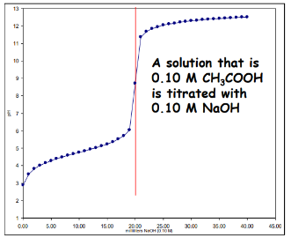N39 – Henderson-Hasselbalch

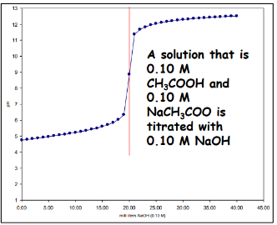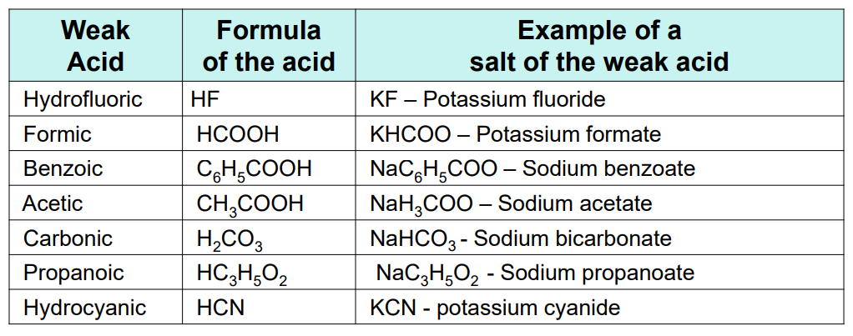

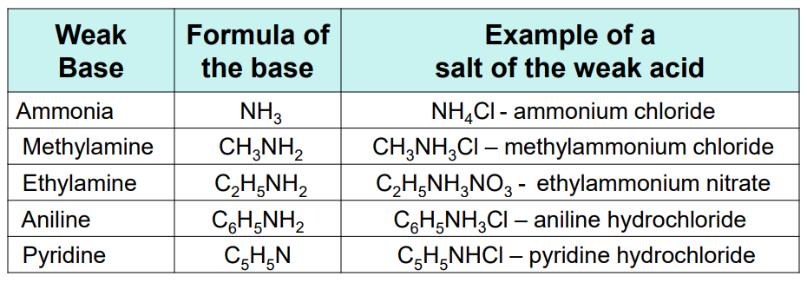

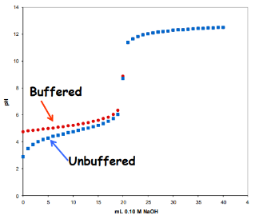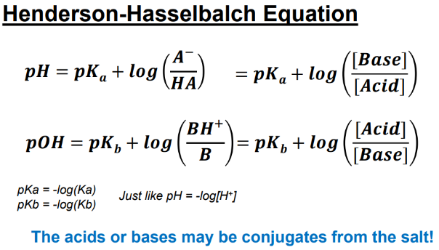

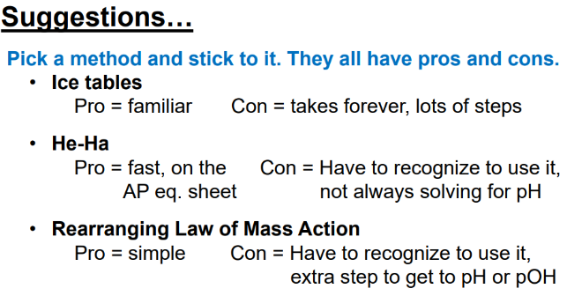

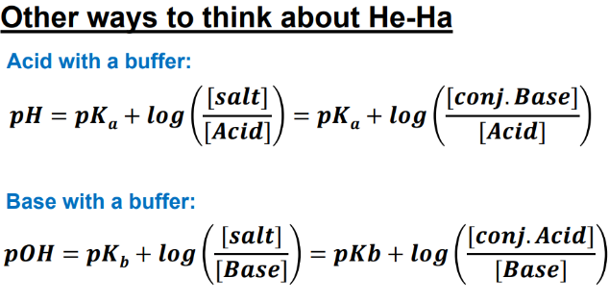

N39 – Henderson-Hasselbalch

N39 – Henderson-Hasselbalch

N39 – Henderson-Hasselbalch

N39 – Henderson-Hasselbalch

N39 – Henderson-Hasselbalch

N39 – Henderson-Hasselbalch

N39 – Henderson-Hasselbalch

