N41 - Titration

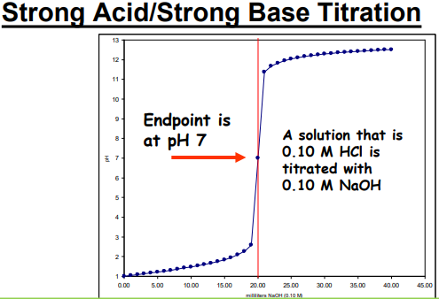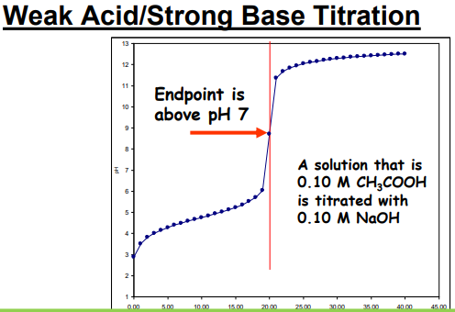

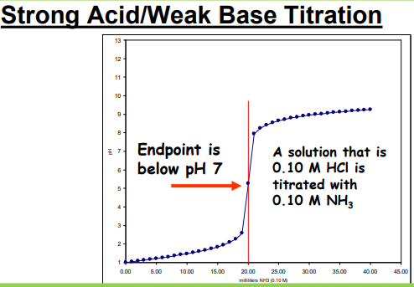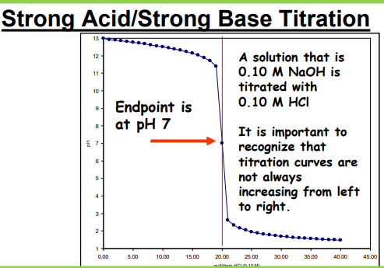

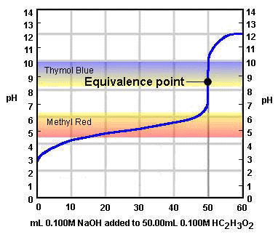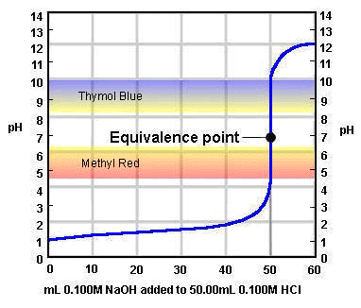

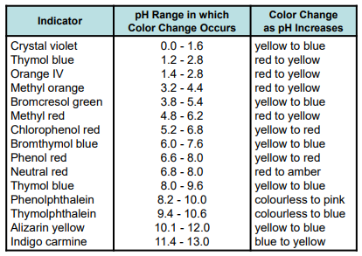

N41 - Titration

N41 - Titration

N41 - Titration

N41 - Titration

N41 - Titration

