**Name: Period: Seat#:**

**Worksheet #11**

**\*USE BINDER PAPER TO DO YOUR CALCULATIONS. STAPLE TO THIS PAGE\***

Information from the Curve:

There are several things you can read from the titration curve itself. Consider this titration curve.

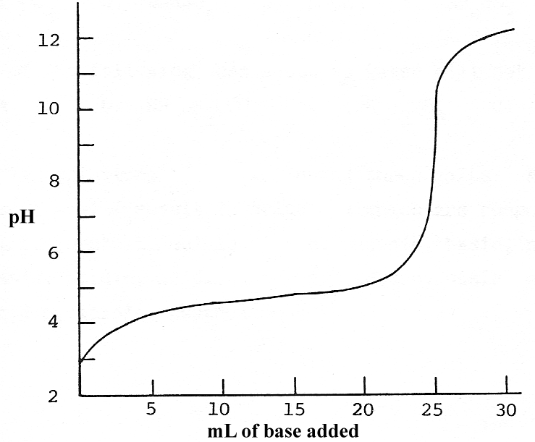

1. This is a **_________________**(strong/weak) acid titrated with a strong base. The acid is

**_________________**(monoprotic/diprotic).   
How would the other strength of acid look?  
*Answer:*

1. Place a dot (•) on the curve at the equivalence point. The pH at the equivalence point is **_________**. Choose a good indicator for this titration, look online or in your book for pH indicator ranges.   
   *Answer:*
2. What volume of base was used to titrate the acid solution? **_________** mL
3. Place a box (■) on the curve where the pH of the solution = the pKa of the acid.

What is the pH at this point? **________**  
What is the pKa of the acid? **________**  
What is the Ka of the acid? **_________**

Calculations knowing the Acid:

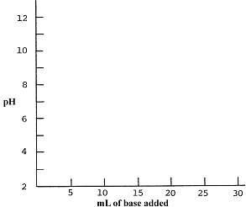

1. Hydrofluoric acid, HF, has a Ka = 7.2 x 10-4. Calculate the pH of 10.0 mL of a 0.050 M solution of HF. Plot the point on the axes. *2.2*
2. A 0.020 M solution of NaOH is used for the titration. What volume will be needed to reach the equivalence point? *25ml*
3. Write the net reaction for the neutralization of a solution of HF with a solution of NaOH:  
   *Answer:*
4. Calculate the moles of F- at the   
   equivalence point. *0.0005 mol*   
   What is the total volume? **_________**L *0.035L*

The [F-] at the equivalence point is**_________** *0.0143M*

1. Calculate the pH of the solution at the equivalence point. *7.65* Use this information and the answer to question 6 to plot the equivalence point on your graph. Choose a good indicator for this titration look online or in your book for pH indicator ranges.   
   *Answer:*
2. What is the pH halfway to the equivalence point? Plot this point on your graph. *3.14*
3. How many moles of HF are in the original 10.0 mL sample of HF? **________** *0.0005 mol*
4. When only 5.0 mL of 0.020 M NaOH has been added, calculate the moles of HF left and F- produced.

|  |  |  |  |  |
| --- | --- | --- | --- | --- |
|  | HF | OH | H2O | F- |
| *i* |  |  | ----- |  |
| *c* |  |  | ----- |  |
| *e* |  |  | ----- |  |

1. Use Henderson-Hesselbach equation or an ice table to calculate the pH when 5.0 mL of base has been added. Plot this point on your graph. *2.53*
2. When 20.0 mL of 0.020 M NaOH has been added, calculate the moles of HF left and F- produced.

|  |  |  |  |  |
| --- | --- | --- | --- | --- |
|  | HF | OH | H2O | F- |
| *i* |  |  | ----- |  |
| *c* |  |  | ----- |  |
| *e* |  |  | ----- |  |

1. Use the Henderson-Hesselbach equation or an icebox to calculate the pH when 20.0 mL of base has been added. Plot this point on your graph. *3.75*
2. When 30.0 mL of base is added, how many moles of OH- is in excess? **___________** *1x10-4* The total volume is **_________** L. *0.04L* [OH-] = **________** *0.0025M* pOH =**________** *2.6* pH = **________** *11.4* Plot this point on your graph.
3. Sketch the final titration curve on your graph on the front of this page.

Weak Base-Strong Acid Curve:

A 20.0 mL sample of 0.10 M CH3NH2 (methyl amine) is titrated with 0.15 M HCl. The Kb for

CH3NH2 = 4.2 x 10-4.

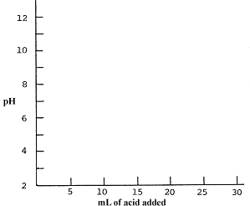Do all the appropriate calculations to sketch a titration curve for this titration.

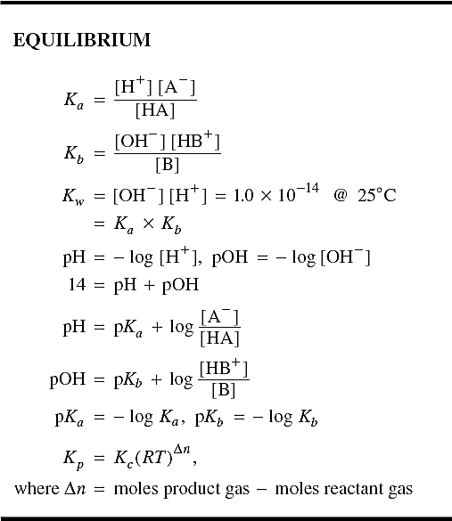**Formulas from the AP Exam:**