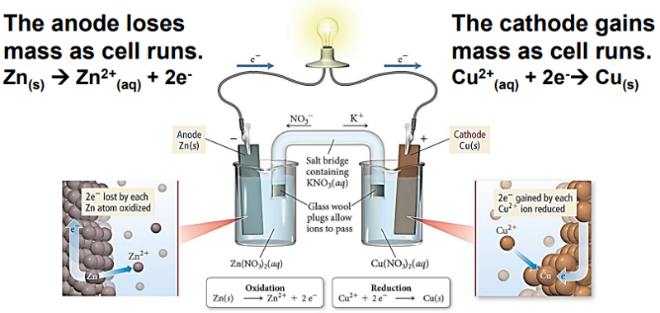N44 - Cells

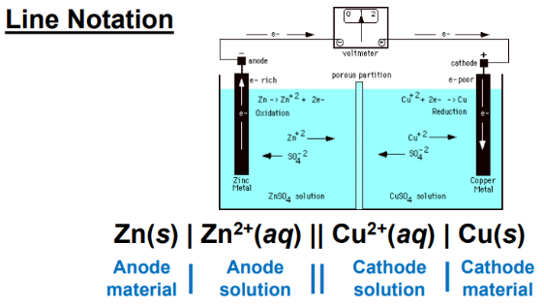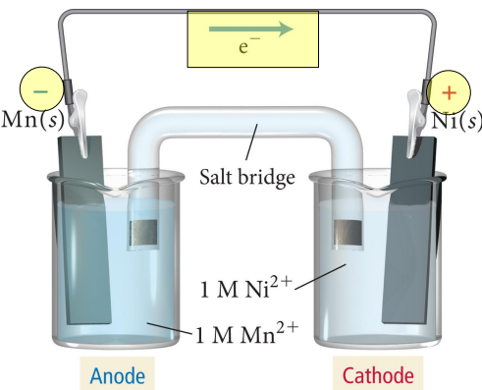

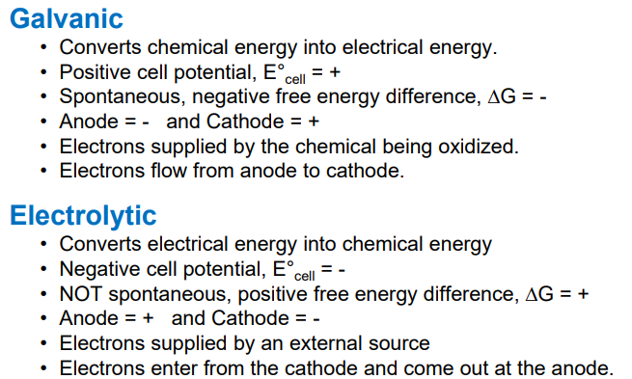

N44 - Cells



