N45

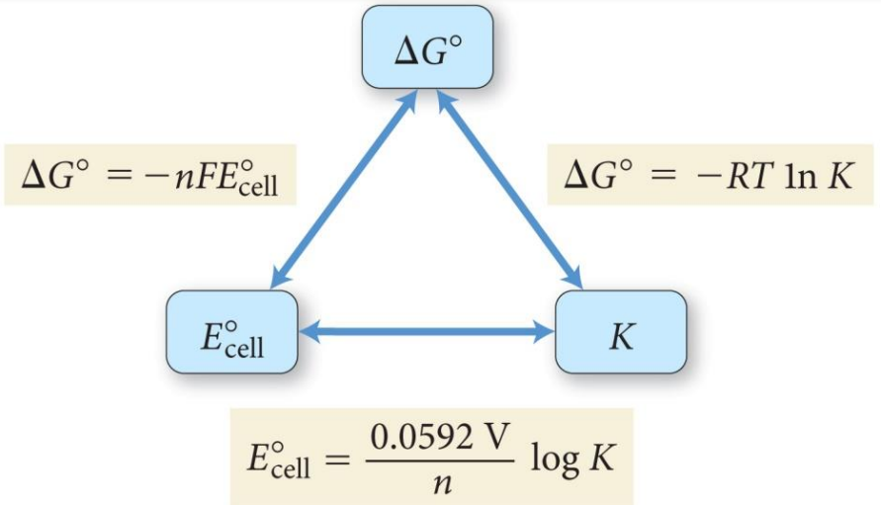

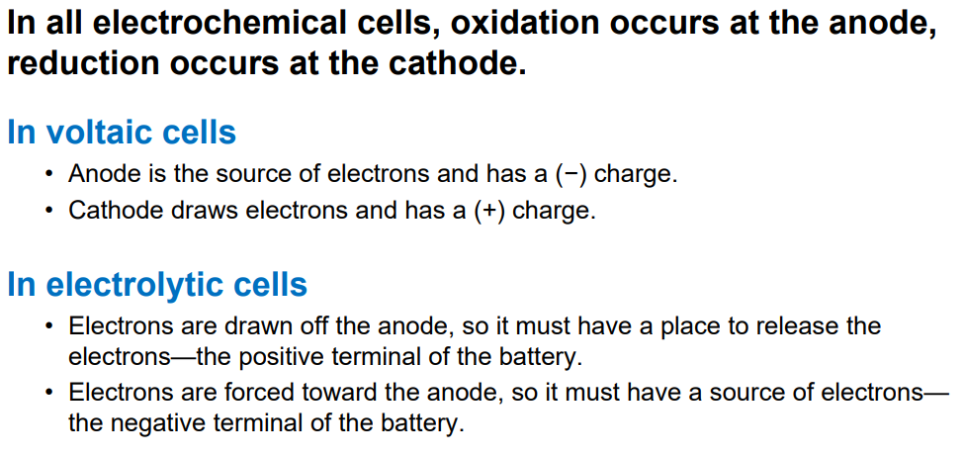

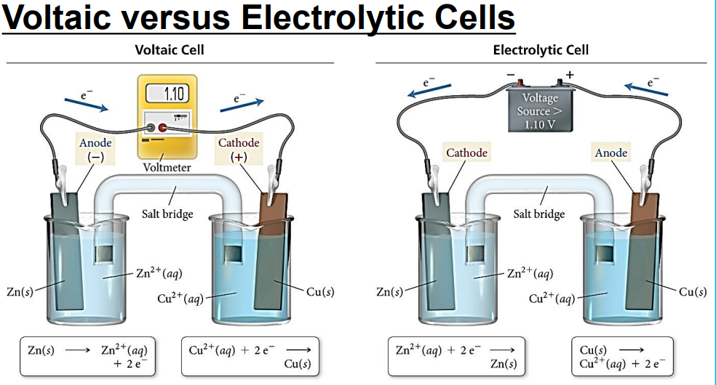

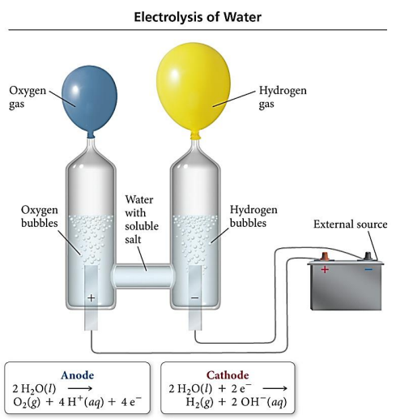

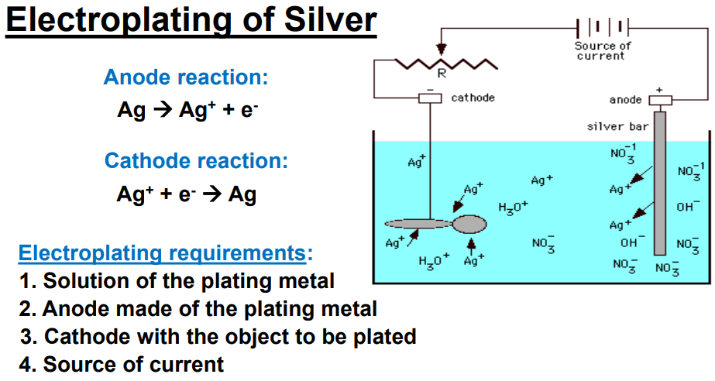

N45











