N45 – Variables Unite

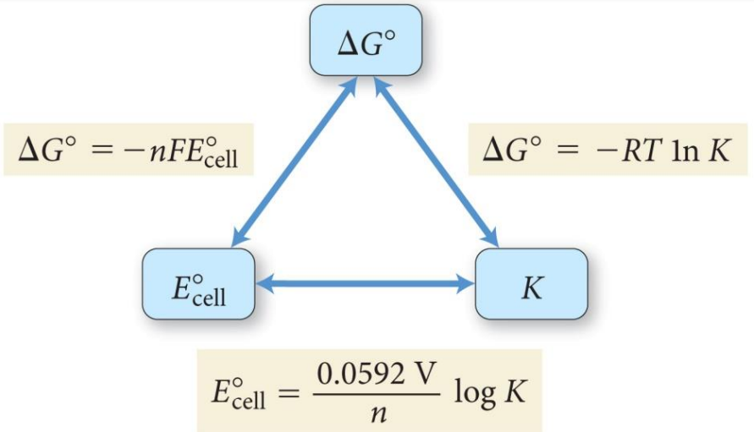

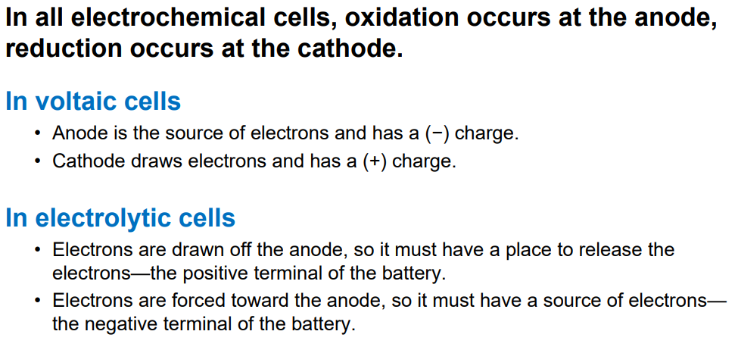

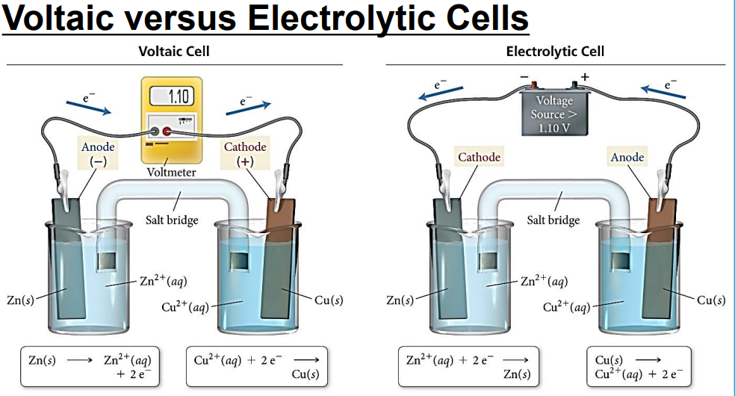

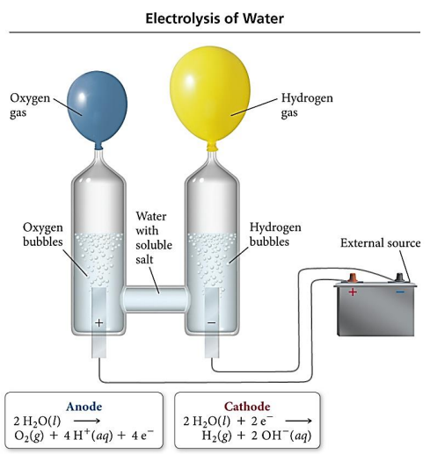

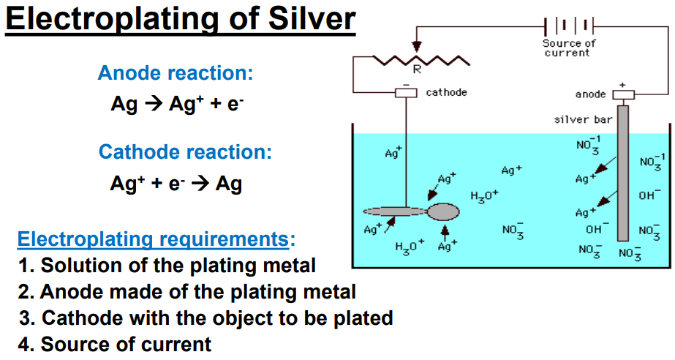

N45 - Variables Unite











