**Dougherty Valley HS AP Chemistry**

**WORKSHEET #5 KEY**

**Electrochemistry – Electrolysis**

**Name: Date: Period: Seat #:**

Show all work

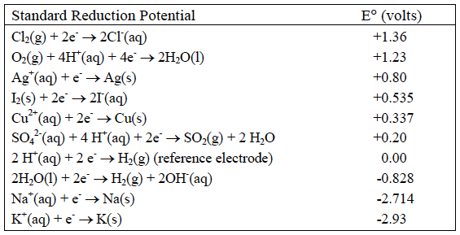

|  |
| --- |
| 1. All of the equations in the chart above are written as **REDUCTIONS** (oxidations/reductions). |
| 2. The chemicals at the upper left (Cl2 and O2) are the most likely to be **REDUCED** (oxidized/reduced) and therefore the best **OXDIZING AGENTS** (oxidizing agents/reducing agents). |
| 3. The chemicals at the lower right (Na and K) are the most likely to be **OXIDIZED** (oxidized/reduced) and therefore the best **REDUCING AGENTS** (oxidizing agents/reducing agents). |
| 4. In an electrolytic cell, the (−) electrode is negative because it has **TOO MANY** (too many/too few) electrons. Chemicals that come into contact with the (−) electrode will **GAIN** (gain/lose) electrons and be **REDUCED** (oxidized/reduced). The (−) electrode in electrolysis is called the **CATHODE** (cathode/anode). |
| 5. Write the change that water goes through at the (−) electrode. **2H2O(*l*) + 2e– ® H2(g) + 2OH–** |
| 6. In an electrochemical cell, the (+) electrode is positive because is has **TOO FEW** (too many/too few) electrons. Chemicals that come into contact with the (+) electrode will **LOSE** (gain/lose) electrons and be **OXDIZED** (oxidized/reduced). The (+) electrode in electrolysis is called the **ANODE** (cathode/anode). |
| 7. Write the change that water goes through at the (+) electrode. **2H2O(*l*) ® 4e– + 4H+(aq) + O2(g)** |
| 8. Add these two reactions together (make certain the electrons cancel) and write the overall reaction for the electrolysis of water. **2H2O(*l*) ® H2(g) + O2(g)** |
| 9. We will perform this electrolysis using an aqueous solution of sodium sulfate. Both the Na+ and H2O will be near the (−) electrode. Which chemical is more likely to be reduced? **H2O,** |
| 10. Both the SO42− and H2O will be near the (+) electrode. Which chemical will be oxidized? **H2O**  * SO42− cannot be oxidized therefore H2O must be |

|  |  |
| --- | --- |
| [11] In the electrolysis of KI(aq)  Both the K+ and H2O will be near the (−) electrode. Which chemical is more likely to be reduced? **H2O, look at chart above, E°**  Both the I− and H2O will be near the (+) electrode. Which chemical is more likely to be oxidized? **I–**  Write the reactions at each electrode and the overall reaction: | |
| Cathode  2H2O + 2e– ® H2 + 2OH– | Anode  2I– ® I2 + 2e– |
| Overall  2H2O + 2I– ® H2 + 2OH– + I2 | |
| [12] In the electrolysis of CuSO4(aq)  Both the Cu2+ and H2O will be near the (−) electrode. Which chemical will be reduced? **Cu2+**  Both the SO42− and H2O will be near the (+) electrode. Which chemical will be oxidized? **H2O**  Write the reactions at each electrode and the overall reaction: | |
| Cathode  2Cu2+ + 4e– ® 2Cu | Anode  2H2O(*l*) ® 4e– + 4H+(aq) + O2(g) |
| Overall  2Cu2+ + 2H2O ® 2Cu + 4H+(aq) + O2(g) | |

|  |
| --- |
| [13] Silver plating occurs when electrolysis of a Ag2SO4 solution is used because silver metal is formed at the **CATHODE** (cathode/anode).  This is the (**-**) ( + / − ) electrode. The reaction at this electrode is: **Ag+ + e– ® Ag** (reduction)  Recall that 1 amp·sec = 1 Coulomb and 96,500 Coulombs = 1 mole e−‘s (Faraday’s constant).  If a cell is run for 200. seconds with a current of 0.250 amps, how many grams of Ag° will be deposited? $$200 s x 0.250 amps x \frac{1 C}{1 amp∙s}x\frac{1 mol e^{-}}{96,500 C}x\frac{1 mol Ag}{1 mol e^{-}}x\frac{107.87 g Ag}{1 mol Ag}=0.056 g Ag$$ |