**Dougherty Valley HS AP Chemistry**

**WORKSHEET #5**

**Electrochemistry – Electrolysis**

**Name: Date: Period: Seat #:**

Show all work

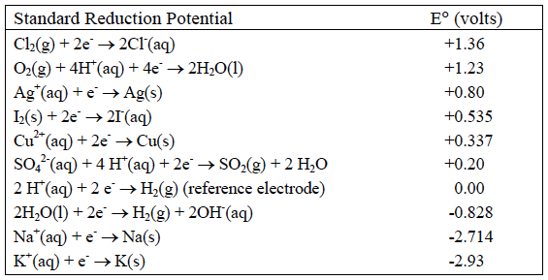

|  |
| --- |
| 1. All of the equations in the chart above are written as _________________ (oxidations/reductions). |
| 2. The chemicals at the upper left (Cl2 and O2) are the most likely to be *_______________* (oxidized/reduced) and therefore the best __________________________ (oxidizing agents/reducing agents). |
| 3. The chemicals at the lower right (Na and K) are the most likely to be _______________ (oxidized/reduced) and therefore the best __________________________ (oxidizing agents/reducing agents). |
| 4. In an electrolytic cell, the (−) electrode is negative because is has ______________ (too many/too few) electrons. Chemicals that come into contact with the (−) electrode will ________ (gain/lose) electrons and be ______________ (oxidized/reduced). The (−) electrode in electrolysis is called the _____________ (cathode/anode). |
| 5. Write the change that water goes through at the (−) electrode. ____________________________________ |
| 6. In an electrochemical cell, the (+) electrode is positive because is has ______________ (too many/too few) electrons. Chemicals that come into contact with the (+) electrode will ________ (gain/lose) electrons and be ______________ (oxidized/reduced). The (+) electrode in electrolysis is called the _____________ (cathode/anode). |
| 7. Write the change that water goes through at the (+) electrode. ____________________________  ________ |
| 8. Add these two reactions together (make certain the electrons cancel) and write the overall reaction for the electrolysis of water. __________________________________ |
| 9. We will perform this electrolysis using an aqueous solution of sodium sulfate. Both the Na+ and H2O will be near the (−) electrode. Which chemical is more likely to be reduced? ____ |
| 10. Both the SO42− and H2O will be near the (+) electrode. Which chemical will be oxidized? ____ |

|  |  |
| --- | --- |
| [11] In the electrolysis of KI(aq)  Both the K+ and H2O will be near the (−) electrode. Which chemical is more likely to be reduced? ____  Both the I− and H2O will be near the (+) electrode. Which chemical is more likely to be oxidized? ____  Write the reactions at each electrode and the overall reaction: | |
| Cathode | Anode |
| Overall | |
| [12] In the electrolysis of CuSO4(aq)  Both the Cu2+ and H2O will be near the (−) electrode. Which chemical will be reduced? ____  Both the SO42− and H2O will be near the (+) electrode. Which chemical will be oxidized? ____  Write the reactions at each electrode and the overall reaction: | |
| Cathode | Anode |
| Overall | |

|  |
| --- |
| [13] Silver plating occurs when electrolysis of a Ag2SO4 solution is used because silver metal is formed at the _______________ (cathode/anode).  This is the (__) ( + / − ) electrode. The reaction at this electrode is: _____________________.  Recall that 1 amp·sec = 1 Coulomb and 96,500 Coulombs = 1 mole e−‘s (Faraday’s constant).  If a cell is run for 200. seconds with a current of 0.250 amps, how many grams of Ag° will be deposited? |