Name: Period: Seat#:
Worksheet #5

Directions: Show all work when applicable.

FILL IN THE BLANKS:

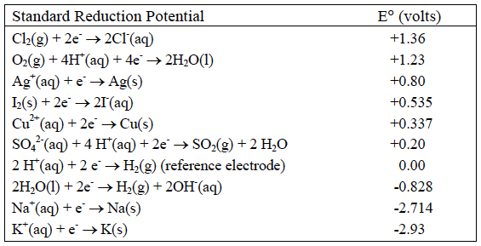
- All of the equations in the chart above are written
as ______________________ (oxidations/reductions).

- The chemicals at the upper left (Cl₂ and O₂) are
the most likely to be _______________________
(oxidized/reduced) and therefore the best __________________________ (oxidizing agents/reducing agents).

- The chemicals at the lower right (Na and K) are the most likely to be _______________________
(oxidized/reduced) and therefore the best __________________________ (oxidizing agents/reducing agents).

- In an electrolytic cell, the (−) electrode is negative because is has __________________ (too many/too few)
electrons. Chemicals that come into contact with the (−) electrode will __________________ (gain/lose)
electrons and be ______________________ (oxidized/reduced). The (−) electrode in electrolysis is called
the ______________________ (cathode/anode).

- Write the change that water goes through at the (−) electrode. ______________________________

- In an electrochemical cell, the (+) electrode is positive because is has ________________
(too many/too few) electrons. Chemicals that come into contact with the (+) electrode will ____________
(gain/lose) electrons and be ___________________ (oxidized/reduced). The (+) electrode in electrolysis is
called the __________________ (cathode/anode).

- Write the change that water goes through at the (+) electrode. ____________________________

- Add these two reactions together (make certain the electrons cancel) and write the overall reaction
for the electrolysis of water. __________________________________

- We will perform this electrolysis using an aqueous solution of sodium sulfate. Both the Na⁺ and H₂O
will be near the (−) electrode. Which chemical is more likely to be reduced? ____________

- Both the SO₄²⁻ and H₂O will be near the (+) electrode. Which chemical will be oxidized? __________
- In the electrolysis of KI(aq)
Both the K⁺ and H₂O will be near the (−) electrode. Which chemical is more likely to be reduced? ______
Both the I⁻ and H₂O will be near the (+) electrode. Which chemical is more likely to be oxidized? _______
Write the reactions at each electrode and the overall reaction:
Cathode | Anode
Overall

- In the electrolysis of CuSO₄(aq)
Both the Cu²⁺ and H₂O will be near the (-) electrode. Which chemical will be reduced? ________
Both the SO₄²⁻ and H₂O will be near the (+) electrode. Which chemical will be oxidized? ________
Write the reactions at each electrode and the overall reaction:
Cathode | Anode
Overall

- Silver plating occurs when electrolysis of a Ag₂SO₄ solution is used because silver metal is formed at the
_____________________ (cathode/anode). This is the _________ ( + / - ) electrode. The reaction at this
electrode is: _______________________.
Recall that 1 amp•sec = 1 Coulomb and 96,500 Coulombs = 1 mole e-‘s (Faraday’s constant).
If a cell is run for 200. Seconds with a current of 0.250 amps, how many grams of Ag⁰ will be deposited?

