Lab – Calculating the Ksp of Calcium Hydroxide via Titration

**Overview**

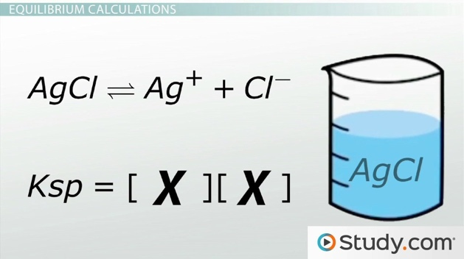Solubility product (Ksp) values represent the number of ions that remain in solution after a solution has reached the point of saturation. Because Ksp values represent salts that are largely insoluble in water, all of the Ksp values are incredibly small ( x <<< 1). As a result, an incredibly small concentration of ions exists in equilibrium with the solid. Most of the ions stay together in the solid, but a few ions exist in solution, and the system is in equilibrium.

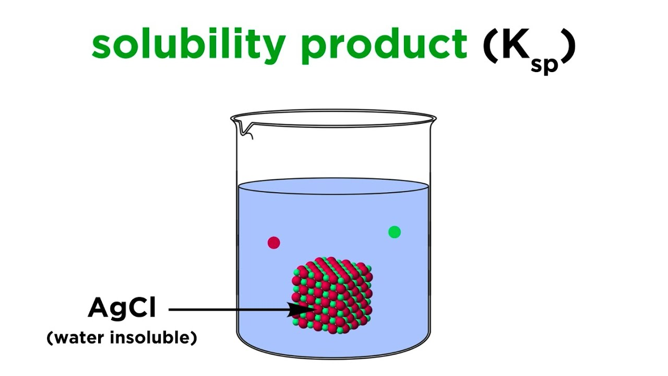

See the diagram to the right, which models what a saturated solution of AgCl (s) in water is like. Most of AgCl remains a solid while a small number of ions exist in solution.

To calculate the Ksp values for different solids, chemists frequently use titration to add a precise amount of reagent that will react with one of the ions in solution.

For the experiment today, we will be reacting the OH- ions from a saturated Ca(OH)2 solution with a precise amount of HCl. To know when the reaction has completed, we will be using an indicator that changes color to indicate the pH of the solution has become neutral (since all of the OH- ions reacted with H+ to form H2O).

**Pre-Lab Questions**

1. Write out the equilibrium reaction of a saturated solution of Ca(OH)2.
2. Write out the Ksp expression for the above reaction.
3. HCl—a strong acid—will be added to our solution today. Write out the reaction of HCl in water below.

|  |
| --- |
| HCl (*aq*) + H2O (*l*) |

1. Write out the balanced neutralization reaction between Ca(OH)2 and HCl below.

|  |
| --- |
| HCl (*aq*) + Ca(OH)2 (*aq*) |

**Procedure**

**Part 1 – Preparing a dilute solution of hydrochloric acid**

Materials: 100 mL volumetric with cap, graduated pipette, water bottle

1. Using a graduated pipette or a graduated cylinder, transfer *precisely* 4.00 mL of the stock 1.00 M HCl to a 100 mL volumetric flask. Carefully fill to the line with water. Cap the volumetric flask, invert a few times to mix, then remove the cap.
2. Using $M_{1}V_{1}=M_{2}V_{2}$, calculate the molarity of this diluted solution. You’ll be using this solution as the titrant for your titration. Show your calculations below.

Molarity of diluted HCl = _______

**Part 2 – Performing the titration**

Materials: stand, burette clamp, burette, glass funnel, two 50 mL beakers, Sharpie, plastic pipet, 125 mL Erlenmeyer flask, 10 mL graduated cylinder

1. Transfer the diluted HCl from your volumetric into the 50 mL beaker (to help with transfer). Label this beaker as “HCl.” Rinse the burette with your diluted HCl solution one time, then fill up the burette so that there solution is near the top of the burette.
2. Using your other beaker, obtain ~ 40 mL sample of the saturated calcium hydroxide solution from the beaker at the front of the room. This will be the Ca(OH)2 (aq) you will use for all 3 trials.

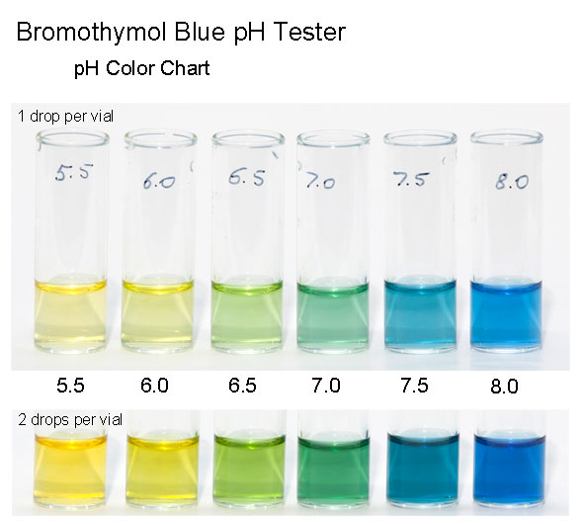

1. Using your 10 mL graduated cylinder + plastic pipette, measure *precisely* 10.0 mL of the saturated Ca(OH)2 solution into a clean 125 mL flask. Precision is key! Add a few squirts to water alongside the inside of the flask to ensure all of the Ca(OH)2 is rinsed down into the solution. Then, add 5 drops of bromothymol blue indicator to this solution. Because the solution is slightly basic from the presence of OH- ions, it will be blue in color. See the diagram on the screen (to the right) to see the color correlating to pH. The goal is to get to pH neutral—a darker green color.
2. The calcium hydroxide solution is now ready to be titrated. Record the initial volume of HCl in your burette to the nearest 0.01 mL on your data table. Titrate with the diluted HCl until the color of the solution changes from blue to greenish yellow, thus indicating that all of the OH- ions have reacted completely with the H+ ions from the HCl. When you’ve reached the end point of the titration (i.e. the ideal color change), bring your flask up to the screen at the front of the room to compare your flask to the image from step 3. Record the final volume of the HCl solution to the nearest 0.01 mL.
3. Dump the contents of the flask into the waste beaker by the sink. Rinse the flask thoroughly with water.

1. Repeat steps 3 – 4for a total of 3 titrations.
2. CLEAN UP: Empty the burette into your HCl beaker. Dispose your remaining solutions (calcium hydroxide and hydrochloric acid) into the waste beaker by the sink, then rinse the two beakers & flask and hang on the dish rack. Rinse the burette with water, then return the burette to the burette stand upside down.

**Data & Calculations**

|  |  |  |  |
| --- | --- | --- | --- |
|  | **Trial 1** | **Trial 2** | **Trial 3** |
| Initial volume of HCl solution, mL |  |  |  |
| Final volume of HCl solution, mL |  |  |  |
| Total Volume of HCl used, mL |  |  |  |
| Color of End Point |  |  |  |
|  |  |  |  |
| Moles HCl added to Ca(OH)2 solution |  |  |  |
| Molar Ratio of HCl to Ca(OH)2 in reaction:  2 HCl + Ca(OH)2 H2O + CaCl2 |  | | |
| Moles Ca(OH)2 in flask (based on molar ratio) |  |  |  |
| Volume of Ca(OH)2 in flask, mL |  |  |  |
| Concentration of Ca(OH)2, |  |  |  |
| Concentration of Ca2+, |  |  |  |
| Concentration of OH-, |  |  |  |
| Calculate Ksp.  Ksp = [Ca2+] [OH-]2 |  |  |  |
| Textbook value of Ksp for Ca(OH)2 @ 25 oC Ksp = 5.5 x 10-6 | | | |
| Percent Error  % Error = |  |  |  |