Gibbs Mental Math

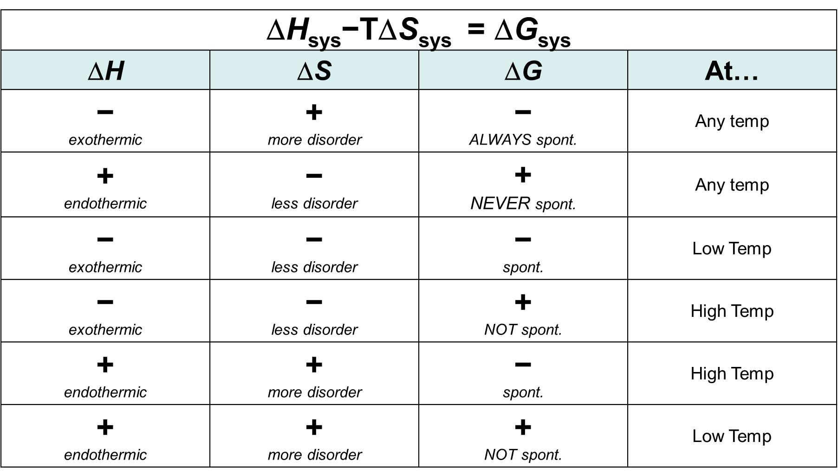

Gibbs Mental Math

