Gibbs Mental Math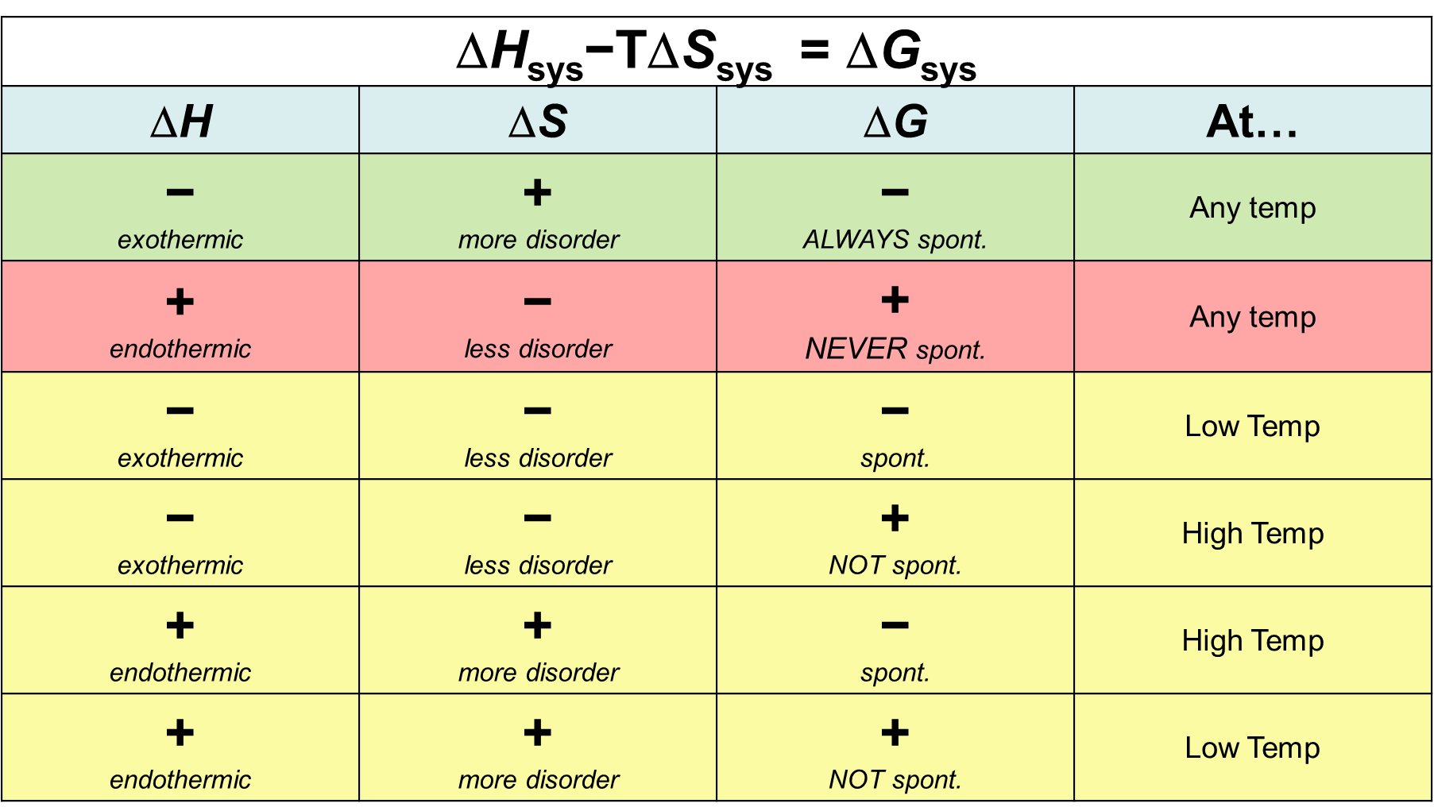

Gibbs Mental Math

