N7 – Gibbs Free Energy
Gibbs free energy, G - the maximum amount of work energy that can be released to the surroundings by a system for a constant temp and pressure system.
Gibbs free energy is often called the
chemical potential because it is similar to the storing of energy in a mechanical system.
Gibbs Mental Math
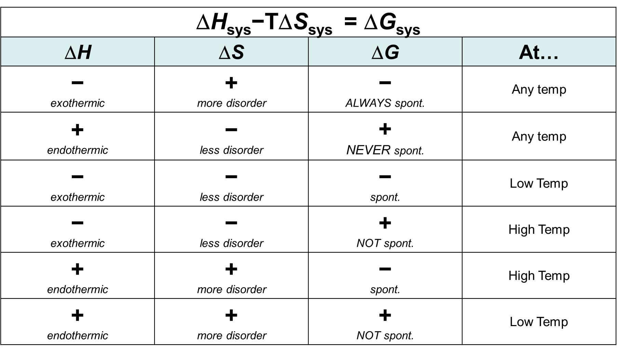

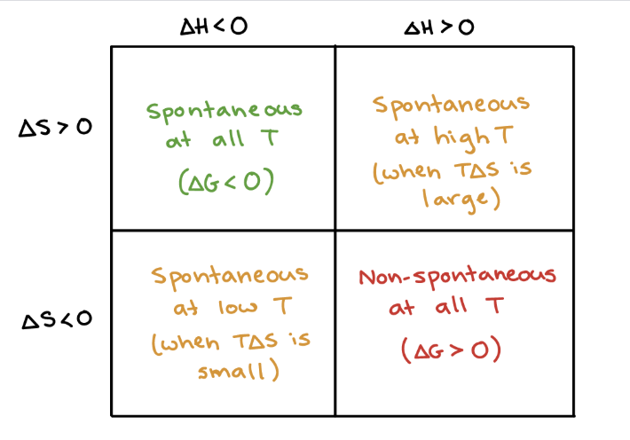

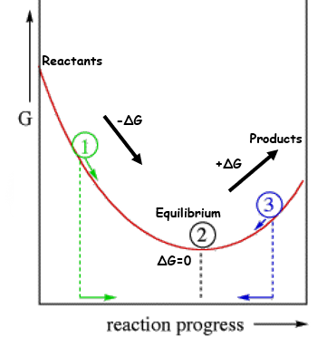

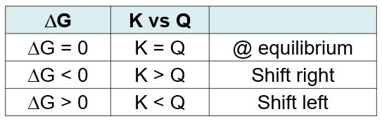

A Variety of Helpful Equations
∆S_{univ} = ∆S_{sys} + ∆S_{surr}

∆S_{surr} = – ∆H_{sys} / T

−T∆S_{univ} = ∆H_{sys}−T∆S_{sys}

−∆G_{sys} = ∆H_{sys}−T∆S_{sys}

∆G°= −RT ln(K)
where R=8.314J/mol•K

∆G = ∆G° + RT ln(Q)

– RT ln(K) = ∆H° – T∆S°

$$\ln{(}K)=-\frac{ΔH^{0}}{RT} + \frac{ΔS^{0}}{R}$$
$$=-\frac{ΔH^{0}}{R}\left(\frac{1}{T}\right) + \frac{ΔS^{0}}{R}$$

y = m x + b

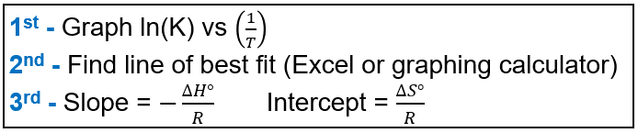

N7 – Gibbs Free Energy – still...sorry...not sorry
Practice Problems

#1 - For the following Rx:
N₂(g) + 3H₂(g) 2NH₃(g)
Calculate the standard Free Energy,
ΔG° for the rxn at 25°C.
ΔH°= -264kJ/mol ΔS°= -278 J/mol•K

#2 - Calculate the Boiling Point of BCl₃.
BCl_{3(l)} ↔ BCl_{3(g).} Given:

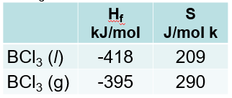

#3 - Under standard conditions (1 atm of NH₃, N₂ and H₂) and at 298 K, what substance(s) will be formed?
(∆G° = 33.4 kJ)
2 NH₃(g) N₂(g) + 3 H₂(g)

#4 - Calculate the equilibrium constant for this reaction at 298 K.
2 NH₃(g) N₂(g) + 3 H₂(g) (∆G° = 33.4 kJ)

