Gibbs Mental Math

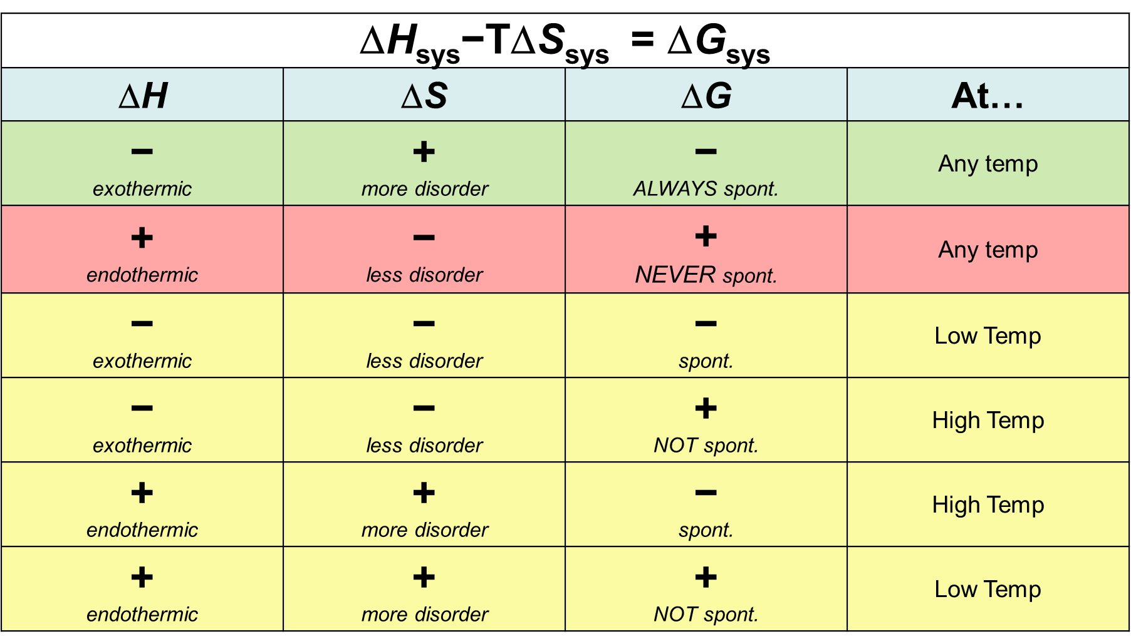 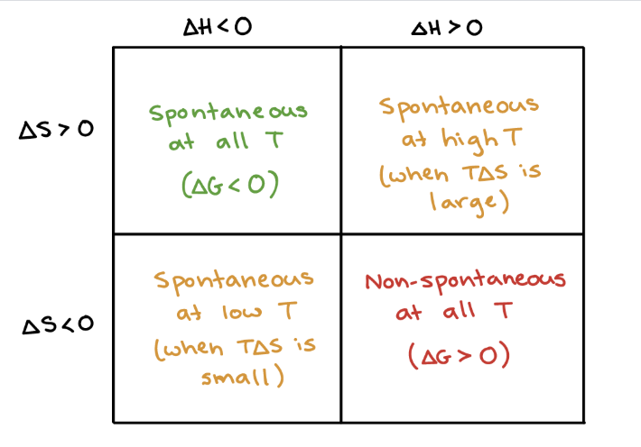

Gibbs Mental Math

 

Gibbs Mental Math

 