N5 – Spontaneity
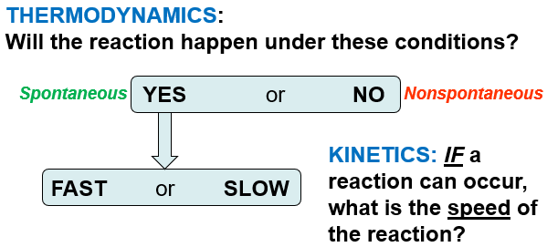
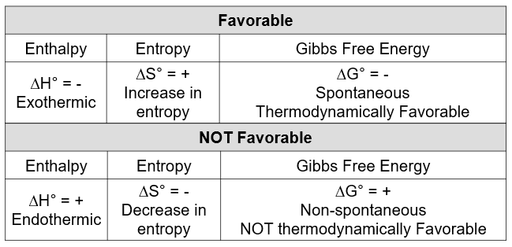
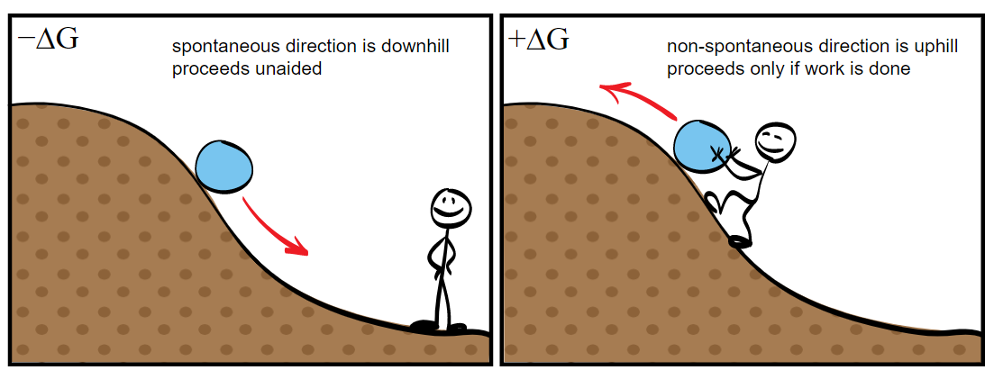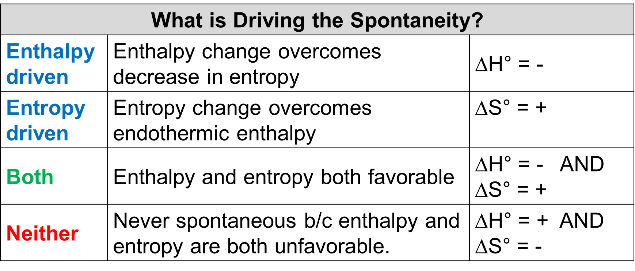

N6 – Entropy
Key Concepts About Entropy
#1 - a thermodynamic function that increases as the number of energetically equivalent ways of arranging the components increases, S.
#2 – Random systems have more energy dispersal and are more energetically stable, lower energy, than ordered systems
#3 – Increase in entropy of the universe is the driving force for spontaneous reactions.
#4 – Nature proceeds toward the states that have the highest probabilities of existing.

Practice Problem:
For the Rx: 2NO(g) + O₂(g) 2NO₂(g)
ΔS°_{rxn}= -146.5 J/mol•K
Calculate the standard molar entropy of O₂(g).
ΔS°_{NO(g)} = 210.8 J/mol•K , ΔS°_{NO2(g)} = 240.1 J/mol•K

Some Changes that Increase Entropy
#1 - Products are in a more dispersed arrangement.
#2 - Larger numbers of product molecules than reactant molecules.
#3 - Rxn’s that have an increase in temperature (exothermic).
#4 – Products that have more degrees of movement.
#5 – Products that have more molecular complexity.

N7 – Gibbs Free Energy
Gibbs free energy, G - the maximum amount of work energy that can be released to the surroundings by a system for a constant temp and pressure system.
Gibbs free energy is often called the
chemical potential because it is similar to the storing of energy in a mechanical system.
Gibbs Mental Math
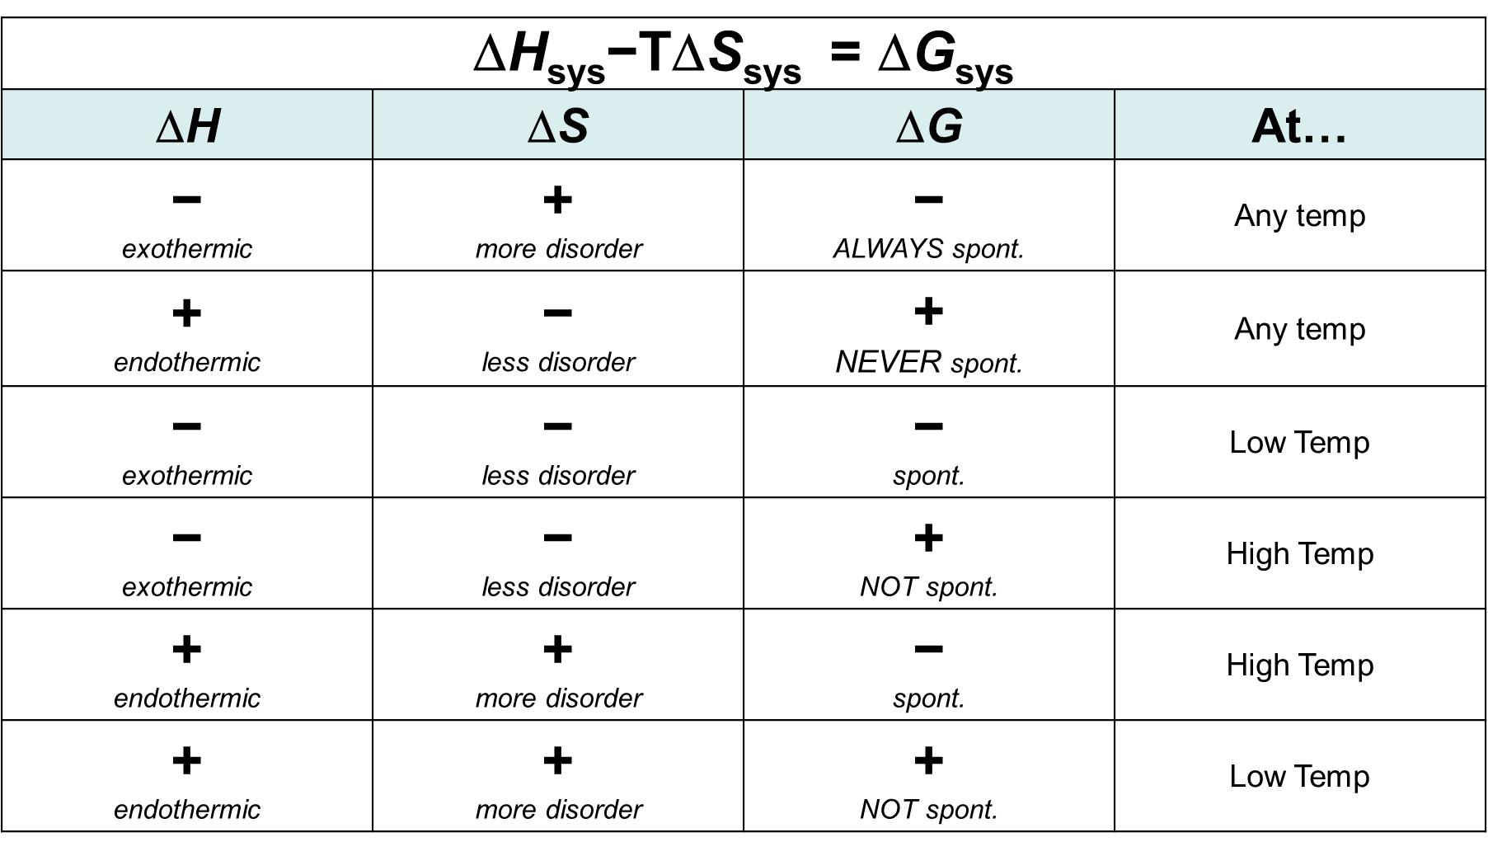

N7 – Gibbs Free Energy – Continued...

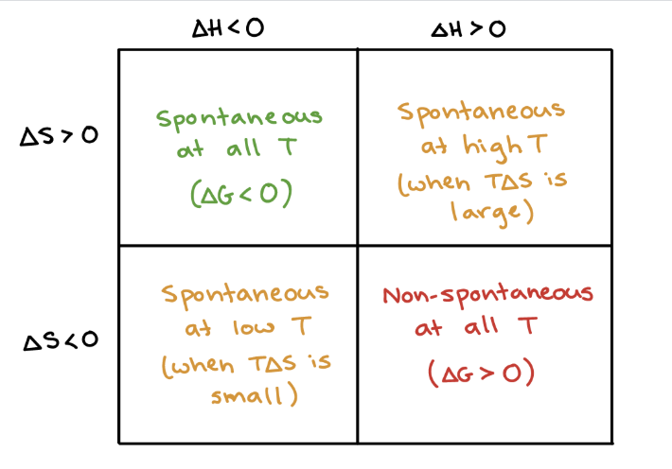

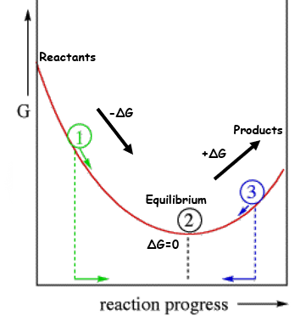

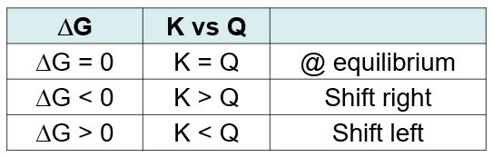

N7 – Gibbs Free Energy – Continued...again...

A Variety of Helpful Equations
∆S_{univ} = ∆S_{sys} + ∆S_{surr}

∆S_{surr} = – ∆H_{sys} / T

−T∆S_{univ} = ∆H_{sys}−T∆S_{sys}

∆G_{sys} = ∆H_{sys}−T∆S_{sys}

∆G°= −RT ln(K)
where R=8.314J/mol•K

∆G = ∆G° + RT ln(Q)

– RT ln(K) = ∆H° – T∆S°

$$\ln{(}K)=-\frac{ΔH^{0}}{RT} + \frac{ΔS^{0}}{R}$$
$$=-\frac{ΔH^{0}}{R}\left(\frac{1}{T}\right) + \frac{ΔS^{0}}{R}$$

y = m x + b

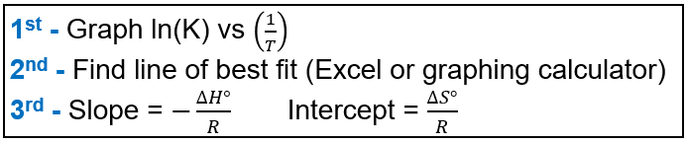
N7 – Gibbs Free Energy – still...sorry...not sorry
Practice Problems

#1 - For the following Rx:
N₂(g) + 3H₂(g) 2NH₃(g)
Calculate the standard Free Energy,
ΔG° for the rxn at 25°C.
ΔH°= -264kJ/mol ΔS°= -278 J/mol•K

#2 - Calculate the Boiling Point of BCl₃.
BCl_{3(l)} ↔ BCl_{3(g).} Given:

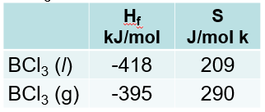

#3 - Under standard conditions (1 atm of NH₃, N₂ and H₂) and at 298 K, what substance(s) will be formed?
(∆G° = 33.4 kJ)
2 NH₃(g) N₂(g) + 3 H₂(g)

#4 - Calculate the equilibrium constant for this reaction at 298 K.
2 NH₃(g) N₂(g) + 3 H₂(g) (∆G° = 33.4 kJ)

