Kinetics of Crystal Violet Fading – Integrated Rate Law Analysis

Crystal violet belongs to a class of intensely colored organic compounds called triphenylmethane dyes. The structure and color of crystal violet depend on pH, making it a valuable acid−base indicator as well as an excellent dye. The major structural form of crystal violet is the monovalent cation, abbreviated CV+, which is shown in Figure 1a. CV+ is the predominant form of crystal violet in the solid state and in aqueous solution across a broad range of pH values from pH 1 to 13. The positive charge shown on the central carbon atom in Figure 1a is delocalized via resonance to the three nitrogen atoms. See Figure 1b for one of the three additional resonance forms with the positive charge on a nitrogen atom. Delocalization of the charge across the system of double bonds in the benzene rings stabilizes the carbocation and is responsible for the vibrant purple color of the dye.

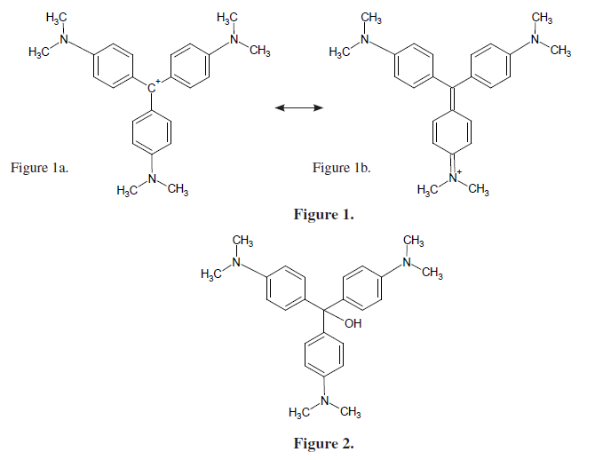

In strongly basic solutions the purple CV+ cation slowly combines with hydroxide ions to form a neutral product, CVOH, which is colorless (see Figure 2). The rate of this reaction (Equation 1) is slower than typical acid–base proton transfer reactions and depends on the initial concentration of both crystal violet and hydroxide ions.



Exactly how much the rate changes as the reactant concentration is varied depends on the rate law for the reaction. In the case of the reaction of CV+ with OH– ion, the rate law has the general form:



The exponents *n* and *m* are defined as **the order of reaction** for each reactant and *k* is the **rate constant** for the reaction at a particular temperature. The values of the exponents *n* and *m* must be determined by experiment.

If the reaction is carried out so that the system is flooded with OH-, so that [OH-]>>[CV+], then the [OH-] will be essentially constant during the reaction. Then Equation 2 will reduce to a simpler form

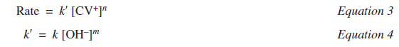

The constant *k*ʹ is a new “**pseudo** **rate constant**” incorporating both the “true” rate constant *k* and the [OH*–*]m term. Equation 3 is referred to as a pseudo-rate law because it is a simplification of the actual rate law, Equation 2.

The pseudo-rate law is valid when the concentration of OH*−* ions is much greater than the concentration of CV*+* ions. Under these conditions the [OH*−*]m term in Equation 2 will not change much over the course of the reaction and may be treated as a con­stant in the rate equation.

Recall that the absorbance for a specific concentration of a solution with a fixed path length varies directly with the absorptiv­ity coefficient of the solution. This relationship is known as **Beer’s law**.

A=bc

where A is **absorbance**, is the **molar absorptivity**, *b* is the **path length** in cm, corresponding to the distance light trav­els through the solution, and *c* is the **molar concentration** of the solution. Beer’s law provides the basis of using spectroscopy in quantita­tive analysis. Using this relationship, concentration and absorbance may be calculated if one variable is known while keeping and *b* constant. This relationship is also extremely valuable in kinetics experiments, making it possible to follow the rate of disap­pearance of a colored substance by measuring its absorbance as a function of time.

The visible absorption spectrum for crystal violet, CV+, is shown below. The concentration of the dye was 12.5 M.

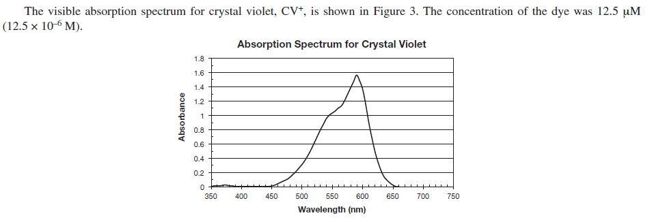

max for Crystal Violet is ________ nm so we will use the ________ nm wavelength on the colorimeter

**Part 1: Create a Beer’s Law plot for Crystal Violet.**

You will be given a 25 mM stock solution. Prepare a series of 5 dilutions in test tubes and measure their absorbance values at a wavelength close to max.

|  |  |  |  |  |  |
| --- | --- | --- | --- | --- | --- |
|  | Test Tube 1 | Test Tube 2 | Test Tube 3 | Test Tube 4 | Test Tube 5 |
| Volume of 25 mM Crystal Violet, mL |  |  |  |  |  |
| Volume of distilled water, mL |  |  |  |  |  |
| Concentration of Crystal Violet, M |  |  |  |  |  |
| Absorbance at _______ nm |  |  |  |  |  |

Perform **linear regression** and record the equation relating the Absorbance and the Concentration of crystal violet here:

**Part 2: Reacting the 25 M Crystal Violet with 0.10 M NaOH.**

Mix 10.0 mL of 25 mM crystal violet with 10.0 mL of 0.10 M NaOH in a 50 mL beaker. Work quickly to mix the solution, rinse a cuvette 3 times and then insert the cuvette into a colorimeter set to the same wavelength used in the Beer’s Law analysis earlier. Record the absorbance values over time, as the crystal violet fades. Record data until the absorbance has fallen by at least 70%. In the table below record at least 8 data points for graphing.

|  |  |  |  |  |  |  |  |  |
| --- | --- | --- | --- | --- | --- | --- | --- | --- |
| Absorbance and time when [CV+] = __________________ M and [OH-] = ___________ M | | | | | | | | |
| Time (s) |  |  |  |  |  |  |  |  |
| Abs |  |  |  |  |  |  |  |  |

**Part 3: Reacting the 25 M Crystal Violet with 0.050 M NaOH.**

Prepare 10.0 mL of 0.050-M NaOH from the 0.10-M NaOH stock solution in a small beaker. Add 10.0 mL of 25 M crystal violet. Work quickly to mix the solution, rinse a cuvette 3 times and then insert the cuvette into a colorimeter set to the same wavelength used in the Beer’s Law analysis earlier. Record the absorbance values over time, as the crystal violet fades. Record data until the absorbance has fallen by at least 70%. In the table below record at least 8 data points for graphing.

|  |  |  |  |  |  |  |  |  |
| --- | --- | --- | --- | --- | --- | --- | --- | --- |
| Absorbance and time when [CV+] = __________________ M and [OH-] = ___________ M | | | | | | | | |
| Time (s) |  |  |  |  |  |  |  |  |
| Abs |  |  |  |  |  |  |  |  |

**Analysis with a TI-8X Graphing Calculator:**

1. Enter the concentrations and absorbance values in L1 and L2 and create your Beer’s Law scatterplot.
2. Perform Linear Regression and obtain the equation for the Beer’s Law plot. Enter this equation on the data sheet. You will use it to convert absorbance values to concentrations for the crystal violet in the kinetics analysis.
3. Clear L1 and L2 to begin the kinetics analysis.
4. Enter the times and absorbance values for Part 2 on your graphing calculator in L1 and L2
5. Rearrange the Beer’s Law equation to solve for concentration of crystal violet.
6. Use the rearranged Beer’s Law equation to convert absorbances to concentrations of Crystal Violet in L3.
7. In L4 take the natural logarithm of your concentrations of Crystal Violet
8. In L5 take the reciprocal of the concentrations of Crystal Violet
9. Prepare 3 scatterplots and sketch each one
10. For the plot that is most linear … conclude the order of the crystal violet and then perform linear regression to find kpseudo in part 2
11. Clear your lists and repeat steps d through j and find kpseudo for part 3.
12. Use the two values of kpseudoand the two [OH-] in parts 2 and 3 to find the order for OH- and the value of the rate constant, k, for the reaction at room temperature.

The same analysis can be done with a spreadsheet like Excel or Google Sheets if printed graphs are required for a lab report.

**Lab Assistant Instructions – Kinetics of Fading Dye**

**Chemicals**:

* Prepare a stock solution of 1% Crystal Violet by dissolving 1.0 g of Crystal Violet dye in water to make 100.0 mL of solution in a volumetric flask. Store this and label it as 25 x 10-3 M Crystal Violet.
* Use a pipet to transfer exactly 1.0 mL of the stock Crystal Violet solution to a 1.00-L volumetric flask and dilute to the mark. Label this flask as "**25 M Crystal Violet**" and have this available in the lab. Store the remaining stock 1% Crystal Violet solution among the dyes in the biology storeroom.
* Prepare 1.0 L of 0.10-M NaOH
* Fill **distilled water bottles** and have them in the lab
* Set out the two solutions in the two fume hoods with several 150-mL beakers for dispensing. Put a tray of 50-mL beakers in each hood.

Equipment

* 10-mL Mohr pipets
* Blue pipet bulbs
* Colorimeters
* Cuvettes with lids
* 2 boxes of KimWipes per bench
* Two boxes of 50-mL beakers (glass & plastic)
* Tray of narrow mouth test tubes
* Fill the distilled water bottles
* Nitrile Gloves – medium, large, x-large
* Set up the pipet washer in the front sink