N8 – Kinetics Review

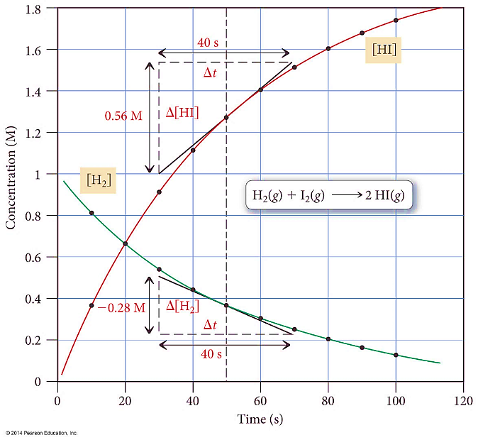

N10 – Mechanisms

**NO2(*g*) + CO(*g*) → NO(*g*) + CO2(*g*) Rateobs = *k*[NO2]2**

1. **NO2(*g*) + NO2(*g*) → NO3(*g*) + NO(*g*) Rate = *k*1[NO2]2 Slow**

2. **NO3(*g*) + CO(*g*) → NO2(*g*) + CO2(*g*) Rate = *k*2[NO3][CO] Fast**

**2H2(g) + 2NO(g) 🡪 N2(g) + 2H2O(g)**

The experimental rate law is:

**R = k[NO]2 [H2]**

Step #1 **H2(g) + 2NO(g) 🡪 N2O(g) + H2O(g)**

Step #2 **N2O(g) + H2(g) 🡪 N2(g) + H2O(g)**

Step #1 **H2(g) + 2NO(g) 🡪 N2O(g) + H2O(g)**

Step #2 **N2O(g) + H2(g) 🡪 N2(g) + H2O(g)**

**2H2(g) + 2NO(g) 🡪 N2(g) + 2H2O(g)**

1. **2 NO(*g*)** ⇔ **N2O2(*g*) Fast**
2. **H2*(g*) + N2O2(*g*)** → **H2O(*g*) + N2O(*g*) Slow Rate = *k2*[H2][N2O2]**
3. **H2*(g*) + N2O(*g*)** → **H2O(*g*) + N2(*g*) Fast**

**2 H2*(g*) + 2 NO(*g*)** → **2 H2O(*g*) + N2(*g*) Rateobs = *k* [H2][NO]2**

N9 – Rate Laws

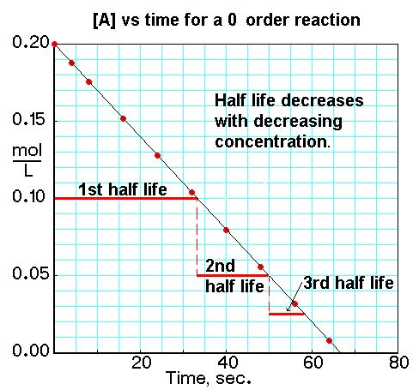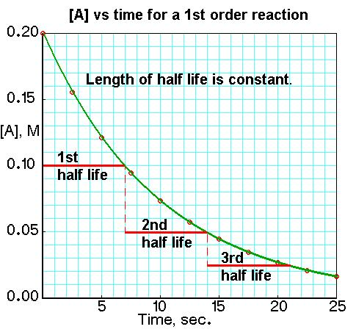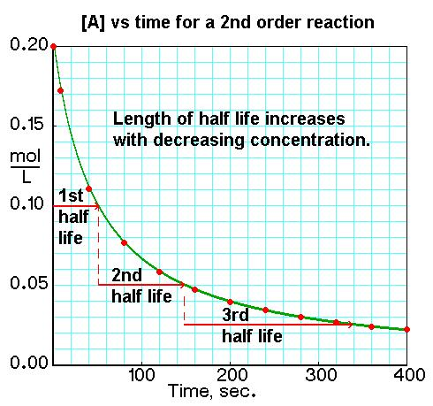

N11 – Collision Theory and More

|  |  |  |
| --- | --- | --- |
| **Elementary Step** | **Molecularity** | **Rate Law** |
| A → products | Unimolecular | Rate = k[A] |
| A + A → products  (2A → products) | Bimolecular | Rate = k[A]2 |
| A + B → products | Rate = k[A][B] |
| A + A + B → products  (2A + B → products) | Termolecular | Rate = k[A]2[B] |
| A + B + C → products | Rate = k[A][B][C] |

$k=Ae^{\left(\frac{-E_{a}}{RT}\right)}$

$ln⁡(k)=-\frac{E_{a}}{R}\left(\frac{1}{T}\right)+ln⁡(A)$

* *-Ea / R* is the slope when graphing ln(*k*) vs. (1/T)
* ln(*A*) is the y-intercept
* *Ea = -R(slope)*

Graphing ln(*k*) vs (1/T) and taking line of best fit   
can quickly yield a slope

$ln\left(\frac{k_{2}}{k_{1}}\right)=\frac{E_{a}}{R}\left(\frac{1}{T_{1}}-\frac{1}{T_{2}}\right)$ or...

$$ln\left(\frac{k_{2}}{k_{1}}\right)=\frac{{-E}_{a}}{R}\left(\frac{1}{T_{2}}-\frac{1}{T_{1}}\right)$$