N8 – Kinetics Review

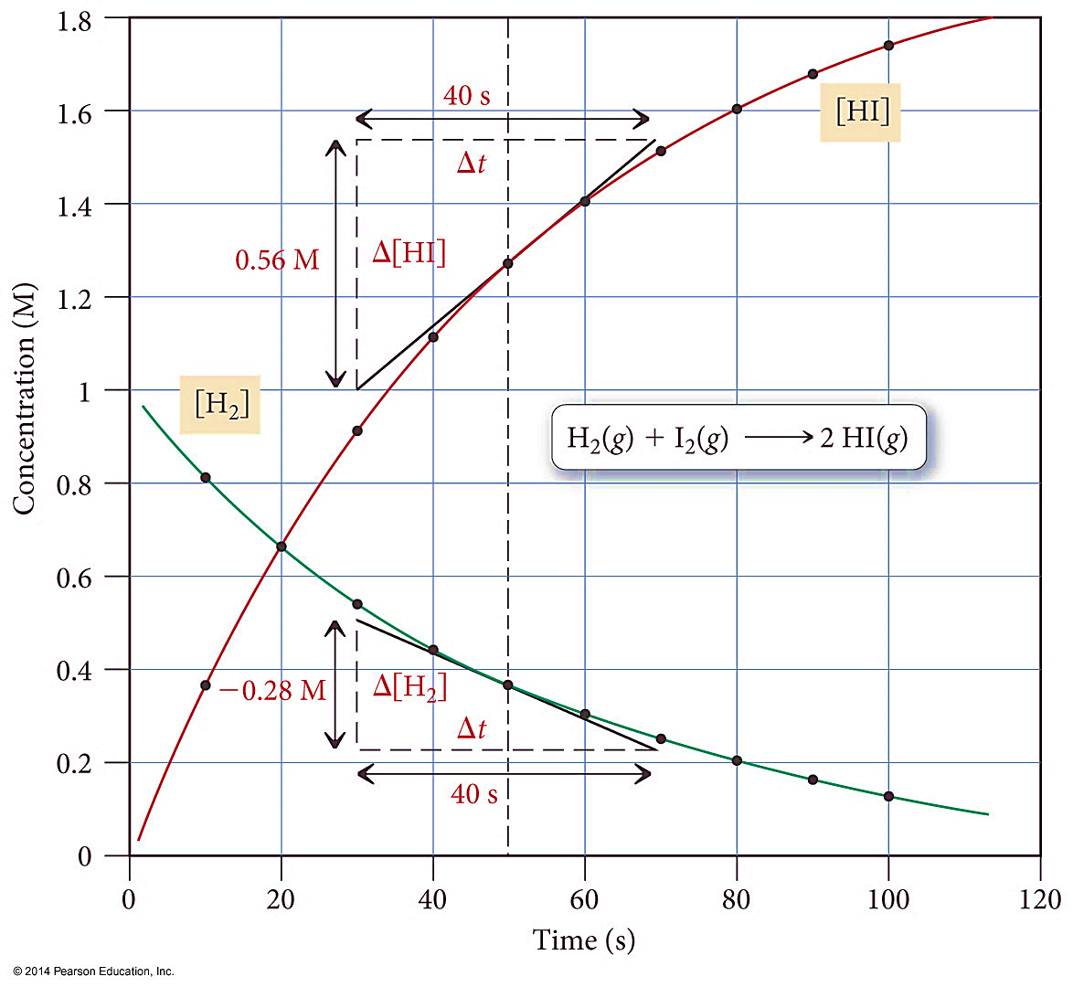

N8 – Kinetics Review



N8 – Kinetics Review



N8 – Kinetics Review



N8 – Kinetics Review



N8 – Kinetics Review

