N9 – Rate Laws

|  |  |  |  |  |  |  |  |  |
| --- | --- | --- | --- | --- | --- | --- | --- | --- |
| **Kinetics Summary Glue In -** *See Kinetics Reference Sheet for More Details* | | | | | | | | |
| **Differential Rate Law** *Rate vs Concentration Data* | | | **Integrated Rate Law**  *Graph the following versus time. The one that is linear tells you the order! Why? Because of Math. Ha!* | | | | | |
| **Order** | **Rate Law** | **Units on K** | **Memory Device** | **Y-axis** | **y = mx + b format** | **Straight Line Plot** | **k from Graph** | **Half Life Equation** |
| 0th | k | M/sec | **C** *Concentration* | [A] |  |  | - slope |  |
| 1st | k [A] | 1/sec | **N** *Natural Log* | Ln [A] |  | A graph of a slope  Description automatically generated  Ln[A]  Ln[A]0 | - slope |  |
| 2nd | k [A]2 | 1/M•sec | **R** *Reciprocal* | 1/[A] |  |  | slope |  |

N9 – Rate Laws

|  |  |  |  |  |  |  |  |  |
| --- | --- | --- | --- | --- | --- | --- | --- | --- |
| **Kinetics Summary Glue In -** *See Kinetics Reference Sheet for More Details* | | | | | | | | |
| **Differential Rate Law** *Rate vs Concentration Data* | | | **Integrated Rate Law**  *Graph the following versus time. The one that is linear tells you the order! Why? Because of Math. Ha!* | | | | | |
| **Order** | **Rate Law** | **Units on K** | **Memory Device** | **Y-axis** | **y = mx + b format** | **Straight Line Plot** | **k from Graph** | **Half Life Equation** |
| 0th | k | M/sec | **C** *Concentration* | [A] |  |  | - slope |  |
| 1st | k [A] | 1/sec | **N** *Natural Log* | Ln [A] |  | Ln[A]0  Ln[A] | - slope |  |
| 2nd | k [A]2 | 1/M•sec | **R** *Reciprocal* | 1/[A] |  |  | slope | $$t_{1/2}= \frac{1}{k {[A]}_{0}}$$ |

N9 – Rate Laws

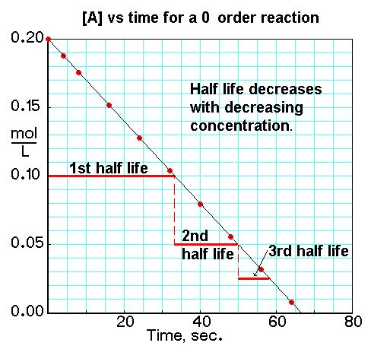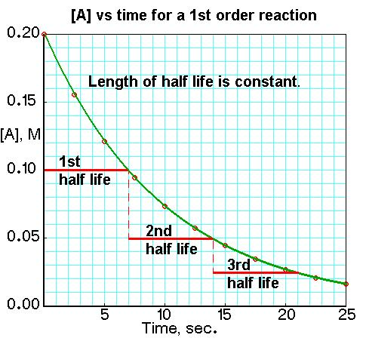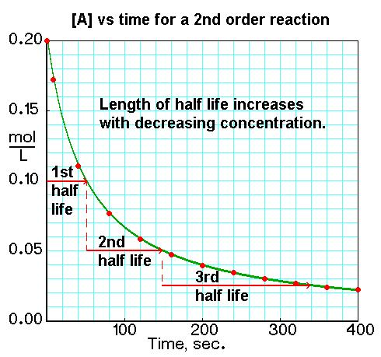

N9 – Rate Laws



N9 – Rate Laws

