Name: Period: Seat#:
Worksheet #4

Directions: Show all work in a way that would earn you credit on the AP Test! This is always the rule! Some answers are provided at the end in italics and underlined. If you need more space, use binder paper and staple to your worksheet.

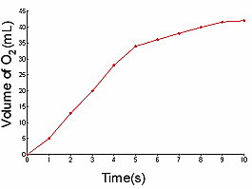 | 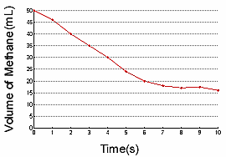 |  | - a) Find the reaction rate of the decomposition of methane between 3 and 7 sec. -4.25ml/s
- Find the reaction rate of the production of oxygen gas between 2 and 6 seconds. 5.5 ml/s |  | - Identify the reactant and product based on the graph. Explain why
- How does temperature affect reaction rate?

- What is activation energy? Explain how a catalyst works relative to activation energy.

- With the given information, determine the rate law, the rate constant, and the overall reaction order. k=2.0

2Mg + O₂ → 2MgO |  | Rate = k[Mg]^{n}[O₂]^{m}
Trial | Initial [Mg] mol⋅L⁻¹ | Initial [O₂] mol⋅L⁻¹ | Measured Rate (M⋅s⁻¹)
1 | 0.10 | 0.10 | 2.0E⁻³
2 | 0.20 | 0.10 | 4.0E⁻³
3 | 0.10 | 0.20 | 8.0E⁻³
- a) Find the half-life of a first-order reaction if the reaction constant, k, is 2.0E-3 s⁻¹ 350 seconds

b) Find the time when only 1% of reactant remains. t = 2300s

ClO₃⁻ + H₂O → ClO₄⁻ + H₂
Reaction constant k (s⁻¹) | Temperature (°C)
2.0E⁻³ | 25
4.0E⁻³ | 35
8.0E⁻³ | 45
1.6E⁻² | 55

$lnk=\frac{-E_{a}}{R}\left(\frac{1}{T}\right)+ln⁡(A)$ $ln⁡(\frac{k_{2}}{k_{1}})=\frac{E_{A}}{R}(\frac{1}{T_{1}}-\frac{1}{T_{2}})$

- Find E_{a} using the following information: (hint: equation can be the form of y = mx + b. Graph and use the slope

5.63E⁴ J/mol
- Find the 2nd order reaction’s Ea with the given information. k₁ = 4.0M⁻¹s⁻¹ at 37°C k₂ = 8.0M⁻¹s⁻¹ at 87°C

1.29E⁴ J/mol

- What is the rate law for this reaction? NO₃ (g) + NO₂ (g) → 2NO(g) + O₃ (g)

Expt. | Initial Concentrations, M |  | Initial Rate, M s⁻¹
 | NO₃ (g) | NO₂(g)
1 | 0.141 | 0.31 | 0.00522
2 | 0.144 | 0.15 | 0.00132
3 | 0.283 | 0.16 | 0.00133

- Order in [NO₂]?

- Order in [NO₃]?

- Overall order? | - Rate Law?
- Value of the rate constant, k? |  | - Units of the rate constant, k?

- Junior Chemist had to analyze the rate at which nitropropylether decomposes at 298 K to determine the rate law. She took the raw data and made a bunch of graphs, but she doesn’t know how to interpret them to determine the rate law. (Her computer drew best fit straight lines and even wrote the equation for the line in the form y = mx + b where m is the slope and b is the intercept.) Please determine the rate law from the data. Explain your steps.

Order:
Rate Constant: | Units of rate constant:
Differential Rate law: | Integrated Rate Law:

nitropropylether → decomposition products
Time | [ ] M | 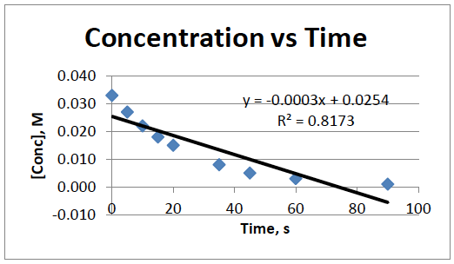 | Time | 1 / [ ] M | 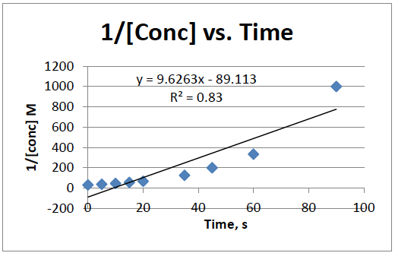
0 | 0.033 |  | 0 | 30.30303
5 | 0.027 |  | 5 | 37.03072
10 | 0.022 |  | 10 | 45.25204
15 | 0.018 |  | 15 | 55.29861
20 | 0.015 |  | 20 | 67.57565
35 | 0.008 |  | 35 | 123.3157
45 | 0.005 |  | 45 | 184.1495
60 | 0.003 |  | 60 | 336.0459
90 | 0.001 |  | 90 | 1119.064

Time | Ln[ ] M | 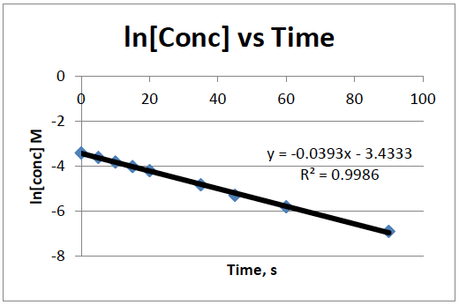
0 | -3.41125
5 | -3.61175
10 | -3.81225
15 | -4.01275
20 | -4.21325
35 | -4.81475
45 | -5.21575
60 | -5.81725
90 | -7.02025

- Half-lives. The decay of Pu-239 occurs with a half-life of 24,000 year. How long will it take for a bomb core, approximately 4 kg of Pu-239, to decay to 0.30 μg (μ means x10⁻⁶), which is the smallest dosage that is known to be lethal? 8.1 x 10⁵
- Solve using the regular half life equation taught in Honors Chem (some years) A_{E} = A_{S} x 0.5^{(t/h)}
A_{E} amount ending, A_{S} amount starting, t time that has passed, h length of half life

- Now solve it again using the appropriate integrated rate law *Hint* You will first need to solve for k

- Effect of temperature on the rate of reaction. It is said that reactions proceed faster at higher temperatures. Explain why the statement is true by describing a reaction on the atomic scale and explaining which processes are influenced by temperature and how increasing temperature affects those processes. Include a Boltzmann Distribution Graph as part of your answer.

