**Name: Period: Seat#:**

**Worksheet #6**

**Directions:** Show all work in a way that would earn you credit on the AP Test! This is always the rule!   
Answers are provided at the end. If you need more space, use binder paper and staple to your worksheet.

**1999 NChO Exam**

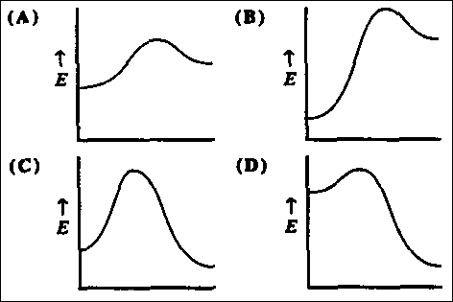28. The rate of a reaction with just two reactants is observed to double when the concentration of one reactant is doubled and the second reactant is held constant. The rate is also observed to increase by a factor of nine when the concentration of the second reactant is tripled, holding the concentration of the first reactant constant. What is the overall order for this reaction?

(A) 2 (C) 5  
(B) 3 (D) 6

29. Which energy diagram represents a highly exothermic reaction that has a small activation energy? (Assume that all curves are plotted on the same scale.)

30. Tritium decays by a first-order process that has half-life of 12.5 years. How many years will it take to reduce the radioactivity of a tritium sample to 15% of it original value?

(A) 64 y (C) 34 y  
(B) 54 y (D) 24 y

31. What is the overall order of a reaction with a rate constant having the units L·mol-1·s-1?

(A) 0 (C) 2  
(B) 1 (D) 3

32. In a reaction with several steps, which step limits the rate of the reaction?

(A) first (C) fastest  
(B) last (D) slowest

**1998 NChO Exam**

27. 2N2O5 (g) → 4NO2(g) + O2(g)

What is the ratio of the rate of decomposition of N2O5 to the rate of the formation of NO2?

(A) 1:2 (C) 1:4  
(B) 2:1 (D) 4:1

28. When reacted with water, the insecticides DDT decomposes with a half-life of 10 years. Approximately how many years will it take for 99% of a given sample to decompose once exposed to water in the environment?

(A) 50 yr (C) 500 yr  
(B) 70 yr (D) 700 yr

29. Which property, if decreased, will cause an increase in the rate of a reaction involving a solid?

(A) temperature (C) concentration  
(B) pressure (D) particle size

30. Which graph corresponds to the change in concentration of a reactant that is a first order reaction?

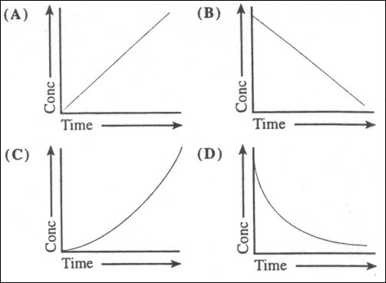31. Which reaction characteristics are changing by the addition of a catalyst to a reaction to a reaction at constant temperature?

1. activation energy  
2. ending concentrations  
3. reaction enthalpy

(A) 1 only (C) 1 and 2 only  
(B) 3 only (D) 1, 2, and 3

**1997 NChO Exam**

27. A plot of reactant concentration versus time gives a straight line. What is the order of the reaction for this reactant?

(A) zero (C) second  
(B) first (D) some other value

28. Which change does not increase the value of the rate constant for a reaction?

(A) decreasing the activation energy  
(B) raising the temperature  
(C) adding a catalyst  
(D) increasing the concentration of reactants

29. A certain reaction has a H = -75 kJ and an activation energy of 40 kJ. A catalyst is found that lowers the activation energy of the forward reaction by 15 kJ. What is the activation energy of the reverse reaction in the presence of this same catalyst?

(A) 25 kJ (C) 90 kJ  
(B) 60 kJ (D) 100 kJ

|  |  |  |
| --- | --- | --- |
| [NO] | [H2] | Rate(M min¯1) |
| 0.015 | 0.020 | 0.60 |
| 0.015 | 0.040 | 1.20 |
| 0.030 | 0.020 | 2.40 |

30. Nitrogen(II) oxide and hydrogen react to form nitrogen and water

2NO(g) + 2H2 → N2(g) + 2H2O(g)

According to these experimental results, what are the orders for NO and H2O?

|  |  |  |
| --- | --- | --- |
|  | Order,NO | Order,H2 |
| (A) | 1 | 1 |
| (B) | 1 | 2 |
| (C) | 2 | 1 |
| (D) | 2 | 2 |

31. At a certain temperature the first-order decomposition of hydrogen peroxide exhibits these data.

|  |  |
| --- | --- |
| time (seconds, s) | [H2O2](mol L¯1) |
| 0 | 2.0 |
| 15 | 1.0 |

At what time will the [H2O2] = 0.50 mol L¯1?

(A) 30. s (C) 22 s  
(B) 25 s (D) 20. s

***Answers***

*1999 1998 1997*

*28) B 27) A 27) A*

*29) D 28) B 28) D*

*30) C 29) D 29) D*

*31) C 30) D 30) C*

*32) D 31) A 31) A*