Name: Period: Seat#:
Worksheet #8

Directions: Show all work in a way that would earn you credit on the AP Test! This is always the rule! Grading rubrics posted in the Google Answer Key Drive. Check your work, correct in green pen after you try them yourself in an honest way! Don’t peek at rubrics while you work! USE BINDER PAPER, STAPLE TO YOUR WORKSHEET. Clearly label work.
LONG ASSIGNMENT! DON’T WAIT UNTIL THE LAST MINUTE! BREAK IT INTO CHUNKS!
SET A TIMER FOR 1.5 MIN PER FRQ PART AND SEE IF YOU FINISH ON TIME!

2008 | 3. Nitrogen monoxide gas, a product of the reaction above, can react with oxygen to produce nitrogen dioxide  gas, as represented below.  2 NO(g) + O₂(g) → 2 NO₂(g)  A rate study of the reaction yielded the data recorded in the table below.  Experiment Initial Concentration of NO (mol L⁻¹) Initial Concentration of O₂ (mol L⁻¹) Initial Rate of Formation of NO₂ (mol L⁻¹ s⁻¹)  1 0.0200 0.0300 8.52 x 10⁻²  2 0.0200 0.0900 2.56 x 10⁻¹  3 0.0600 0.0300 7.67 x 10⁻¹  - Determine the order of the reaction with respect to each of the following reactants. Give details of your reasoning, clearly explaining or showing how you arrived at your answers.  - NO  - O₂  - Write the expression for the rate law for the reaction as determined from the experimental data.  - Determine the value of the rate constant for the reaction, clearly indicating the units.
2008B | A(g) + B(g) C(g) + D(g)  2. For the gas-phase reaction represented above, the following experimental data were obtained.  Experiment Initial Concentration of A (mol L⁻¹) Initial Concentration of B(mol L⁻¹) Initial Reaction Rate (mol L⁻¹ s⁻¹)  1 0.033 0.034 6.67 x 10⁻⁴  2 0.034 0.137 1.08 x 10⁻²  3 0.136 0.136 1.07 x 10⁻²  4 0.202 0.233 ?  (a) Determine the order of the reaction with respect to reactant A. Justify your answer.  (b) Determine the order of the reaction with respect to reactant B. Justify your answer.  (c) Write the rate law for the overall reaction.  (d) Determine the value of the rate constant, k, for the reaction. Include units with your answer.  (e) Calculate the initial reaction rate for experiment 4.  (f) The following mechanism has been proposed for the reaction.  Step 1: B + B E + D slow  Step 2: E + A ↔ B + C fast equilibrium  Provide two reasons why the mechanism is acceptable.  (g) In the mechanism in part (f), is species E a catalyst, or is it an intermediate? Justify your answer.
1999B | 2 NO(g) + Br₂(g) 2 NOBr(g)  3. A rate study of the reaction represented above was conducted at 25°C. The dtaa that were obtained are shown in the table below.  Experiment Initial [NO] (mol L⁻¹) Initial [Br₂] (mol L⁻¹) Initial Rate of Appearance of NOBr (mol L⁻¹ s⁻¹)  1 0.0160 0.0120 3.24 x 10⁻⁴  2 0.0160 0.0240 6.38 x 10⁻⁴  3 0.0320 0.0060 6.42 x 10⁻⁴  - Calculate the initial rate of disappearance of Br₂(g) in experiment 1.  - Determine the order of the reaction with respect to each reactant. Br₂(g) and NO(g). In each case,  explain your reasoning.  - For the reaction,  - write the rate law that is consistent with the data, and  - calculate the value of the specific rate constant, k, and specify units.  - The following mechanism was proposed for the reaction:  Step 1: Br₂(g) + NO(g) NOBr₂(g) slow  Step 2: NOBr₂(g) + NO(g) 2 NOBr(g) fast  Is this mechanism consistent with the given experimental ovservations? Justify your answer.
2003 | 5 Br ⁻ (aq) + BrO₃⁻ (aq) + 6 H⁺ (aq) 3 Br₂(l) + 3 H₂O(l)  3. In a study of kinetics of the reaction represented above, the following data were obtained at 298 K.  Experiment Initial [Br⁻] (mol L⁻¹) Initial [BrO₃⁻] (mol L⁻¹) Initial [H⁺] (mol L⁻¹) Initial Rate of Appearance of Br₂ (mol L⁻¹ s⁻¹)  1 0.00100 0.00500 0.100 2.50 x 10⁻⁴  2 0.00200 0.00500 0.100 5.00 x 10⁻⁴  3 0.00100 0.00750 0.100 3.75 x 10⁻⁴  4 0.00100 0.01500 0.200 3.00 x 10⁻³  - From the data given above, determine the order of the reaction for each reactant listed below. Show your reasoning.  - Br⁻  - BrO₃⁻  - H⁺  - Write the rate law for the overall reaciton.  - Determine the value of the specific rate constant for the reaction at 298 K. Include the correct units.
2001  2001 cont. | 3 I⁻ (aq) + S₂O₈²⁻ (aq) I₃⁻ (aq) + 2 SO₄²⁻ (aq)  6. Iodide ion, I- (aq), reacts with peroxydisulfate ion, S₂O₈²⁻(aq), according to the equation above. Assume that the reaction goes to completion.  - Identify the type of reaction (combustion, disproportionation, neutralization, oxidation-reduction, precipitation, etc.) represented by the equation above. Also, give the formula of another substance that could convert I⁻ (aq) to I₃⁻ (aq).  - In an experiment, equal volumes of 0.0120 M I⁻ (aq) and 0.0040 M S₂O₈²⁻ (aq) are mixed at 25°C. The concentration of I₃⁻ (aq) over the following 80 minutes is shown in the graph below.  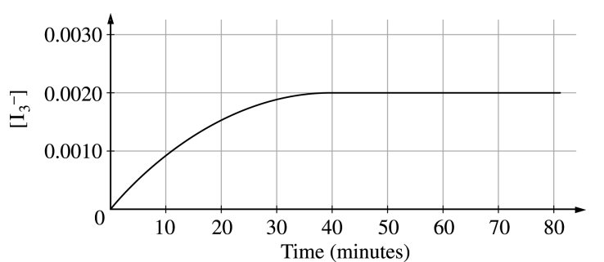  - Indicate the time at which the reaction first reaches completion by marking an “X” on the curve above at the point that corresponds to this time. Explain your reasoning.  - Explain how to determine the instantaneous rate of formation of I₃⁻(aq) at exactly 20 minutes. Draw on the graph above as part of your explanation.  - Describe how to change the conditions of the experiment in part (b) to determine the order of the reaction with respect to I⁻(aq) and with respect to S₂O₈²⁻(aq).  - State clearly how to use the information from the results of the experiments in part (c) to determine the value of the rate constant, k, for the reaction.  - On the graph below (which shows the results of the initial experiment as a dashed curve), draw in a curve for the results you would predict if the initial experiment were to be carried out at 35°C rather than at 25°C.  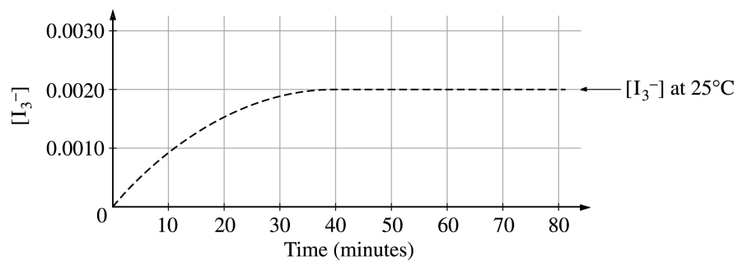
2003B | 8. The decay of radioisotope I-131 was studied in a laboratory. I-131 is known to decay by beta (${}_{-1}^{0}e$) emission.  - Write a balanced nuclear equation for the decay of I-131.  - What is the source of the beta particle emitted from the nucleus?  The radioactivity of a sample of I-131 was measured. The data collected are plotted on the graph below  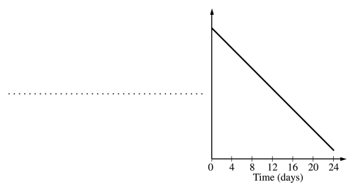  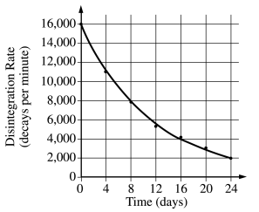  - Determine the half-life, t_{1/2} , of I-131 using the graph above.  - The data can be used to show that the decay of I-131 is a first-order reaction, as indicated on the graph below.  - Label the vertical axis of the graph to the right.  - What are the units of the rate constant, k, for the decay reaction?  - Explain how the half-life of I-131 can be calculated using the slope of the line plotted on the graph.  - Compare the value of the half-life of I-131 at 25°C to its value at 50°C.
2004 | 3. The first-order decomposition of a colored chemical species, X, into colorless products is monitored with a spectrophotometer by measuring changes in absorbance over time. Species X has a molar absorptivity constant of 5.00 × 103 cm–1 M –1 and the path length of the cuvette containing the reaction mixture is 1.00 cm. The data from the experiment are given in the table below.  [X] ( M ) Absorbance Time (min)  ? 0.600 0.0  4.00 x 10⁻⁵ 0.200 35.0  3.00 x 10⁻⁵ 0.150 44.2  1.50 x 10⁻⁵ 0.075 ?
2004 cont. | - Calculate the initial concentration of the colored species.  - Calculate the rate constant for the first-order reaction using the values given for concentration and time. Include units with your answer.  - Calculate the number of minutes it takes for the absorbance to drop from 0.600 to 0.075.  - Calculate the half-life of the reaction. Include units with your answer.  - Experiments were performed to determine the value of the rate constant for this reaction at various temperatures. Data from these experiments were used to produce the graph below, where T is temperature. This graph can be used to determine the activation energy, E_{a} , of the reaction.  - Label the vertical axis of the graph.  - Explain how to calculate the activation energy from this graph.  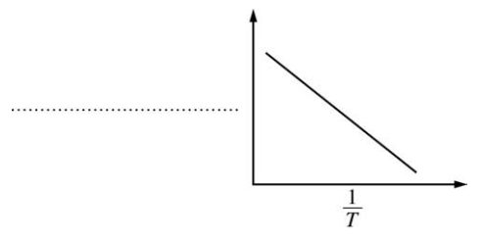
2004B | 2 H₂O₂(aq) → 2 H₂O(l) + O₂(g)  3. Hydrogen peroxide decomposes according to the equation above.  - An aqueous solution of H₂O₂ that is 6.00 percent H₂O₂ by mass has a density of 1.03 g mL^{–1}. Calculate each of the following.  - The original number of moles of H₂O₂ in a 125 mL sample of the 6.00 percent H₂O₂ solution  - The number of moles of O₂(g) that are produced when all of the H₂O₂ in the 125 mL sample decomposes  - The graphs below show results from a study of the decomposition of H₂O₂ .  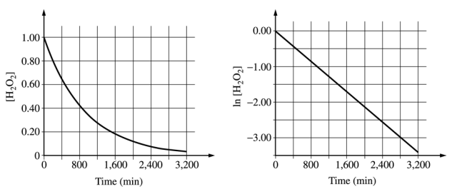  - Write the rate law for the reaction. Justify your answer.  - Determine the half-life of the reaction.  - Calculate the volue of the rate constant, k. Include appropriate units in your answer.  - Determine [H₂O₂] afer 2,000 minutes elapse from the time the reaction began.
2005 | 3. Answer the following questions related to the kinetics of chemical reactions.  I⁻(aq) + ClO⁻(aq) $\underset{→}{{OH}^{-}}$ IO⁻(aq) + Cl⁻(aq)  Iodide ion, I⁻, is oxidized to hypoiodite ion, IO⁻, by hypochlorite, ClO⁻, in basic solution according to the  equation above. Three initial-rate experiments were conducted; the results are shown in the following table  Experiment [I⁻] (mol L⁻¹) [ClO⁻] (mol L⁻¹) Initial Rate of Formation of IO⁻ (mol L⁻¹ s⁻¹)  1 0.017 0.015 0.156  2 0.052 0.015 0.476  3 0.016 0.061 0.596
2005 cont. | - Determine the order of the reaction with respect to each reactant listed below. Show your work  - I⁻(aq)  - ClO⁻(aq)  - For the reaction  - write the rate law that is consistent with the calculations in part (a);  The catalyzed decomposition of hydrogen peroxide, H2O2(aq), is represented by the following equation.  2 H₂O₂(aq) $\underset{→}{catalyst}$2 H₂O(l) + O₂(g)  The kinetics of the decomposition reaction were studied and the analysis of the results show that it is a first-order reaction. Some of the experimental data are shown in the table below.  [H₂O₂] (mol L⁻¹) Time (minutes)  1.00 0.0  0.78 5.0  0.61 10.0  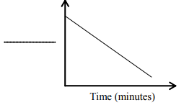  - During the analysis of the data, the graph below was produced.  - Label the vertical axis of the graph.  - What are the units of the rate constant, k, for the decomposition of H₂O₂(aq) ?  - On the graph, draw the line that represents the plot of the uncatalyzed first-order decomposition of 1.00 M H₂O₂(aq).
2005B | X 2 Y + Z  3. The decomposition of gas X to produce gases Y and Z is represented by the equation above. In a certain experiment, the reaction took place in a 5.00 L flask at 428 K. Data from this experiment were used to produce the information in the table below, which is plotted in the graphs that follow.  Time (minutes) [X] (mol L⁻¹) Ln [X] [X]⁻¹ (mol L⁻¹ s⁻¹)  0 0.00633 −5.062 158  10. 0.00520 −5.259 192  20. 0.00427 −5.456 234  30. 0.00349 −5.658 287  50. 0.00236 −6.049 424  70. 0.00160 −6.438 625  100. 0.000900 −7.013 1,110  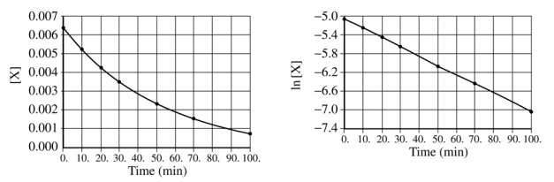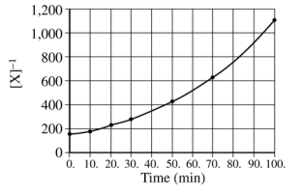  - How many moles of X were initially in the flask?  - How many molecules of Y were produces in the first 20. minutes of the reaction?  - What is the order of this reaciton with respect to X ? Justify your answer.  - Write the rate law for this reaction.  - Calculate the specific rate constant for this reaction. Specify units.  - Calculate the concentration of X in the flask after a total of 150. mintues of reaciton.
2006 | 6.  (d) Consider the four reaction-energy profile diagrams shown below.  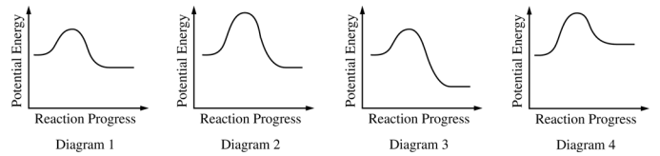  - Identify the two diagrams that could represent a catalyzed and an uncatalyzed reaction pathway for the same reaction. Indicate which of the two diagrams represents the catalyzed reaction pathway for the reaction.  - Indicate whether you agree or disagree with the statement in the box below. Support your answer with a short explanation.  Adding a catalyst to a reaction mixture adds energy that causes the reaction to proceed more quickly.
Reflection: Think about the types of mistakes you made, things you need to restudy, things that tricked you, etc. One of the most important skills to develop in AP Chem is self reflection and not making the same mistakes. The joke is – you should always make NEW mistakes, not the SAME mistakes

