Name: ____________________ 1.6 Coulombic Attraction & PES Pogil

**Coulombic Attraction**

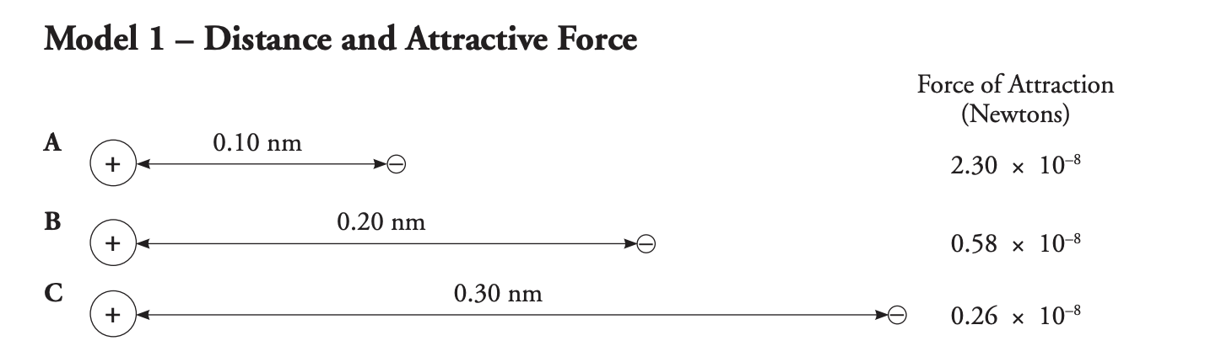**Read:** **Coulombic attraction** is the attraction between oppositely charged particles. For example, the protons in the nucleus of an atom have attraction for the electrons surrounding the nucleus. This is because the protons are positive and the electrons are negative. The attractive force can be weak or strong. In this activity, you will explore the strength of attraction between protons and electrons in various atomic structures.

1. What subatomic particles do these symbols represent in **Model 1**?



1. Would you observe **attraction** or **repulsion** between the subatomic particles in Model 1?
2. Consider the data in **Model 1**.
   1. What are the independent and dependent variables in the data? ***Hint:*** *Independent variable changes and dependent variable is measured.*
   2. What is the relationship between the independent and dependent variable? ***Hint:*** *Direct or indirect. Does one increase or decrease?*

**Model 2 – Number of Protons and Attractive Force**

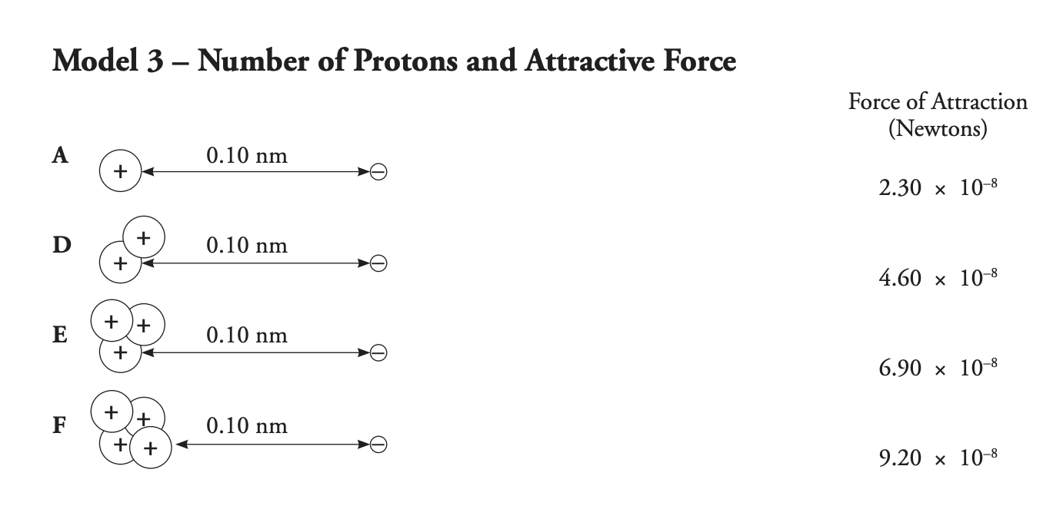

1. Consider the data in **Model 2**.
   1. What are the independent and dependent variables in the data?
   2. What is the relationship between the independent and dependent variable?
2. Imagine that a second electron were placed to the right of a nucleus containing two protons (Model 2, **D**). A student claims that the force of attraction would decrease. **Do you agree with them? Justify your answer.**

**Photoelectron Spectroscopy**

**Read:** When scientists first discovered X-rays, they realized they could do more than just make images of people’s bones. X-rays could also allow them to “see” inside the atom. They could not do this directly, but in looking for patterns in ionization energy data they were able to determine the energy levels and sublevels of electrons and how many electrons were in each level.

**Model 3 – A Soccer Player in a Ditch**

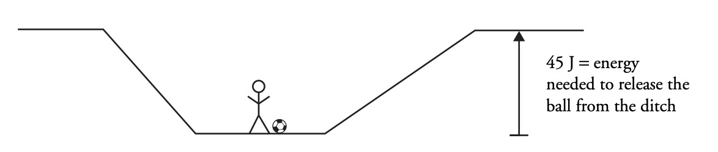

1. **Consider Model 3:** Imagine that a soccer player is trying to kick a ball out of a ditch. Gravity is the force of attraction that is keeping the soccer ball at the bottom of the ditch. Gravity is a type of potential energy that must be overcome to get the ball out of the ditch.
   1. What type of energy must the ball have for it to get out of the ditch? ***Hint:*** *Does it have kinetic or potential? Remember kinetic means motion.*
   2. How much energy must be given to the ball by kicking it to get it out of the ditch? ***Hint:*** *Look at the model*
2. Determine if the soccer ball can leave the ditch if the soccer player’s kick provides:
   1. 30 J of energy to the soccer ball in the ditch. Does the ball leave of the ditch?
   2. 45 J of energy to the soccer ball in the ditch. Does the ball leave the ditch?
   3. 60 J of energy to the soccer ball in the ditch. Does the ball leave of the ditch?

**Model 4 – A Hydrogen Atom**

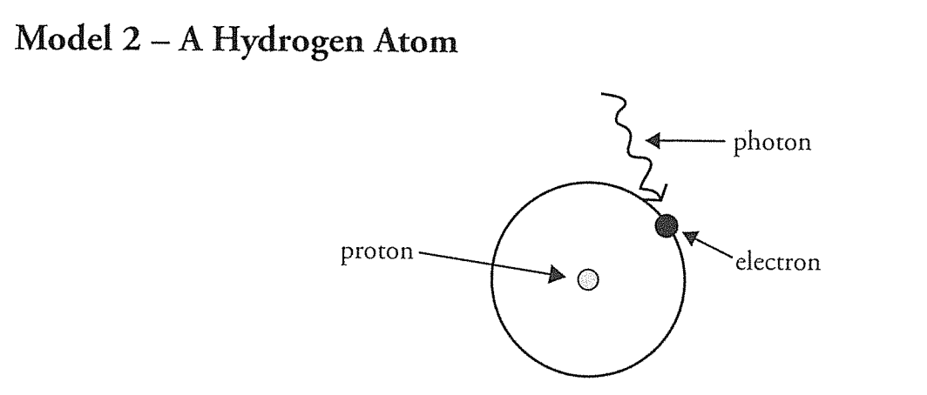

1. What attraction keeps the electron in the hydrogen atom in **Model 4**?
2. What allows (provides energy) for the electron to be removed from the atom in **Model 4**?
3. Fill in the table below to show how the hydrogen atom (**Model 4)** connects to the ball in the ditch analogy (**Model 3**).

|  |  |
| --- | --- |
| **Soccer Ball in Ditch** | **Hydrogen Atom** |
| Gravity |  |
| Ball |  |
| Player’s Kick |  |

1. The amount of energy necessary to remove an electron from an atom is called the **ionization energy** of that electron. What part of the soccer ball in a ditch analogy in **Model 3** represents the ionization energy?
2. What is the *relationship* between the ionization energy of an electron and the attractive force that holds an electron in an atom? ***Hint:*** *Direct or indirect. Does one increase or decrease?*

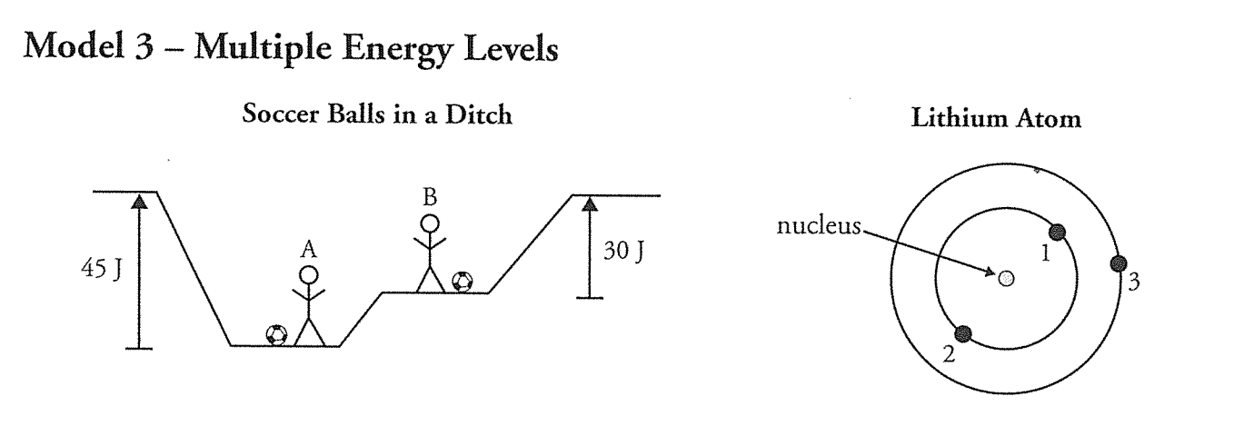**Model 5 – Multiple Energy Levels**

1. In **Model 5**, which player (A or B) will need to put more energy into their soccer ball to get it out of the ditch? Explain your answer in terms of both height, energy, and attraction.
2. Consider the electrons in an atom of lithium in **Model 5**. Which electron, 1 or 3, will require more energy to be removed? Explain your answer using attractive forces.
3. Compare electrons 1, 2 and 3 in terms of their ionization energy. ***Hint:*** *Which one has the largest or smallest ionization energy?*

**Model 6 – Photoelectron Spectra of Lithium**

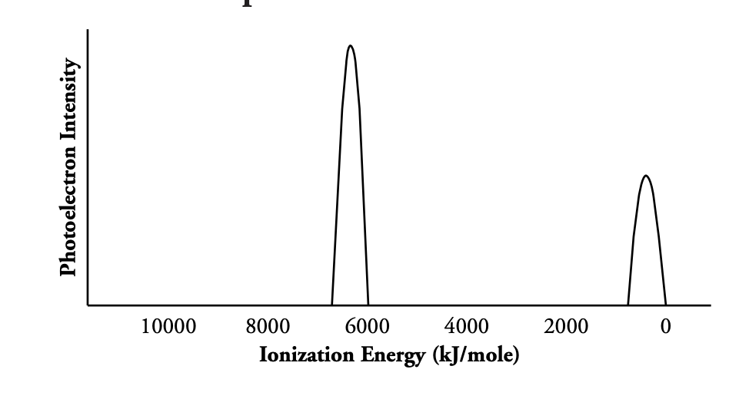

1. In **Model 6**, which of the peaks in the graph represents electrons that are more tightly held by the nucleus?
2. Does this graph represent one atom of Lithium or multiple being ionized?
3. Based on the energy values of the peaks, label each peak with the electrons in a lithium atom (see **Model 5**) for the electron numbers and locations.
4. Why is the higher energy peak about twice as tall as the lower energy peak?
5. Using the lithium PES spectra (**model 6**) as a starting point, create a spectrum for Beryllium using the graph below. **Hint:** Beryllium will have one more proton one more electron.

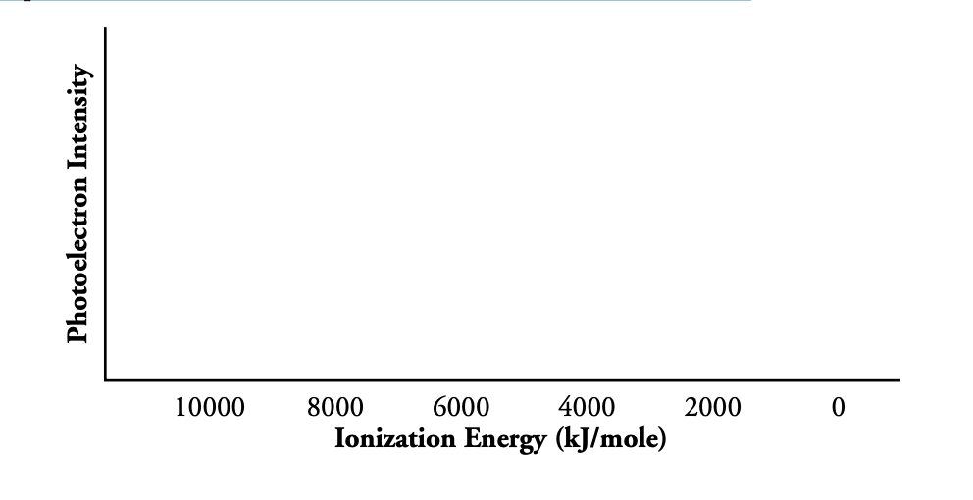

*Upload an image of just this last page to Schoology, Assignment 1.6 Coulomb & PES Pogil.*