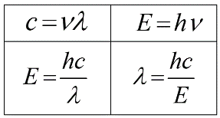N16 – Waves and Math

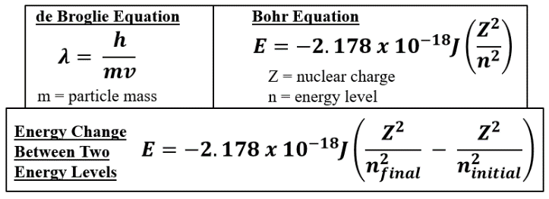

N16 – Waves and Math

N16 – Waves and Math

N16 – Waves and Math

N16 – Waves and Math

N16 – Waves and Math

N16 – Waves and Math

N16 – Waves and Math

