N17 – Shielding and Such
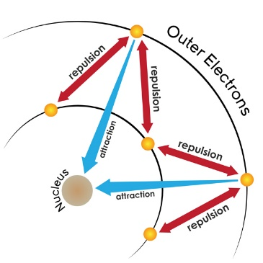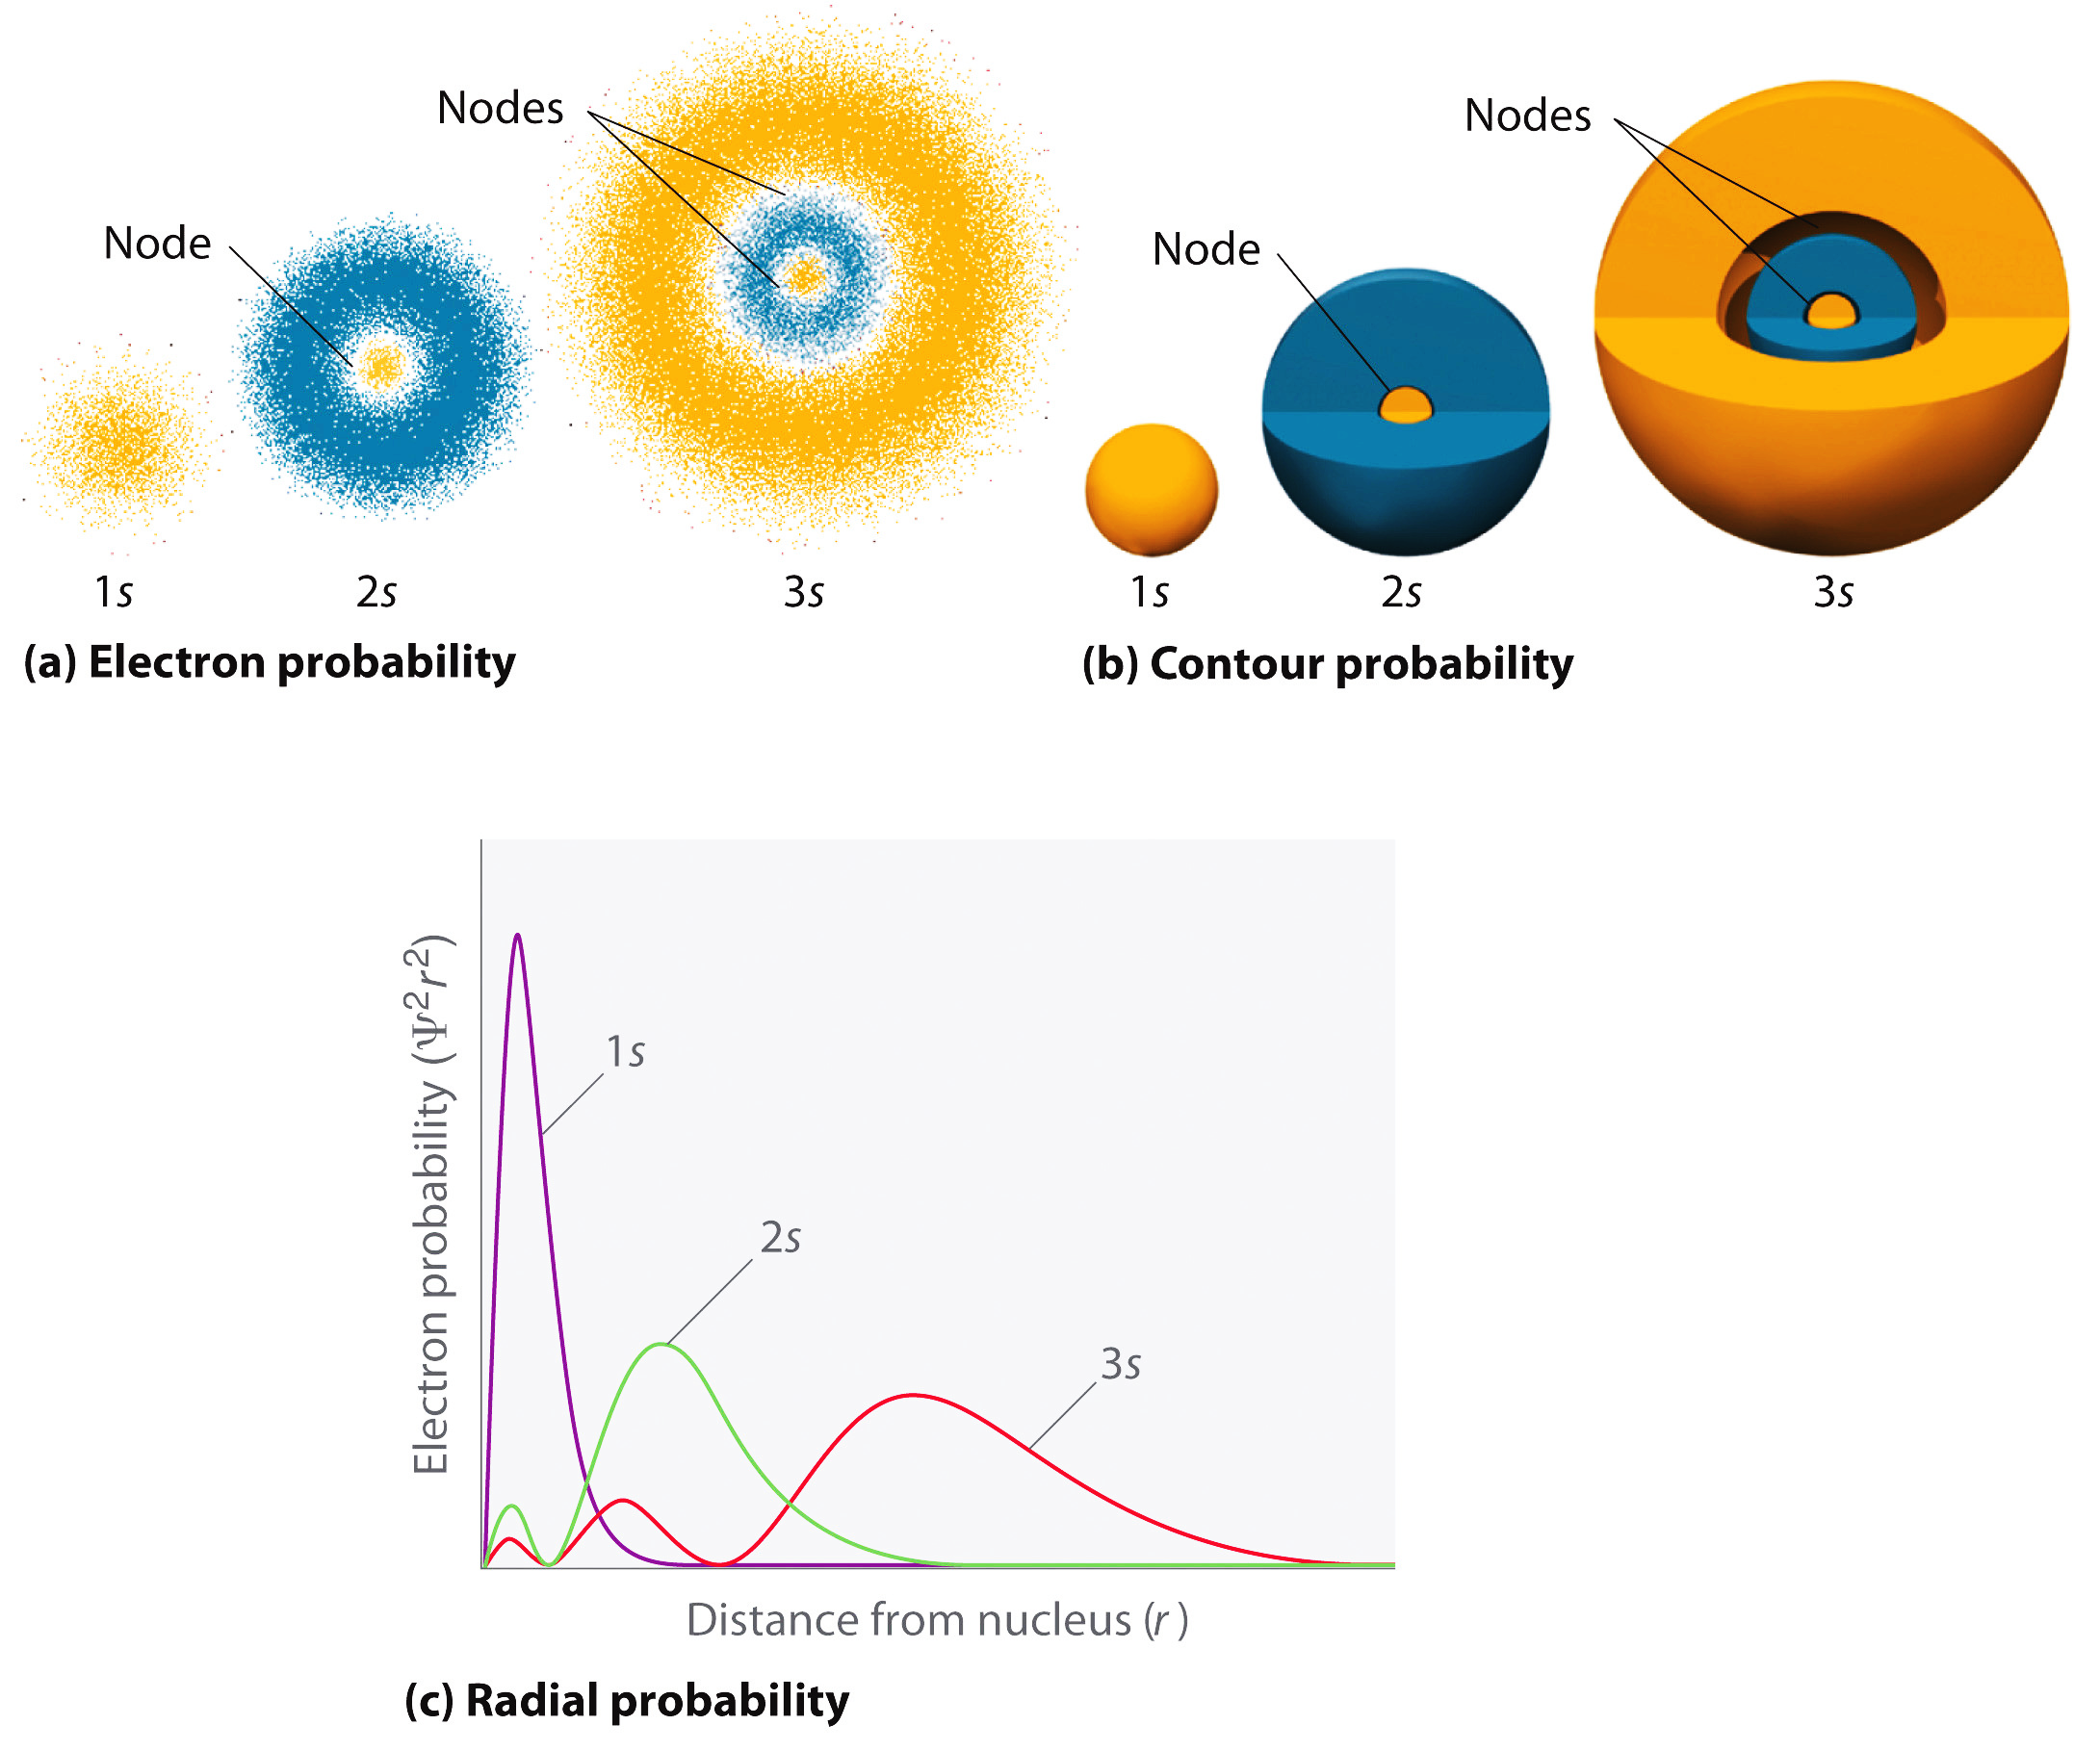

N17 – Shielding and Such

N17 – Shielding and Such

N17 – Shielding and Such

N17 – Shielding and Such

N17 – Shielding and Such

N17 – Shielding and Such

N17 – Shielding and Such

