N19 – PES

**Oxygen:**

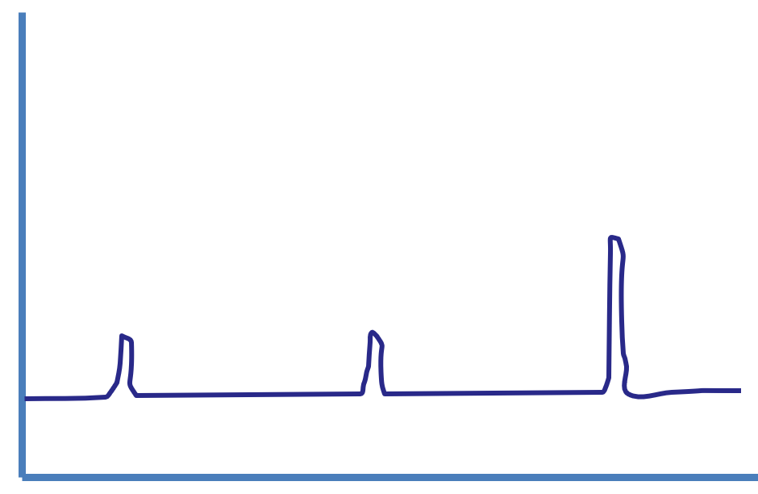

**Scandium:**

**Example #1:**

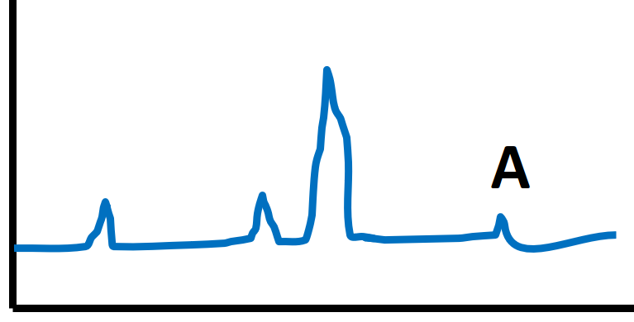

**Example #2:**

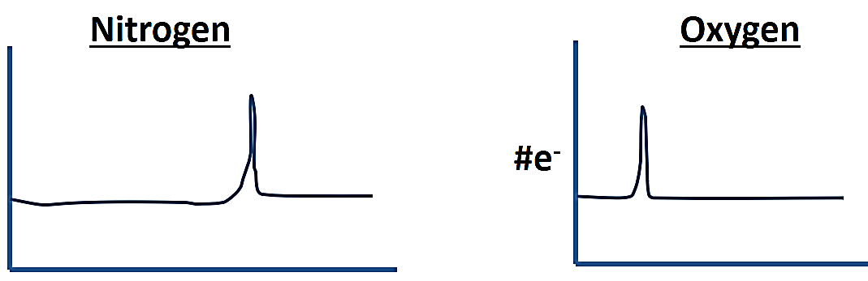

**Example #3:**

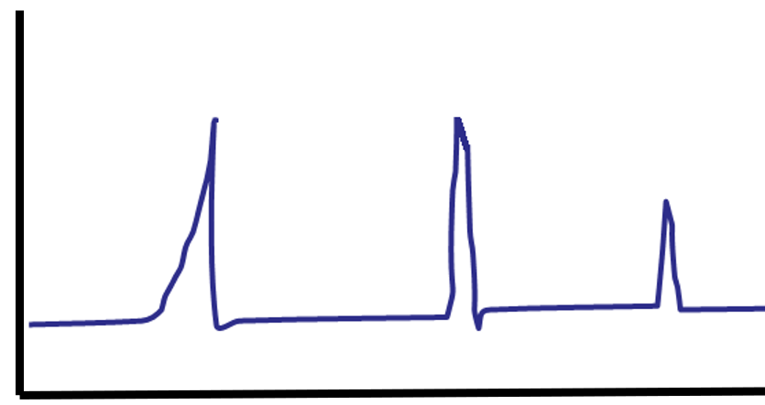

N19 – PES

**Oxygen:**



**Scandium:**

**Example #1:**



**Example #2:**



**Example #3:**



N19 – PES

**Oxygen:**



**Scandium:**

**Example #1:**



**Example #2:**



**Example #3:**

