Name: Period: Seat#:
Worksheet #6

- Below is the PES of sulfur, and a table of successive ionization energies. The energy scale for the PES is in MJ/mol (1 MJ = 1000 kJ). There is exactly one peak on this graph whose energy corresponds to an ionization energy in table 7.2. What is it? Why doesn't anything else match up?
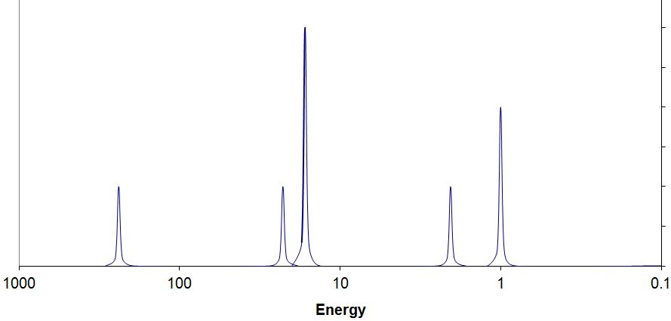 | Explain here:  From Brown et al., Chemistry the Central Science 12 ed.,  copyright Pearson Prentice Hall
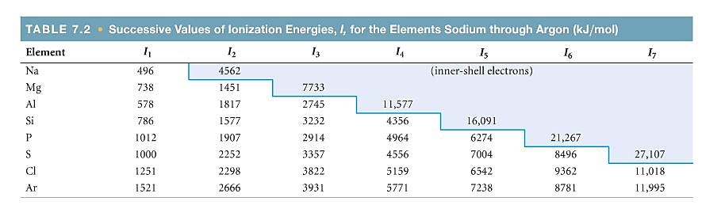

- Here is a picture of the original Bohr model of lithium (Z=3), and next to it, the PES of lithium. Is there anything in the PES data for this element that requires revision of the Bohr model? Explain.
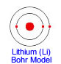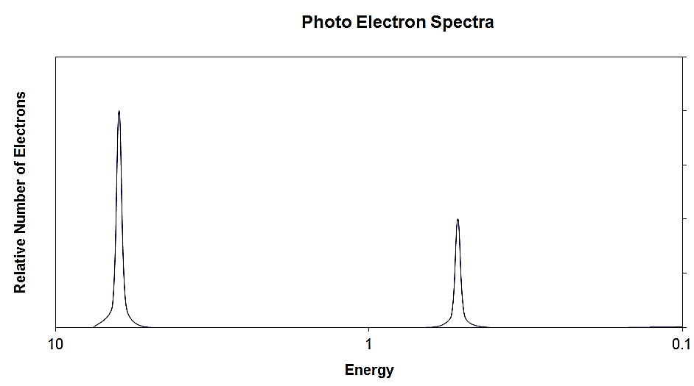 | Explain here:

- Similarly, here is the original Bohr model of carbon and the corresponding PES. Is there anything in the PES data for this element that requires revision of the Bohr model? Explain.
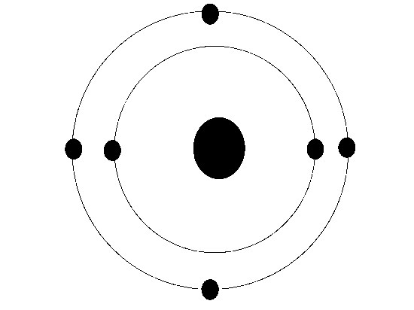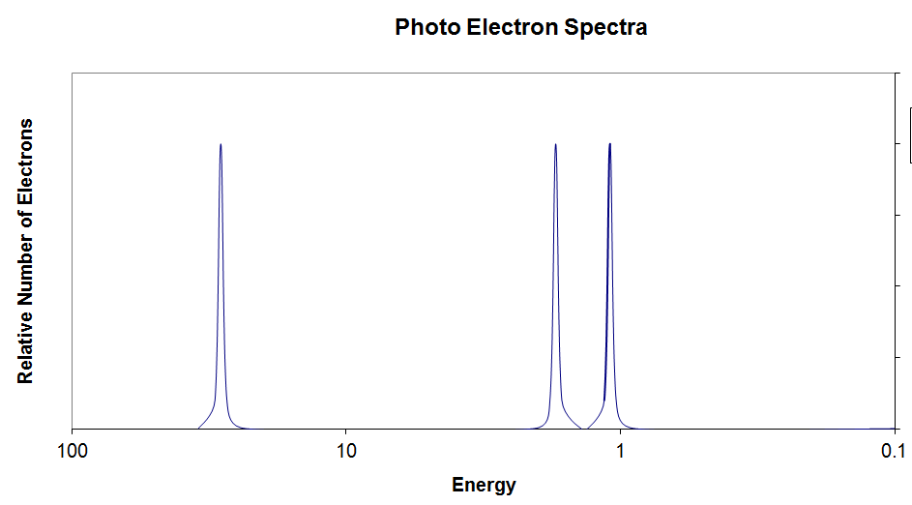 | Explain here:
- Here is a PES spectrum of boron (Z=5) superimposed on that of fluorine (Z=9)
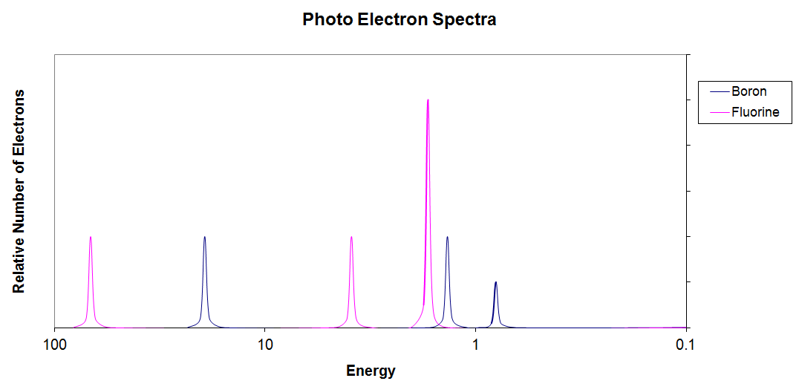  F  F  B  B  B  F | - Why are the fluorine peaks to the left of the boron peaks?
 | - Why is there one peak in fluorine that is so much taller than all the others?

- Below is shown the PES spectrum of sulfur (atomic number = 16)
- Write the full electron configuration of sulfur
- Label each peak in the spectrum to show which subshell it represents (i.e., 1s, 2s, etc.) On diagram above
- On the spectrum, sketch in the relative locations and correct peak heights for the spectrum of aluminum (atomic number = 13). By relative location, I mean correctly to the left or right of the same subshell peak in the sulfur spectrum. On diagram above
- Draw a circle around the sulfur peak whose energy is equal to the first ionization energy of sulfur.
On diagram above

