Name: Period: Seat#:
Worksheet #7

- In a photoelectron spectrum, photons of 165.7 MJ/mol strike atoms of an unknown element. If the kinetic energy of the ejected electrons is 25.4 MJ/mol, what is the ionization energy of the element? 140.3 MJ/mol

- What determines the position and the height (intensity) of each peak in a photoelectron spectrum?

- Why is the distance of the energy level from the nucleus important in determining the corresponding peak position in the photoelectron spectrum?

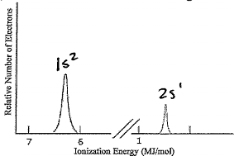
- The ionization energy of an electron from the first energy level of lithium is 6.26 MJ/mol. The ionization energy of an electron for the second energy level of lithium is 0.52 MJ/mol.

  - Write the electron configuration for lithium.

  - Sketch the photoelectron spectrum for lithium;
include the values of the ionization energies
stated above and label peaks.

- Based on the information provided below, draw a photoelectron spectrum for argon.
Indicate the relative intensities and positions of all peaks.

1s² | 2s² | 2p⁶ | 3s² | 3p⁶
-309.0 | -31.5 | -24.1 | -2.83 | -1.52

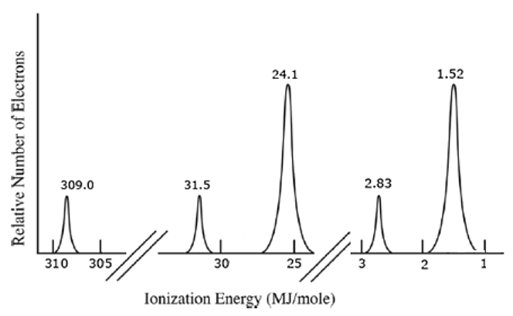
- Identify the element in the photoelectron spectrum shown below.  Explain your reasoning.  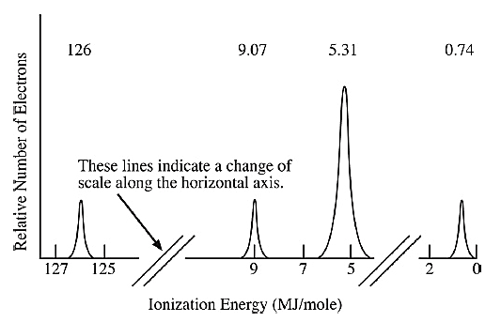 | Explain here:
- Identify if either of the following statements is correct. If yes, why. If not, why not:

- The photoelectron spectrum of Mg²⁺ is expected to be identical to the photoelectron spectrum of Ne.

- The photoelectron spectrum of ³⁵Cl is identical to the photoelectron spectrum of ³⁷Cl.

- Is it possible to deduce the electron configuration for an atom from its photoelectron spectrum?
If so, explain how. If not, explain why not.

- Why is the peak at 0.42 MJ/mol in the K photoelectron spectrum identified as being in the 4th energy level?  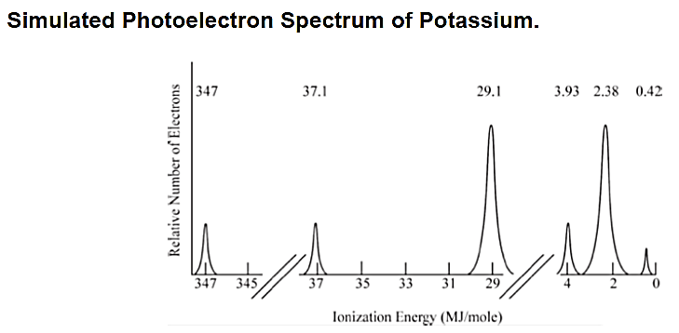 | Explain here:

