**Dougherty Valley HS AP Chemistry**

**WORKSHEET #7**

**Atomic Structure – Photoelectron Spectroscopy more**

**Name: Date: Period: Seat #:**

Show all work

|  |
| --- |
| 1. In a photoelectron spectrum, photons of 165.7 MJ/mol strike atoms of an unknown element. If the kinetic energy of the ejected electrons is 25.4 MJ/mol, what is the ionization energy of the element? **140.3 MJ/mol** |

|  |
| --- |
| 1. What determines the position and the height (intensity) of each peak in a photoelectron spectrum? |

|  |
| --- |
| 1. Why is the distance of the energy level from the nucleus important in determining the corresponding peak position in the photoelectron spectrum? |

|  |  |
| --- | --- |
| 1. The ionization energy of an electron from the first energy level of lithium is 6.26 MJ/mol. The ionization energy of an electron for the second energy level of lithium is 0.52 MJ/mol.    1. Draw an electron config. for lithium. | * 1. Sketch the photoelectron spectrum for lithium is below; include the values of the ionization energies stated above and label peaks. |

|  |
| --- |
| 1. Based on the information provided below, draw a photoelectron spectrum for argon. Indicate the relative intensities and positions of all peaks. |

|  |  |  |  |  |
| --- | --- | --- | --- | --- |
| 1s2 | 2s2 | 2p6 | 3s2 | 3p6 |
| -309.0 | -31.5 | -24.1 | -2.83 | -1.52 |

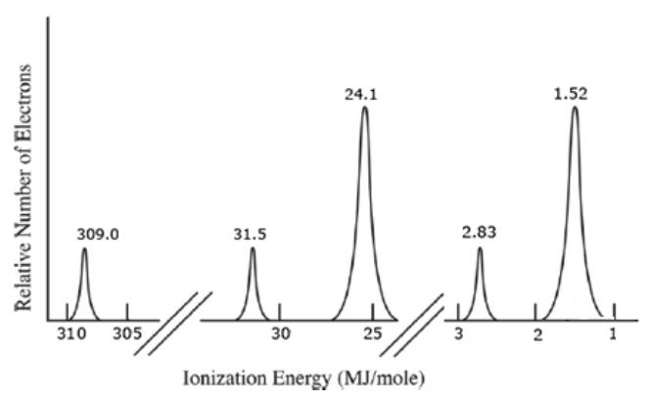

|  |
| --- |
| 1. Identify the element in the photoelectron spectrum shown below. Explain your reasoning. |
|  |
| Explain: |

|  |
| --- |
| 7. Identify if either of the following statements is correct. If yes, why. If not, why not: |
| a) The photoelectron spectrum of Mg2+ is expected to be identical to the photoelectron spectrum of Ne. |
| b) The photoelectron spectrum of 35Cl is identical to the photoelectron spectrum of 37Cl. |

|  |
| --- |
| 1. Is it possible to deduce the electron configuration for an atom from its photoelectron spectrum? If so, explain how. If not, explain why not. |

|  |
| --- |
|  |
| 1. Why is the peak at 0.42 MJ/mol in the K photoelectron spectrum identified as being in the 4th energy level? |