**Name: Period: Seat#:**

**Worksheet #8\***

**Directions**: Any worksheet that is labeled with an * means it is suggested extra practice. We do not always have time to assign every possible worksheet that would be good practice for you to do. You can do this worksheet when you have extra time, when you finish something early, or to help you study for a quiz or a test. If and when you choose to do this Extra Practice worksheet, please do the work on binder paper. You will include this paper stapled into your Rainbow Packet when you turn it in, even if you didn’t do any of this. We want to make sure we keep it where it belongs so you can do it later if you want to (or need to). If you did the work on binder paper you can include that in your Rainbow Packet after this worksheet. If we end up with extra class time then portions of this may turn into required work. If that happens you will be told which problems are turned into required. Remember there is tons of other extra practice on the class website…and the entire internet! See me if you need help finding practice on a topic you are struggling with.

**Read:** Question: Do all electrons in the same level have the same energy?

One important conclusion we reached based on the first ionization energy experimental data is that electrons in higher shells require less energy to remove the electron. We have experimental data that relates energy required to remove an electron depending on the shell the electron occupies. (An electron in which shell requires more energy to remove? An electron in the second shell or the fourth shell?) An interesting question we could ask, that can not be answered from the experimental data of the first ionization energy is, do all electrons in the same shell require the same amount of energy to remove? We can answer this question if we look at photoelectron spectroscopy (PES) data for the atoms.

In a photoelectron spectroscopy experiment any electron can be ionized when the atom is excited. Like the first ionization only one electron is removed from the atom, however in this experiment it can be any electron, not just the electron that requires the least amount of energy.

|  |  |  |
| --- | --- | --- |
| 1. The label on the x-axis is energy and the units are in megajoules. What is the label on the y-axis? 2. What is interesting about the photoelectron spectrum for hydrogen and the first ionization energy for hydrogen? 3. Helium is next, but before looking at its photoelectron spectrum;    1. How many electrons does helium have in its first shell?    2. Can you predict what the PES would look like if the same amount of energy is required to remove either of the electrons? If the amount of energy required to remove either electron is different? | | |
| 1. Look at the PES and describe what you see and the conclusion(s) you  reached? (Note: be sure to comment about the relative energy of the peak (s) in the PES for He and the PES for H.)   He  H | | |
| **Note:** For questions 5-7 you do not have to predict the exact energies of each  electron but you can make reasonable estimates based on the first ionization  energies for each element and the PES for earlier elements. | | |
| 1. **Lithium** | 1. **Beryllium** | 1. **Boron** |
| 1. How many e- does it have? | **a.** How many e- does it have? | **a.** How many e- does it have? |
| 1. Which shells do they occupy? | **b.** Which shells do they occupy? | **b.** Which shells do they occupy? |
| 1. Before looking at the PES for lithium, draw your prediction for what you think it would look like. | **c.** Before looking at the PES for beryllium, draw your prediction for what you think it would look like. | **c.** Before looking at the PES for boron predict what you believe the spectrum would look like. |

**Directions:** For questions 8-10 - Use the following [PES generator](https://drive.google.com/file/d/1f8M1QGEDVZVisXddzZLiJ9PU7M61Pt6K/view?usp=sharing) to answer the following questions. You will need download to your computer using EXCEL.

1. Predict what changes in the PES you would expect to see going from carbon to neon? Look at the PES for these second period elements.
2. Answer the following questions after looking at the PES for hydrogen through neon.
3. Would you agree or disagree with the following statement? Explain.   
   ‘The electrons in the second shell all have the same energy.’
4. How many ‘subshells’ are found in the second shell? How many ‘subshells’ are found in the first shell?
5. How many electrons are in each subshell in the second shell? In the first shell?
6. Moving systematically from lithium to neon;
7. How many electrons are in the first shell?
8. what happens to the energy required to remove an electron in the first shell moving from left to right in the second period? Support your observation with a meaningful explanation.
9. What happens to the energy of the electrons in the outer most shell?
10. Look at the PES for the elements in the third period (sodium – argon) and briefly describe your observations. Any surprises? Briefly explain your observations.

**PES Graphs for Questions 5-7 to look at after you drew your predictions.**

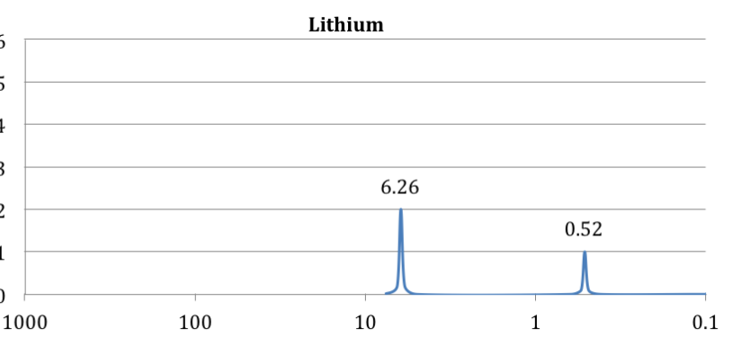 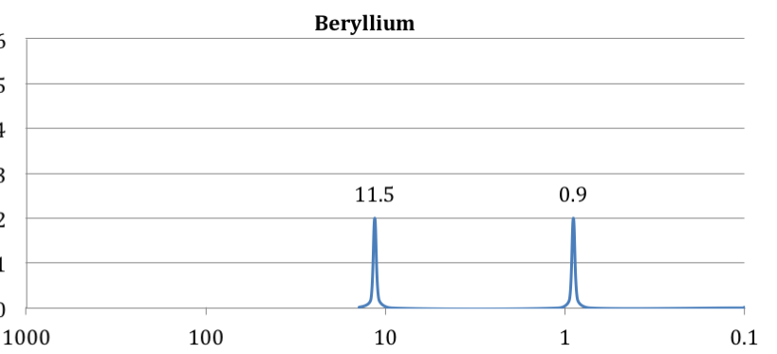 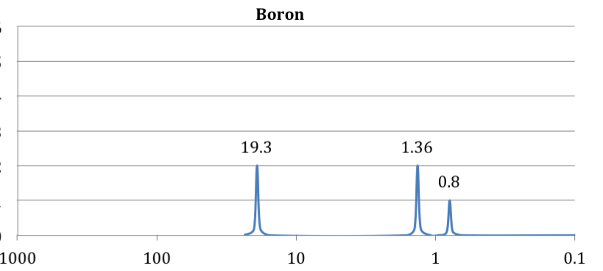

**EVEN MORE PRACTICE! Hard work now during the chapter will set you up for success and save you time long term! Make smart, mature choices!**

1. Consider doing some of the Honors Chem worksheets! *(You would be surprised how many AP Chem students miss points on exams for Honors level questions and not even the AP level questions! You will hear me all year long saying “don’t lose points in AP Chem for Honors level material!”*) [www.mychemistryclass.net/HCrainbowpacket2NEW.html](http://www.mychemistryclass.net/HCrainbowpacket2NEW.html)  
   <https://mychemistryclass.net/HCrainbowpacket3.html>
2. *A picture containing pattern, square, pixel

   Description automatically generated*Read, take notes, try some problems from your Tro online Textbook. *(Remember that the textbook often covers more material than we need for this class. If it isn’t something I talked about in my lectures/handouts/ worksheets, then you can skip it! I won’t officially assign reading or problems from the textbook because it isn’t a very efficient way to teach this class, but some students might need to read the textbook sections, or do extra practice in order for things to “click” differently for them. That is ok! Not everyone is going to need the same amount or type of studying. A lot of this class is figuring out what you personally need to do in order to feel successful. You will have access to the textbook all year, don’t forget about it!)*   
   Chapter 2: Atoms and Elements Chapter 7: The Quantum Mechanical Model  
   Chapter 8: Periodic Properties of the Elements [mlm.pearson.com/northamerica/masteringchemistry/](https://mlm.pearson.com/northamerica/masteringchemistry/)
3. Don’t forget there is extra practice on class website too! AP Chem Tab 🡪 Study Materials Link 🡪 Scroll to chapter we are on 🡪 Extra Study Materials Link. *(I don’t always have answer keys for the extra materials. If there is one, it will be in the folder!)*
4. Don’t forget that there is extra practice on GoFormative too! [www.goformative.com](http://www.goformative.com)   
   *(Another teacher made some assignments on GoFormative the year the school was Remote due to Covid. I have not proofread all the remote assignments, but I have published them so they are available for you to try if you would like!*
5. Don’t forget that there is extra practice on AP Classroom too! <https://myap.collegeboard.org>   
   *(AP Classroom is a bit clunky, doesn’t allow me to easily post questions in the order we go, sometimes crashes, still has old material we no longer cover, etc. BUT it is a source of questions that we know came from College Board! You can use the “tags” I made to pull up practice that is just on the chapter you are interested in studying.)*
6. ScienceGeek.net has some good online practice tests. I haven’t checked all of them, but the ones I have checked are pretty good! <https://www.sciencegeek.net/APchemistry/APtaters/directory.shtml>
7. Don’t forget that you can sign up for my Access periods! You must sign up by Tuesday 8am of the week you want to attend. The links are on the front page of my class website and at the top of my Class Calendar.
8. Don’t forget that our school has free peer tutoring available through the Academic Leadership class! The links   
   are on the top of my Class Calendar.