**Dougherty Valley HS AP Chemistry**

**WORKSHEET #8\***

**Atomic Structure – Extra Photoelectron Spectroscopy more**

**Name: Date: Period: Seat #:**

**Directions**: Any worksheet that is labeled with an * means it is suggested extra practice. We do not always have time to assign every possible worksheet that would be good practice for you to do. You can do this worksheet when you have extra time, when you finish something early, or to help you study for a quiz or a test. If and when you choose to do this Extra Practice worksheet, please do the work on binder paper. You will include this paper stapled into your Rainbow Packet when you turn it in, even if you didn’t do any of this. We want to make sure we keep it where it belongs so you can do it later if you want to (or need to). If you did the work on binder paper you can include that in your Rainbow Packet after this worksheet. If we end up with extra class time then portions of this may turn into required work. If that happens you will be told which problems are turned into required. Remember there is tons of other extra practice on the class website…and the entire internet! See me if you need help finding practice on a topic you are struggling with.

Show all work

Question: Do all electrons in the same level have the same energy?

One important conclusion we reached based on the first ionization energy experimental data is that electrons in higher shells require less energy to remove the electron. We have experimental data that relates energy required to remove an electron depending on the shell the electron occupies. (An electron in which shell requires more energy to remove? An electron in the second shell or the fourth shell?) An interesting question we could ask, that can not be answered from the experimental data of the first ionization energy is, do all electrons in the same shell require the same amount of energy to remove? We can answer this question if we look at photoelectron spectroscopy (PES) data for the atoms.

In a photoelectron spectroscopy experiment any electron can be ionized when the atom is excited. Like the first ionization only one electron is removed from the atom, however in this experiment it can be any electron, not just the electron that requires the least amount of energy.

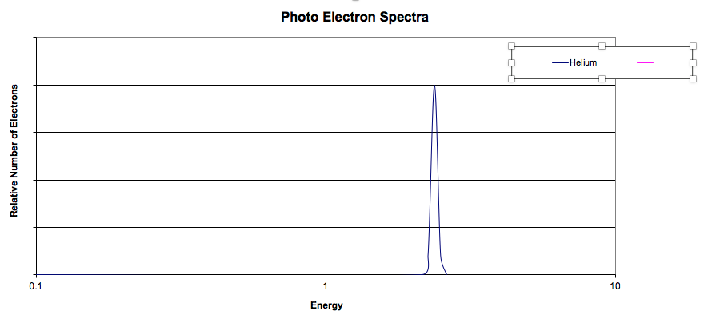

|  |
| --- |
| 1. The label on the x-axis is energy and the units are in megajoules. What is the label on the y-axis? |
| 2. What is interesting about the photoelectron spectrum for hydrogen and the first ionization  energy for hydrogen? |
| 3. Helium is next, but before looking at its photoelectron spectrum; |
| a. how many electrons does helium have in its first shell? |
| b. Can you predict what the PES would look like if the same amount of energy is required to remove either of the electrons? If the amount of energy required to remove either electron is different? |

|  |
| --- |
| 4. Look at the PES and describe what you see and the conclusion(s) you reached? (Note: be sure to comment about the relative energy of the peak(s) in the PES for He and the PES for H.) |
|  |

|  |  |  |
| --- | --- | --- |
| 5. The next element is lithium.  a. How many electrons does lithium have and what shells do those electrons occupy? | 6. The next element is beryllium.  a. How many electrons does beryllium have and what shells do those electrons occupy? | The next element is boron.  c. How many electrons does boron have and what shells do those electrons occupy? |
| b. Before looking at the PES for lithium predict what you believe the spectrum would look  like? **Note**: you do not have to predict the exact energies of each electron but you can make  reasonable estimates based on the first ionization energy for lithium and the PES for  helium. | b. Before looking at the PES for beryllium predict what you believe the spectrum would look  like? **Note**: you do not have to predict the exact energies of each electron but you can make  reasonable estimates based on the first ionization energy for beryllium and the PES for  lithium. | d. Before looking at the PES for boron predict what you believe the spectrum would look like. |
| e. Describe the experimental PES for boron. Briefly describe how to interpret the PES for  boron. |

|  |
| --- |
| Lithium: |
|  |
| Beryllium: |
|  |
| Boron: |
|  |

Use the following [PES generator](https://drive.google.com/file/d/1f8M1QGEDVZVisXddzZLiJ9PU7M61Pt6K/view?usp=sharing) to answer the following questions. You will need download to your computer using EXCEL.

|  |
| --- |
| 7. Predict what changes in the PES you would expect to see going from carbon to neon? Look at the  PES for these second period elements. |

|  |
| --- |
| 8. Answer the following questions after looking at the PES for hydrogen through neon. |
| 1. Would you agree or disagree with the following statement? Explain. ‘The electrons in the second shell all have the same energy.’ |
| 1. How many ‘subshells’ are found in the second shell? How many ‘subshells’ are found in the first shell? |
| 1. How many electrons are in each subshell in the second shell? In the first shell? |
| d. Moving systematically from lithium to neon; |
| 1. How many electrons are in the first shell? |
| 1. what happens to the energy required to remove an electron in the first shell moving from left to right in the second period? Support your observation with a meaningful explanation. |
| 1. What happens to the energy of the electrons in the outer most shell? |

|  |
| --- |
| 9. Look at the PES for the elements in the third period (sodium – argon) and briefly describe your observations. Any surprises? Briefly explain your observations. |