Candy Chromatography
Introduction
Paper chromatography is a widely-used method of separation. It separates compounds based on differences in polarity. This activity will demonstrate the basic techniques of paper chromatography. The substance is separated in the stationary phase by the mobile phase. In this lab, the separation of food dyes used in two or more different kinds of candy is performed (this particular lab compares Skittles with M&M’s, but other candies with a hard, colored shell can also be used). By comparing the Rf values of the dyes in each of the candies, we can hypothesize that the dyes with the same Rf values are the same compound.

Purpose
The purpose of this experiment is to separate and compare dyes found in two different kinds of candy.

Materials

- 600mL beaker
- 100mL beaker
- Disposable pipette
- Wooden stir stick
- Small binder clips
- Sodium chloride, NaCl
- Rubbing alcohol
- Vinegar
- Capillary tubes
- Pencil – NOT pen
- Ruler
- Chromatography paper
- Petri dish x 2
- M&Ms
- Skittles

Procedure
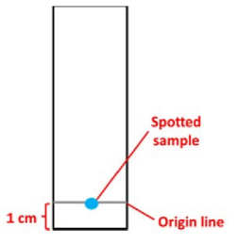
- Choose two colors of candy that you want to test – make sure the color you pick comes in both types of candy (red skittle and red M&M, orange skillet and orange M&M for example).

- Obtain a beaker, add enough vinegar to cover the bottom, and cover the beaker with plastic wrap.
- Draw a pencil line 1cm from the bottom of the chromatography paper. Use the same distance for each new paper used and for each new sample. This line will be the origin line. You will spot the candy color for each strip on this line as shown.

- Next you need to extract some dye from each candy you wish to test.
  - Fill the 100 mL beaker with some water.
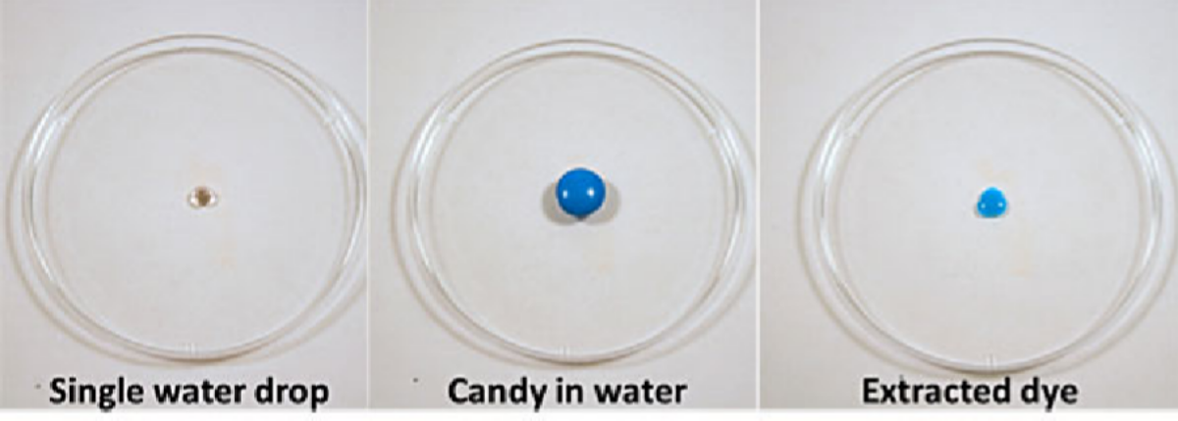
  - Use the pipette to put a SINGLE drop of water in the clean plastic plate/lid as shown in the figure below. Set one candy in the drop of water.
    - TIP – if you use too much water, the dye will not be concentrated enough to see on the chromatography strip.
  - Leave the candy in the drop of water for three minutes to allow the dye to dissolve.

- Remove the candy. (DO NOT EAT IT...)
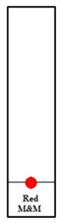
- Spot your strips:
  - Place the point of the capillary tube into the dye sample. Some solution will be drawn up. Gently and quickly touch the top of the capillary tube to the line drawn to make a spot. Allow the spot to dry.
  - Spot four more times directly on top of the first spot you made (the more times spotted, the more dye that will be available on the paper), allowing the sample to dry in between applications. Label with a pencil at the bottom of the location of each sample. See diagram.
  - Repeat steps 6 & 7 with the dye from the other candy.
- Clip 2 strips of prepared chromatography strips to a wooden splint. Make sure the two strips do not touch each other, or touch the beaker. Make sure their bottoms are aligned.

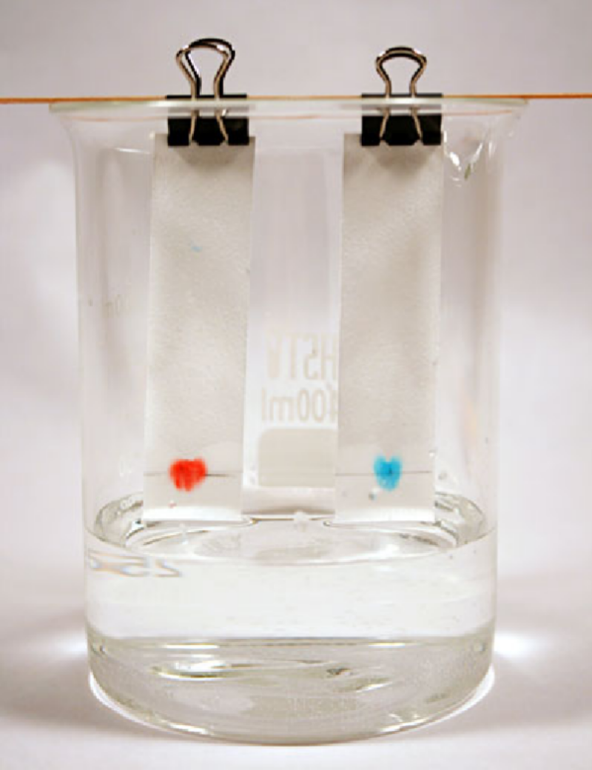
- Rest the splint on top of the beaker so that the strips hang straight into the beaker. The spots should NOT be in the vinegar. Cover the beaker with plastic wrap. The goal is to have the end of the chromatography strips just touching the surface of the solvent solution as shown in the diagram.

- Allow the chromatogram to develop until the solvent (vinegar) is about 0.5 cm from the top. Keep a close eye on your chromatography strip and the solvent front- if you let it run too long the dye may run off the paper and become distorted.

- Remove the sample from the beaker and allow it to stand upright. In our tests, we found that the vinegar continued to advance up the paper for about another two minutes, after being removed from the solvent. Draw a line across the paper at the furthest point of the solvent’s progression.

- Draw the chromatogram in the data section, measure the distance travelled by the solvent in Step 7 and the approximate center point of each dye used. To find the approximate center point, draw a circle that surrounds the specific color dye (red, yellow, orange, etc). The center of the circle is the approximate center point. Calculate an Rf value for each observed color dye contained in the sample.
Rf = distance from the origin (starting line) to center of spot
distance from the origin to solvent front (line from step

- Depending on time, and supplies available, you may retry the experiment with:
  - Different color candies
  - Plain water instead of vinegar as the solvent
  - Salt water instead of vinegar as the solvent (1 gram NaCl, to 1 L of water – you don’t need to make an entire liter, but that is the ratio you should use).

Data Table and Calculations
For each completed chromatography strip - sketch and color the chromatography strips for each completed dye. Make sure to label what type of candy, what component colors were present in the dye, and what the Rf value was for each component color in the dye. Make sure to show the calculation for each Rf value found.
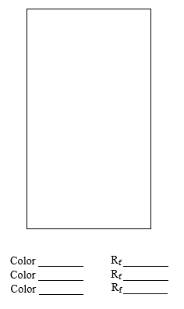
Data Analysis
- Make a pie chart for each candy type and color. The pie chart should show the number of component colors (one wedge per color), the color of each component (label and color each wedge appropriately), and the Rf value for each component (part of the wedge’s label).
- Compare the Rf values for the candy colors. Are there any food dye colors that are common between types of candy and/or colors of candy? What do you notice about the number and combinations of colors in each type and color candy (think back to art class – primary colors mix to make secondary colors!).
- Look at the ingredients on the packaging to see which food dyes may have been used. Do you see any that match between the two types of candies? (Note – it is possible that other components in the candies may affect how well the food coloring dyes travel through the paper. Why do you think this might be?)

