N21 – Formal Charge and VSEPR  
  


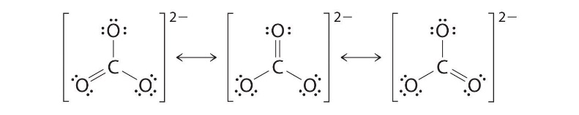

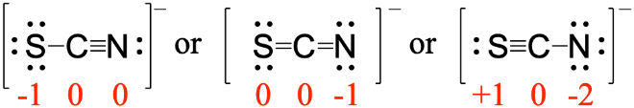

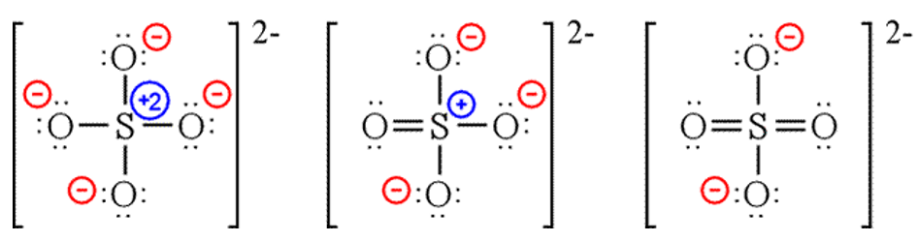

|  |  |  |
| --- | --- | --- |
| **X + E** | **Overall Structure**  **(Electronic Geometry)** | **Forms** |
| **2** | **Linear** | **AX2** |
| **3** | **Trigonal Planar** | **AX3, AX2E** |
| **4** | **Tetrahedral** | **AX4, AX3E, AX2E2** |
| **5** | **Trigonal bipyramidal** | **AX5, AX4E, AX3E2, AX2E3** |
| **6** | **Octahedral** | **AX6, AX5E, AX4E2** |

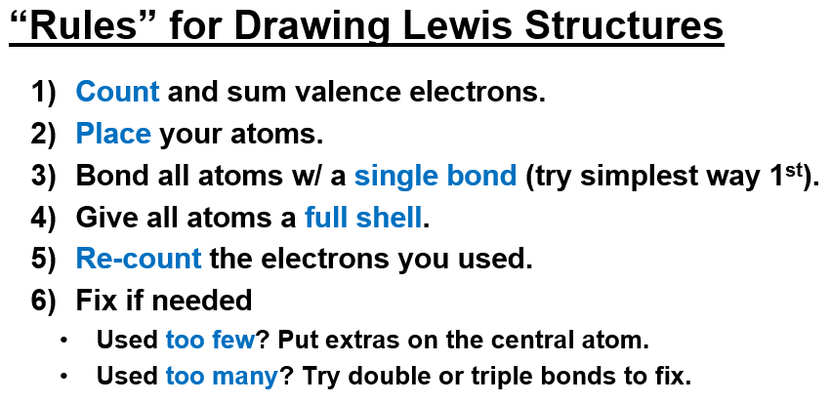

N21 – Formal Charge and VSEPR









|  |  |  |
| --- | --- | --- |
| **X + E** | **Overall Structure**  **(Electronic Geometry)** | **Forms** |
| **2** | **Linear** | **AX2** |
| **3** | **Trigonal Planar** | **AX3, AX2E** |
| **4** | **Tetrahedral** | **AX4, AX3E, AX2E2** |
| **5** | **Trigonal bipyramidal** | **AX5, AX4E, AX3E2, AX2E3** |
| **6** | **Octahedral** | **AX6, AX5E, AX4E2** |



N21 – Formal Charge and VSEPR









|  |  |  |
| --- | --- | --- |
| **X + E** | **Overall Structure**  **(Electronic Geometry)** | **Forms** |
| **2** | **Linear** | **AX2** |
| **3** | **Trigonal Planar** | **AX3, AX2E** |
| **4** | **Tetrahedral** | **AX4, AX3E, AX2E2** |
| **5** | **Trigonal bipyramidal** | **AX5, AX4E, AX3E2, AX2E3** |
| **6** | **Octahedral** | **AX6, AX5E, AX4E2** |

