N23 - Hybridization

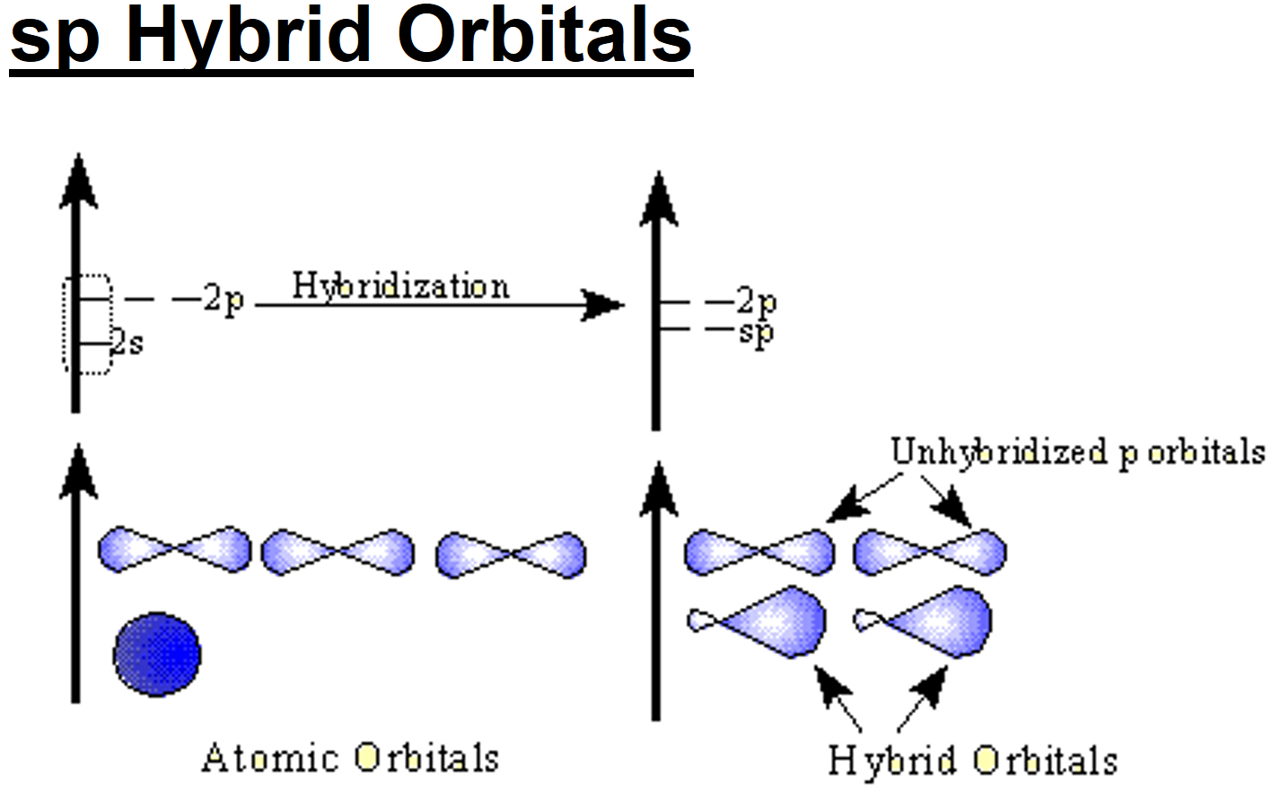

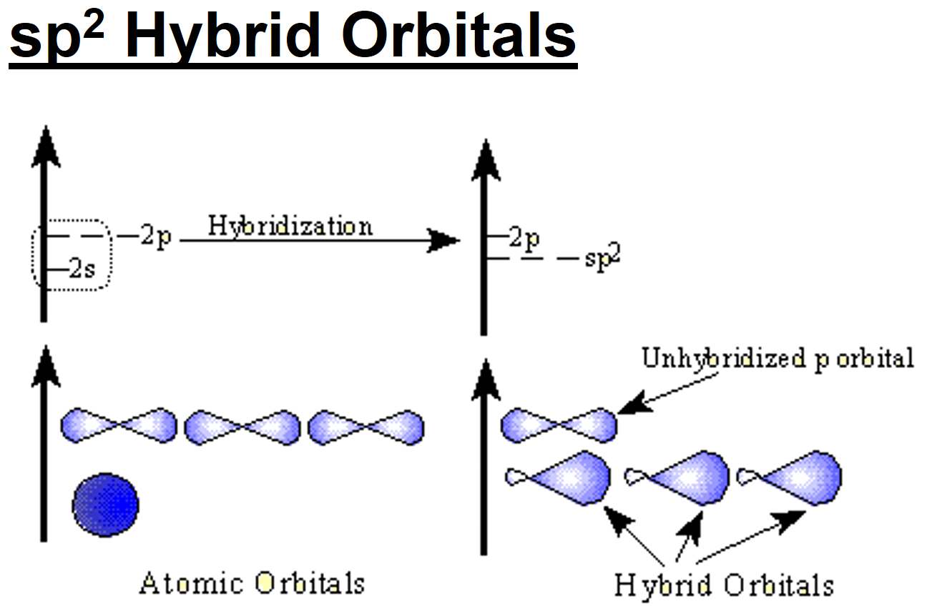

N23 - Hybridization

N23 - Hybridization

N23 - Hybridization

N23 - Hybridization

N23 - Hybridization

