**Name: Period: Seat#:**

**Worksheet #10**

**Directions:** Show all work in a way that would earn you credit on the AP Test! This is always the rule! Some answers are provided at the end of the worksheet.

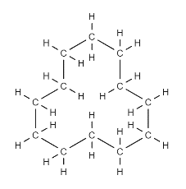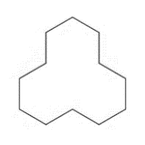

Hint C12H24 is a weird molecule. It looks like this, with all single bonds

**Takes to break = +**

**Free to Form = -**

|  |
| --- |
| 1. Considering bonds broken and formed ONLY, what is the enthalpy change for the following reaction:   **C40H82 🡪 C16H34 + 2C12H24** |
| 1. The rxn **BBr3(g) + BCl3(g) 🡪 BBr2Cl(g) + BCl2Br(g)** has a ΔH very close to zero. Explain why ΔH is so small. |
| 1. Determine the enthalpy of reaction for the following using bond energies.   **H2(g) + ½ O2(g) 🡪 H2O(g) ΔH = −246 kJ** |
| 1. Ammonia reacts with oxygen to form nitrogen dioxide and steam, as follows. Use data for bond energies to determine the bond energy of the N−O bond of NO2 (Hint N-O bond has resonance. Just do the AVERGE N-O, assume all bonds are equal)   **4NH3(g) + 7O2(g) 🡪 4NO2(g) + 6H2O(g) ΔH = −1135 kJ** |
| 1. Determine the enthalpy of the following reaction using bond energies:   CH3CH=CH2 + 4.5 O=O **🡪** 3 O=C=O + 3 H−O−H |
| 1. Determine the enthalpy for the following reaction: **C(s) + CO2(g) 🡪 2CO(g)**   The enthalpy of sublimation of  graphite, C(s) is 719 kJ/mol |
| 1. Calculate the bond dissociation energy for one mole of O−F bonds, given the following data. (Hint: oxygen is the central atom of OF2)   **F2(g) + ½ O2(g) 🡪 OF2 (g) ΔH = 28 kJ** |
| 1. Using bond enthalpy (in kJ mol-1) values, determine the heat of formation of methane:   Sublimation energy of  C (s, gr) = 719 kJ/mol |
| 1. An unknown gas, X2, which behaves much like nitrogen gas (N≡N), is analyzed and the following enthalpies of formation are obtained. The X−H bond energy is known to be 383 kJ/mol. Use this information to estimate the X−X single-bond energy in the X2H4 molecule. (Hint Write a rxn forming X2H4 to start)   X(g) = 412 kJ/mol  H(g) = 217 kJ/mol  X2H4(g) = 3 kJ/mol |

**Answers** (Remember that answers for this topic vary greatly if not using the same bond enthalpy data charts! Not a big deal. Use my numbers when given so that your answers will match)

1. 0 KJ/mol
2. Breaking and making same number of same type of bonds
3. -243 KJ/mol
4. 467 KJ/mol
5. -1905 KJ/mol
6. 173 KJ/mol
7. 187 KJ/mol
8. -61 KJ/mol
9. 157 KJ/mol