Name: Period: Seat#:
Worksheet #6

Directions:
ATTACH BINDER PAPER TO THE BACK SHOWING THAT YOU ACTUALLY DREW THE STRUCTURES!!!!!
- For each of the following molecules, determine the number of lone pairs and bonded pairs around the central atom. What is the steric number based on this?
- Describe the structure according to the number of “regions of electron density.”
In other words – what is the Electron Geometry?
- Rename the shape you see based on the bonded atoms. In other words – what is the Molecular Geometry?
- Estimate the angle between the atoms attached to the central atom.

Molecule | # of Lone Pairs | # of Bond Pairs | Steric # | Electron Geometry  (the “generic” one that  includes lone pairs) | Molecular Geometry  (the “specific” one based on the atoms. If in doubt, always give Molec. Geo!) | Angle between bonds
BeCl₂
CH₄
NH₃
H₂O
PCl₅
BF₃
PBr₃
SI₂
SF₆
HCN

Directions: Fill out the following chart. For your examples of molecules and polyatomic ions, please only choose from the following:
CO₂ | ClF₃ | PF₃ | SF₂ | SO₂ | XeF₂
CF₄ | ClF₅ | PF₅ | SF₄ | SO₃ | XeF₄
 |  |  | SF₆
Br₃⁻ | ClO₂⁻ | NO₂⁺ | PF₄⁻ | SO₄²⁻
 | ClO₃⁻ | NO₂⁻ | PF₆⁻ | SF₅⁺
 | ClF₄⁻ | NO₃⁻

Bonding Domains around central atom | Nonbonding Domains around central atom | Total # e-Domains around central atom | Electron Domain Geometry | Molecular Geometry | Example of a Molecule | Example of Polyatomic Ion | Total Number of Valence Electrons
2 | 0 | 2 | linear
3 | 0 | 3 | trigonal  planar
2 | 1 | 3 | trigonal  planar
4 | 0 | 4 | tetrahedral
3 | 1 | 4 | tetrahedral
2 | 2 | 4 | tetrahedral
5 | 0 | 5 | trigonal  bipyramidal
4 | 1 | 5 | trigonal bipyramidal
3 | 2 | 5 | trigonal bipyramidal |  |  | N/A
2 | 3 | 5 | trigonal  bipyramidal
6 | 0 | 6 | octahedral
5 | 1 | 6 | octahedral |  |  | N/A
4 | 2 | 6 | octahedral

Directions: Determine the total number of valence electrons for each molecule or polyatomic ion below.

Formula | # Valence e- |  | Lewis Structure | # Valence e- |  | Lewis Structure | # Valence e-
CO₂ |  |  | 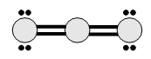 |  |  | 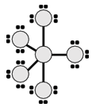
CF₄
ClF₃ |  |  | 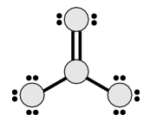
ClF₅ |  |  |  |  |  | 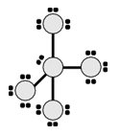
PF₃
PF₅ |  |  | 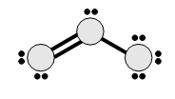
SF₂ |  |  |  |  |  | 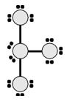
SF₄ |  |  | 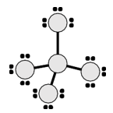
SF₆
SO₂ |  |  |  |  |  | 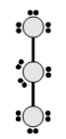
SO₃ |  |  | 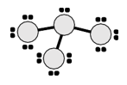
XeF₂
XeF₄ |  |  | 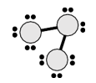 |  |  | 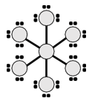
Br₃⁻
ClO₂⁻
ClO₃⁻ |  |  |  |  |  | 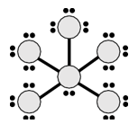
ClF₄⁻
NO₂⁺
NO₂⁻ |  |  |  |  |  | 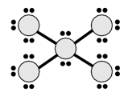
NO₃⁻
PF₄⁻
PF₆⁻
SO₄²⁻
SF₅⁺

Directions: Identify the number of bonding and nonbonding domains around the central atom, and identify the name of the molecular geometry shape.

Molecule | # of Bonding Domains around central atom | # of Nonbonding Domains around central atom | Name of Molecular Geometry shape |  | Molecule | # of Bonding Domains around central atom | # of Nonbonding Domains around central atom | Name of Molecular Geometry shape
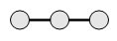 |  |  |  |  | 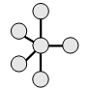
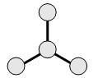 |  |  |  |  | 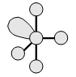
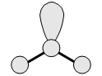 |  |  |  |  | 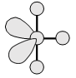
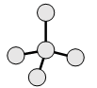 |  |  |  |  | 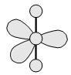
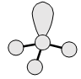 |  |  |  |  | 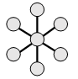
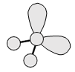 |  |  |  |  | 
 |  |  |  |  | 