**Dougherty Valley HS Chemistry Summary of Molecular Geometry**

**Name**: **Per**: **Seat #**:

WORKSHEET #6a

In the “Molecular Geometry” column, write one the following molecular shapes in the appropriate spot in the table. Note that some terms may be used more than once.

|  |  |  |  |
| --- | --- | --- | --- |
| bent | seesaw | T-shaped | trigonal bipyramidal |
| linear | square planar | tetrahedral | trigonal pyramidal |
| octahedral | square pyramidal | trigonal planar |  |

In the “Example of a Molecule” column, write one of the following chemical formulas in the appropriate spot in the table.

|  |  |  |  |  |  |
| --- | --- | --- | --- | --- | --- |
| CO2 | ClF3 | PF3 | SF2 | SO2 | XeF2 |
| CF4 | ClF5 | PF5 | SF4 | SO3 | XeF4 |
|  | | | SF6 |  | |

In the “Example of a Polyatomic Ion” column, write one of the following chemical formulas in the appropriate spot in the table.

|  |  |  |  |  |
| --- | --- | --- | --- | --- |
| –  Br3 | –  ClO2 | +  NO2 | –  PF4 | 2–  SO4 |
|  | –  ClO3 | –  NO2 | –  PF6 | +  SF5 |
| –  ClF4 | –  NO3 |  | |

In the “Total Number of Valence Electrons” column, write one of the following numbers in the appropriate spot in the table.

16 18 20 22 24 26 28 32 34 36 40 42 48

|  |  |  |  |  |  |  |  |
| --- | --- | --- | --- | --- | --- | --- | --- |
| Bonding Domains around central atom | Nonbonding Domains around central atom | Total # of Electron Domains around  central atom | Electron Domain Geometry | Molecular Geometry | Example of a Molecule | Example of a Polyatomic Ion | Total Number  of Valence Electrons |
| 2 | 0 | 2 | linear |  |  |  |  |
| 3 | 0 | 3 | trigonal planar |  |  |  |  |
| 2 | 1 | 3 | trigonal planar |  |  |  |  |
| 4 | 0 | 4 | tetrahedral |  |  |  |  |
| 3 | 1 | 4 | tetrahedral |  |  |  |  |
| 2 | 2 | 4 | tetrahedral |  |  |  |  |
| 5 | 0 | 5 | trigonal  bipyramidal |  |  |  |  |
| 4 | 1 | 5 | trigonal bipyramidal |  |  |  |  |
| 3 | 2 | 5 | trigonal bipyramidal |  |  | N/A |  |
| 2 | 3 | 5 | trigonal  bipyramidal |  |  |  |  |
| 6 | 0 | 6 | octahedral |  |  |  |  |
| 5 | 1 | 6 | octahedral |  |  | N/A |  |
| 4 | 2 | 6 | octahedral |  |  |  |  |

Use the periodic table to determine the total number of valence electrons for each molecule or polyatomic ion.

|  |  |
| --- | --- |
| Chemical Formula | Total Number of Valence Electrons |
| CO2 |  |
| CF4 |  |
| ClF3 |  |
| ClF5 |  |
| PF3 |  |
| PF5 |  |
| SF2 |  |
| SF4 |  |
| SF6 |  |
| SO2 |  |
| SO3 |  |
| XeF2 |  |
| XeF4 |  |

|  |  |
| --- | --- |
| Chemical Formula | Total Number of Valence Electrons |
| –  Br3 |  |
| –  ClO2 |  |
| –  ClO3 |  |
| –  ClF4 |  |
| +  NO2 |  |
| –  NO2 |  |
| –  NO3 |  |
| –  PF4 |  |
| –  PF6 |  |
| 2–  SO4 |  |
| +  SF5 |  |

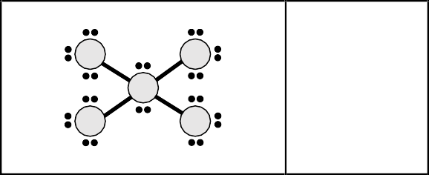Write the total number of valence electrons for each of the following Lewis dot structures.

|  |  |
| --- | --- |
| Lewis Dot Structure | Total Number  of Valence Electrons |
|  |  |
|  |  |
|  |  |
|  |  |
|  |  |
|  |  |

|  |  |
| --- | --- |
| Lewis Dot Structure | Total Number  of Valence Electrons |
|  |  |
|  |  |
|  |  |
|  |  |
|  |  |
|  |  |

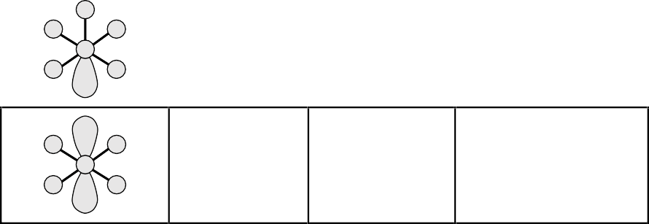For each type of molecular geometry, identify the number of bonding and nonbonding domains around the central atom. In addition, write the name of the molecular shape.

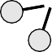

|  |  |  |  |
| --- | --- | --- | --- |
|  | Bonding | Nonbonding |  |
| Molecular Geometry | Domains around central | Domains around central | Name of Molecular Shape |
|  | atom | atom |  |
|  |  |  |  |
|  |  |  |  |
|  |  |  |  |
|  |  |  |  |
|  |  |  |  |
|  |  |  |  |

|  |  |  |  |
| --- | --- | --- | --- |
|  | Bonding | Nonbonding |  |
| Molecular Geometry | Domains around central | Domains around central | Name of Molecular Shape |
|  | atom | atom |  |
|  |  |  |  |
|  |  |  |  |
|  |  |  |  |
|  |  |  |  |
|  |  |  |  |
|  |  |  |  |