**Dougherty Valley HS AP Chemistry**

**WORKSHEET #7**

**Bonding – FRQ’s**

**Name: Date: Period: Seat #:**

[1] Answer the following questions about the structures of ions that contain only sulfur and fluorine.

(a) The compounds SF4 and BF3 react to form an ionic compound according to the following equation.

SF4 + BF3 ® SF3BF4

(i) Draw a complete Lewis structure for the SF3+ cation in SF3BF4.

(ii) Identify the type of hybridization exhibited by sulfur in the SF3+ cation.

(iii) Identify the geometry of the SF3+ cation that is consistent with the Lewis structure drawn in part (a)(i).

(iv) Predict whether the F—S—F bond angle in the SF3+ cation is larger than, equal to, or smaller than 109.50˚. Justify your answer.

(b) The compounds SF4 and CsF react to form an ionic compound according to the following equation.

SF4 + CsF ® CsSF5

(i) Draw a complete Lewis structure for the SF5– anion in CsSF5.

(ii) Identify the type of hybridization exhibited by sulfur in the SF5– anion.

(iii) Identify the geometry of the SF5– anion that is consistent with the Lewis structure drawn in part (b)(i).

(iv) Identify the oxidation number of sulfur in the compound CsSF5.

[2] Answer each of the following in terms of principles of molecular behavior and chemical concepts.

(a) The structures for glucose, C6H12O6, and cyclohexane, C6H12, are shown below.

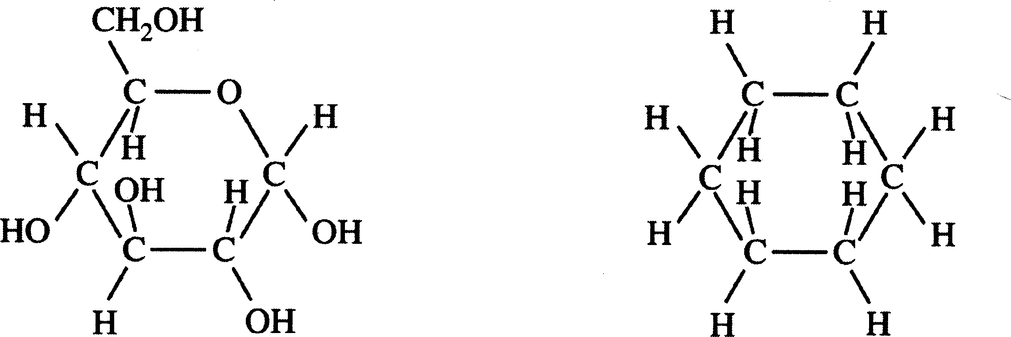

Identify the type(s) of intermolecular attractive forces in

(i) pure glucose

(ii) pure cyclohexane

(b) Glucose is soluble in water but cyclohexane is not soluble in water. Explain.

(c) Consider the two processes represented below.

Process 1: H2O*(l)* ® H2O*(g)* ∆*H*˚ = +44.0 kJ mol-1

Process 2: H2O*(l)* ® H2*(g)* +  O2*(g)* ∆*H*˚ = +286 kJ mol-1

(i) For each of the two processes, identify the type(s) of intermolecular or intramolecular attractive forces that must be overcome for the process to occur.

(ii) Indicate whether you agree or disagree with the statement in the box below. Support your answer with a short explanation.

When water boils, H2O molecules break apart to form hydrogen molecules and oxygen molecules.

(d) Consider the four reaction-energy profile diagrams shown below.

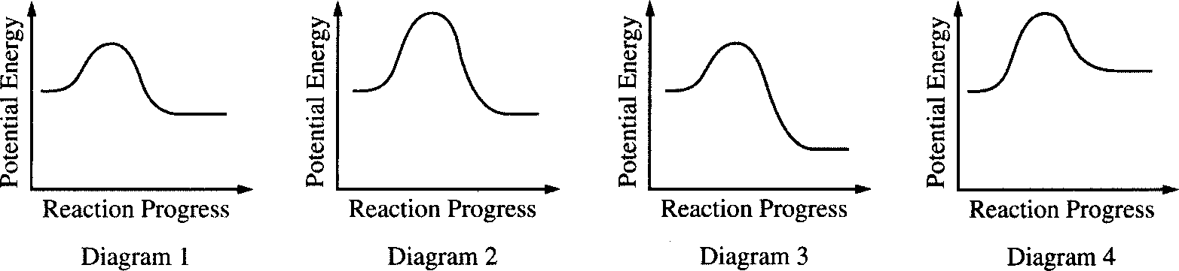

(i) Identify the two diagrams that could represent a catalyzed and an uncatalyzed reaction pathway for the same reaction. Indicate which of the two diagrams represents the catalyzed reaction pathway for the reaction.

(ii) Indicate whether you agree or disagree with the statement in the box below. Support your answer with a short explanation.

[3] Use principles of atomic structure, bonding and/or intermolecular forces to respond to each of the following. Your responses must include specific information about all substances referred to in each question.

(a) At a pressure of 1 atm, the boiling point of NH3*(l)* is 240 K, whereas the boiling point of NF3*(l)* is 144 K.

(i) Identify the intermolecular forces(s) in each substance.

(ii) Account for the difference in the boiling points of the substances.

(b) The melting point of KCl*(s)* is 776˚C, whereas the melting point of NaCl*(s)* is 801˚C.

(i) Identify the type of bonding in each sub­stance.

(ii) Account for the difference in the melting points of the substances.

(c) As shown in the table below, the first ionization energies of Si, P, and Cl show a trend.

|  |  |
| --- | --- |
| Element | First Ionization Energy (kJ mol-1) |
| Si | 786 |
| P | 1012 |
| Cl | 1251 |

(i) For each of the three elements, identify the quantum level (e.g., *n* =1, *n* = 2, etc.) of the valence electrons in the atom.

(ii) Explain the reasons for the trend in the first ionization energy.

(d) A certain element has two stable isotopes. The mass of one of the isotopes is 62.93 amu and the mass of the other isotope is 64.93 amu.

(i) Identify the element. Justify your answer.

(ii) Which isotope is more abundant? Justify your answer.

[4] Answer the following questions that relate to chemical bonding

1. In the boxes provided, draw the complete Lewis structure (electron-dot diagram) for each of the three molecules represented below.

|  |  |  |
| --- | --- | --- |
| CF4 | PF5 | SF4 |

(b) On the basis of the Lewis structures drawn above, answer the following questions about the particular molecule indicated.

(i) What is the F-C-F bond angle in CF4?

(ii) What is the hybridization of the valence or­bitals of P in PF5?

(iii) What is the geometric shape formed by the atoms in SF4?

(c) Two Lewis structures can be drawn for the OPF3 molecule, as shown below.



Structure 1 Structure 2

(i) How many sigma bonds and how many pi bonds are in structure 1?

(ii) Which one of the two structures best repre­sents a molecule of OPF3? Justify your an­swer in terms of formal charge.

[5] Use appropriate chemical principles to account for each of the following observations. In each part, your response must include specific information about both substances.

(a) At 25˚ C and 1 atm, F2 is a gas whereas I2 is a solid.

(b) The melting point of NaF is 993˚ C, whereas the melting point of CsCl is 645˚.

(c) The shape of ICl4– ion is square planar, whereas the shape of BF4– ion is tetrahedral.

(d) Ammonia, NH3, is very soluble in water, whereas phosphine, PH3, is only moderately soluble in water.

**ANSWERS**

[1](a) i. 

(ii) sp3.

(iii) pyramidal

(iv) smaller than 109.50˚. The lone pair of unbonded electrons occupies more space than the bonded pairs and, therefore, pushed the bonded pairs away and hence, a smaller bond angle than a perfect tetrahedron.

(b)i. 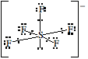

(ii) sp3d2

(iii) square pyrimidal

(iv) S = +4

[2]

(a)

|  |  |  |  |
| --- | --- | --- | --- |
|  | London dispersion forces | polar attractions | hydrogen bonding |
| (i) pure glucose | + | + | + |
| (ii) pure cyclohexane | + | – | – |

(b) The hydroxyl groups (–OH) in glucose create polar regions on the molecule, these polar regions can be attracted to the polar water molecules, allowing it to dissolve. Cyclohexane has not such structures and is non-polar and non-water soluble. Like dissolves like.

(c)i.

|  |  |  |  |  |
| --- | --- | --- | --- | --- |
|  | Intermolecular forces | | | Intramolecular forces |
|  | London dispersion forces | polar attractions | hydrogen bonding | H–O covalent bond |
| process 1 | + | + | + | – |
| process 2 | + | + | + | + |

(ii) disagree; there is not enough energy in boiling water (373 K) to break a H–O covalent bond.

(d) (i) diagrams 1 & 2; diagram 1 represents the catalyzed reaction pathway

(ii) disagree; a catalyst does not increase the temperature and, therefore, does not increase the amount of energy present in the mixture. It only provides a lower energy pathway (i.e., smaller activation energy requirement) for the reaction to occur.

[3] (i)

|  |  |  |
| --- | --- | --- |
| force | NH3 | NF3 |
| London dispersion | + | + |
| polar attraction | + | + |
| hydrogen bonding | + | - |
| ionic attraction | - | - |

(ii) the ability of ammonia to create intermolecular hydrogen bonds, leads to higher amount of energy to separate the molecules by boiling them.

(b) (i) both compounds have ionic bonding

(ii) the sodium ion in NaCl is a smaller size than the corre­sponding potassium ion in KCl. This smaller size creates a larger charge density and greater ion Coulombic attraction in the NaCl, making it harder to melt.

(c) (i) Si, n = 3; P, n = 3; Cl, n = 3

(ii) in terms of atomic radius, Si > P > Cl and nuclear charge Cl > P > Si, the smaller and higher charged chlorine atom has the greatest attraction for its electrons than the other two. This means that it takes more energy to remove an electron from chlorine that the other two. The opposite is true for silicon and it should have the smallest value.

(d) (i) copper; since the atomic mass of an element is the weighted average of its natural isotopes, then the atomic mass of the element must be between 62.93 and 64.94.

(ii) 62.93; the isotope that is closer to the atom mass of the element is more abundant of the two (63.546 – 62.93 = 0.616; 64.94 – 63.546 = 1.384)

[4] (a) 

(b) (i) 109.5˚

(ii) *sp3d*

(iii) see-saw

(c) (i) 4 sigma, 1 pi

(ii) structure 1;

In structure 1, oxygen has a formal charge of 0 (6 valence electrons – 6 assigned electrons), each flu­orine is 0 (7 valence electrons – 7 assigned elec­trons), phosphorus is 0 (5 valence electrons – 5 assigned electrons),

In structure 2, oxygen has a formal charge of –1 (6 valence electrons – 7 assigned electrons), each flu­orine is 0 (7 valence electrons – 7 assigned elec­trons), phosphorus is +1 (5 valence electrons – 4 assigned electrons)

According to the electroneutrality rule, the better Lewis structure is the one with the smallest separa­tion of formal charge, *i.e.*, structure 1.

[5]

(a) F2 is a smaller & lighter molecule than I2, at the same temperature F2, on average is faster than I2. The I2 molecule has 106 electrons to the 18 of the F2 and, therefore, exhibits a greater vander Waal attraction.

(b) each ion in NaF has a smaller size than the corre­sponding ion in CsCl. This smaller size creates a larger charge density and greater ion Coulombic attraction in the NaF, making it harder to melt.

(c) The ICl4– ion contains the *sp*3*d*2 hybridization due to the expanded octet around the central iodine. The chlorides are equatorially bonded in a square around the iodine with the extra pairs of electrons along the axis. The BF4– ion has *sp*3 hybridization which characteristically has the tetrahedral shape.

(d) ammonia is a more polar molecule than phospine and can make hydrogen bonds with the solvent, water. This creates a greater solute-solvent attrac­tion and greater solubility.