Determining Melting Temperature

The melting temperature of a compound is the temperature at which it changes from a solid to a liquid. This is a physical property often used to help identify compounds or to check the purity of a compound. The melting temperature is related to the amount of kinetic energy that one adds to a solid substance to overcome the intermolecular attractions that maintain its solid state under given conditions.

It is not possible, however, to find an exact melting *point*. Being a thermodynamic process, when a substance begins to melt, a dynamic equilibrium is established within which the substance exists in both solid and liquid form. Because the energy transferred to this system is not used entirely to convert the solid to a liquid, a single temperature value cannot be given for this process, but rather a temperature *range*.

Thus, melting temperatures are usually reported as values with a range of 2–3oC. Melting temperature is not a unique physical property of a substance, but it does help you understand more about the substance. It can also help determine the purity of a substance that you have synthesized.

You will use a Vernier Melt Station to determine the melting temperature of a solid substance. Your sample will be one of several possible pure compounds. Your first trial will help you narrow your possibilities. On subsequent trials you will be able to accurately determine the melting temperature of your sample, thus identifying the compound.

OBJECTIVES

In this experiment, you will

* Prepare a solid substance for measuring melting temperature.
* Measure the temperature of a solid substance as it warms to melting.
* Analyze the temperature *vs*. time graphs to determine the rate of heating and the melting temperature of a sample of a solid organic compound.
* Identify the solid from a list of possible pure compounds.
* Rank the solids from weakest to strongest IMF

MATERIALS

|  |  |
| --- | --- |
| LabQuest or computer interface | glass capillary tubes – one closed end |
| LabQuest App or Logger *Pro* | tissues (preferably lint-free) |
| Vernier Melt Station | sample of an organic solid |
|  | mortar and pestle (optional) |
| **Compounds** | **Melting Temperature (°C)** |
| Palmitic acid | 61 – 63 |
| Oxalic acid | 100 – 103 |
| Benzoic acid | 122 –124 |
| Maleic acid | 138 –141 |
| Dextrose | 146 –152 |
| Salicylic acid | 158 –160 |
| Tartaric acid | 168 – 172 |
| Succinic acid | 185 –187 |

PROCEDURE

1. Obtain and wear goggles.

2. Check the control dial on the Melt Station to confirm that it is in the Off position. Connect the Melt Station power supply to a powered electrical outlet.

3. Connect the Melt Station sensor cable to a computer interface.

4. Obtain a small amount of a solid organic compound. The solid should be in powder form. If it is not, use a mortar and pestle to carefully grind the solid to a powder.

5. Prepare a sample for melting.

1. Pack a capillary tube 3–4 mm (~1/8 inch) deep with your sample by inserting the open end into a small pile of the solid. A small amount of the solid will be pushed up into the tube.
2. Wipe off any loose solid that is on the outside of the capillary tube.
3. Tap the closed end of the capillary tube on the desk top to compress the sample into the closed end.
4. To further pack down the sample in the tube, drop the capillary tube (closed end down) down a section of glass tubing that has been set up for this purpose.
5. Carefully insert the capillary tube of solid into one of the three slots in the heating block of the Melt Station. You may rotate the Melt Station toward you slightly for a better look at the heating block.
6. Rotate the Melt Station up or down slightly to get the best view of the solid sample through the viewing lens.

6. Start the data-collection program, and then choose New from the File menu. You are now set up to take melting temperature data for up to 20 minutes.

7. In the first trial, you will want to observe the melting process and make a *rough estimate* of the melting temperature of your sample. Don’t worry if the heating rate is a bit too rapid, and the sample melts too quickly. To do this:

1. Start data collection.
2. On the Melt Station, turn the control knob to a setting of 180ºC. The red light will turn on indicating active heating.
3. Carefully observe your sample. If the solid begins to melt, click Mark to mark the temperature on your graph (or press the **D key on the computer**). When the entire solid has completely melted, click Mark again. The two values marked on your graph describe the estimated melting temperature range of your substance.
4. If the solid does not melt by the time the temperature gets to 150ºC, turn the control knob to the 220ºC setting. Continue observing your sample, and if the sample begins to melt, mark the temperatures on the graph as previously described.
5. If the sample has not melted by the time the temperature gets to 190ºC, turn the knob to the Rapid Heat setting. When the sample finally begins to melt, mark the graph as previously indicated.
6. When you have determined the approximate melting temperature range for the sample, stop data collection. Store the run by tapping the File Cabinet icon in LabQuest, or choosing Store Latest Run from the Experiment menu in Logger *Pro*. Discard the capillary tube and sample as directed by your instructor.
7. On the Melt Station, turn the control knob to the Fan/Cooling setting to get ready for the next trial. The blue light will turn on indicating that the fan is cooling the Melt Station.

8. Now that you have a rough idea of the melting temperature, a more accurate determination can be made. Prepare a new sample in a capillary tube, as described in Step 5, to determine the melting temperature:

1. Start data collection.
2. On the Melt Station, turn the control knob to the Rapid Heat setting.
3. Carefully observe the temperature *vs*. time graph. When the temperature is within approximately 10ºC of the lowest possible melting temperature of your sample, turn the control knob to a temperature setting corresponding to your expected melting temperature.
4. Carefully observe your sample. When the solid begins to melt, click Mark to mark the temperature on your graph. When the entire solid has completely melted, click Mark again. The two values marked on your graph describe the estimated melting temperature range of your substance. When you are finished with this step, stop data collection.
5. Store the run.
6. Discard the capillary tube and sample as directed by your instructor.
7. On the Melt Station, turn the control knob to the Fan/Cooling setting to get ready for the next trial.

9. At the end of the experiment, record the melting temperature range and turn the control knob on the Melt Station to Off.

10. Complete the Data Analysis section before exiting Logger *Pro* or the LabQuest App. Print a copy of your graph and/or save your data, as directed by your instructor.

Discussion q’s

1. What is the code number of your solid sample? What was the melting temperature range of your sample?

2. Use the list of possible compounds, provided by your instructor, to identify your sample. Also identify each sample that was used in the lab. There are 8 different samples.

3. A heating rate of 1–2°C/min is considered ideal for the most accurate determination of the melting temperature of a solid substance. Use the **Tangent tool in Logger *Pro*** or LabQuest App to determine the approximate heating rate during the time that your sample was melting.

4. Using the class set of data with melting points for each sample number, explain in detail how the IMF for each sample differs to explain the difference in melting points.

INSTRUCTOR INFORMATION

1. Many solid substances may be used for this experiment. We suggest the substances shown in the table below, but feel free to consider other compounds.

|  |  |
| --- | --- |
| Compound | Melting Temperature (°C) |
| Palmitic acid | 61 – 63 |
| Oxalic acid | 100 – 103 |
| Benzoic acid | 122 –124 |
| Maleic acid | 138 –141 |
| Dextrose | 146 –152 |
| Salicylic acid | 158 –160 |
| Tartaric acid | 168 – 172 |
| Succinic acid | 185 –187 |

2. The temperature control on the Melt Station is divided into three regions.

* The first area, nearest the Off setting, is for cooling the heating block after you have completed a melting temperature run. When the Melt Station is cooling, the fan and the blue LED will come on.
* The second area is divided into specific temperature settings, whose values represent *expected* melting temperatures. The warming rate will slow to ~1°C/min at each of these settings. You will choose one of these settings when the Melt Station has warmed to within about 10°C of the expected melting temperature of your solid sample.
* The third area is Rapid Heat. In Rapid Heat, the Melt Station will warm at a rate of >10°C/min.

3. Logger *Pro* version 3.8.4 (or newer) and LabQuest App 1.5 (or newer) have a special feature for use with the Melt Station, called a *Data Mark*. Your students will use the Data Mark feature to mark the beginning and ending of the melting temperature range of a sample.

* In Logger *Pro*, you can add text to the Mark box by double-clicking on the box and typing in the text field.
* In LabQuest App, you can add text to the Mark by tapping on the box to the right of the graph, and typing in the appropriate text field.

4. The procedure guides the student to warm the Melt Station fairly slowly to see the rough melting temperature range more easily, as well as give them practice at using the temperature control. To save some time, you may change the procedure starting with Step 7b to use only the Rapid Heat setting for the first test.

5. Logger *Pro* and the LabQuest App will display a live reading of the temperature of the Melt Station’s heating block even when the Melt Station is turned off. This is a safety feature which gives you a way to check the temperature of the Melt Station at any time.

6. The Melt Station has an internal safety timer which prevents it from being left on, in a heating mode, for longer than 60 minutes. The safety timer starts when the Melt Station’s control knob is set at any heating mode (the red LED is on). After approximately 60 minutes of running time passes, the heater will automatically shut off and the yellow LED will come on. To reset the timer, turn the control knob to the Fan/Cooling setting (the blue LED is on).

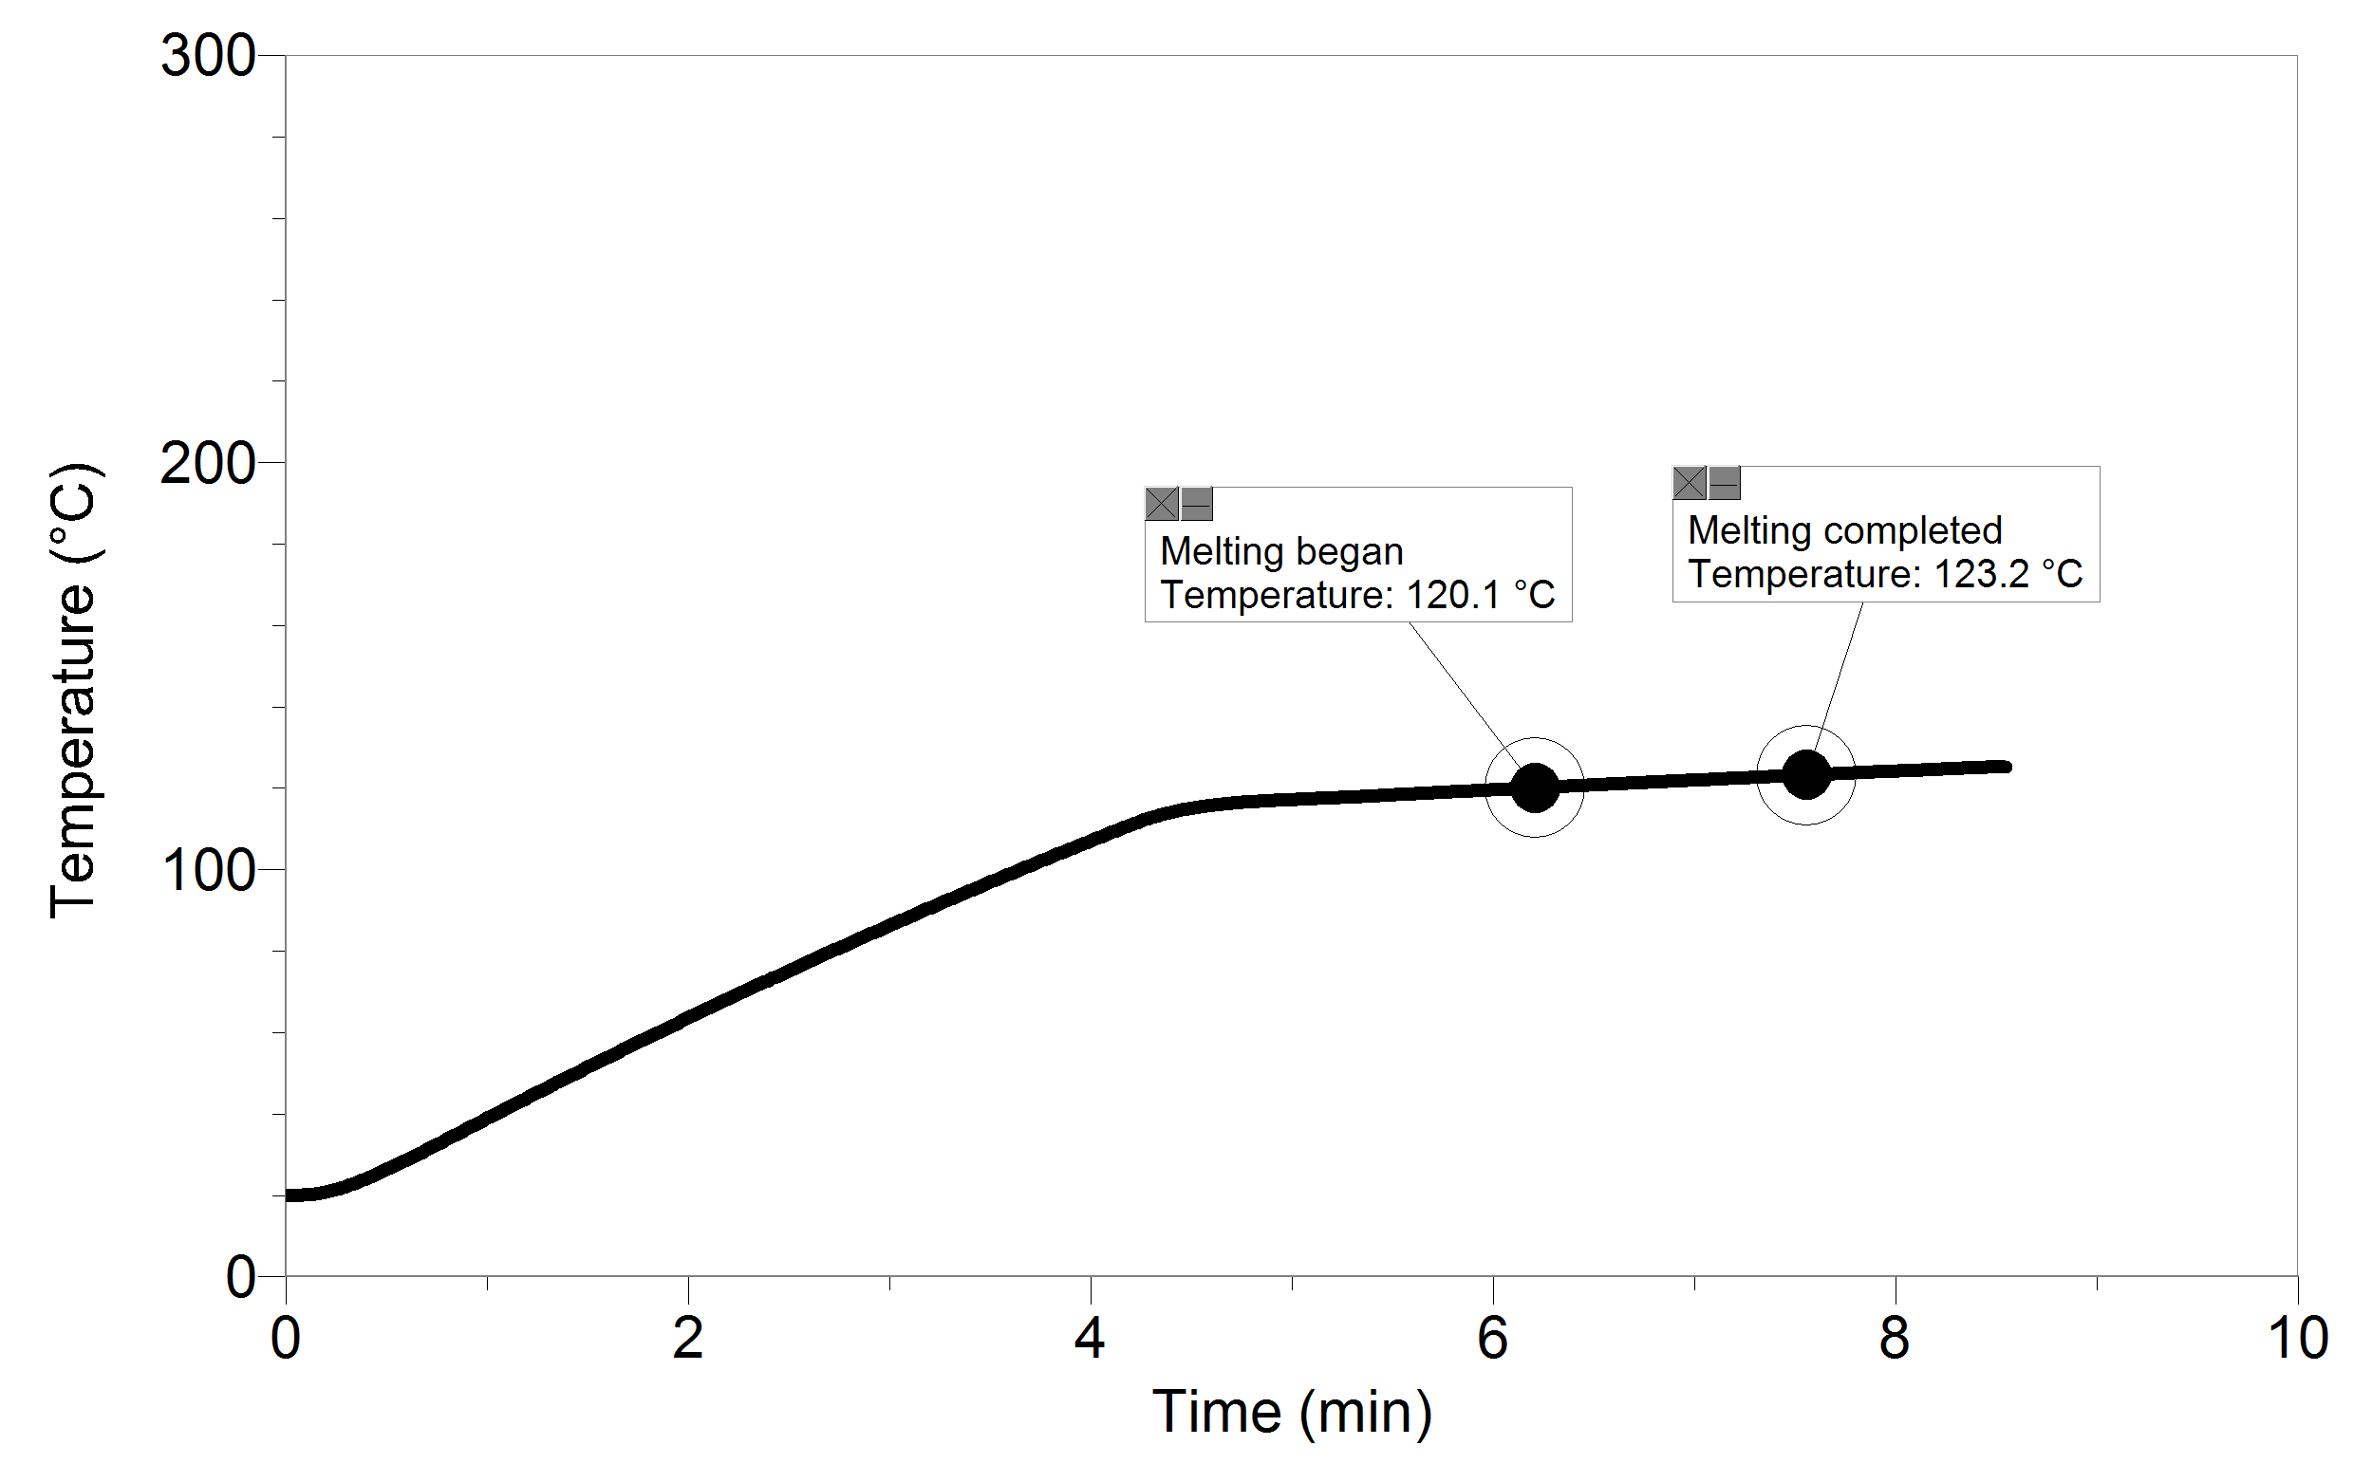Sample results

Melting temperature of an unknown solid