N27 – Gas Density and More

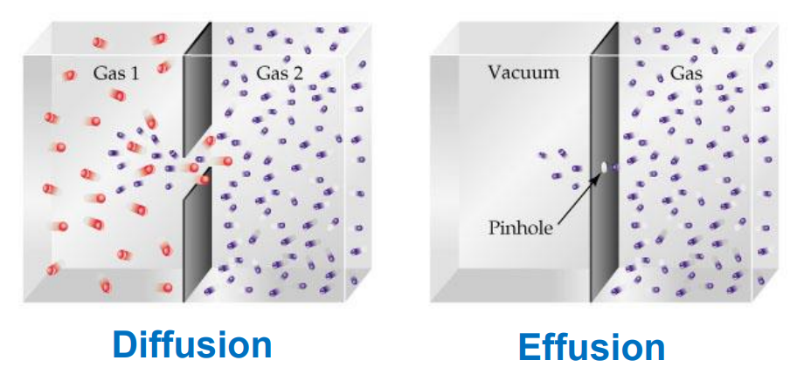 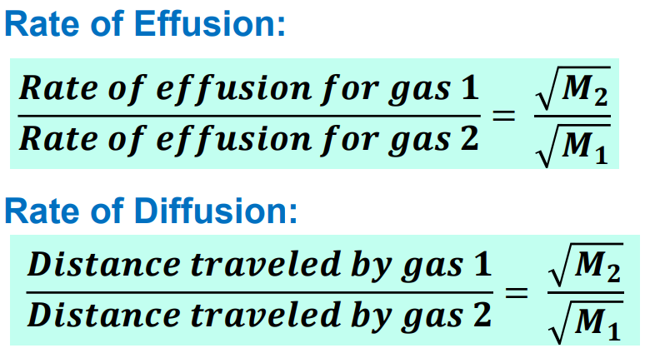 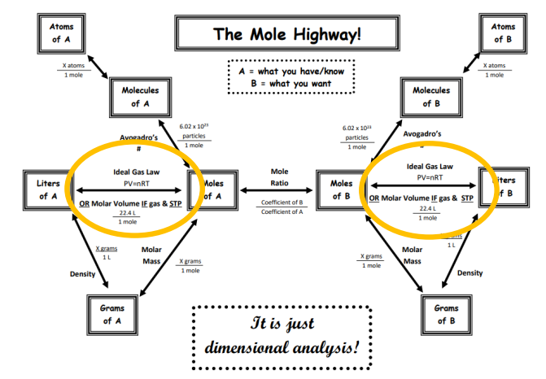

N26 – Ideal Gases and Laws

**Ideal Gas Law**

$$PV = nRT$$

**Molar Mass Kitty**

$$M= \frac{DRT}{P}$$

**Boyle’s Law**

**Charles’s Law**

**Gay-Lussac’s Law**

**Avogadro’s Law**

**Dalton’s Partial Pressure**

$$P_{total}=P_{1}+P_{2}+…$$

**Mole Fraction**

$X_{a}= \frac{n_{a}}{n_{total}}$ $P_{a}= X_{a}P_{total}$

N25 – Gases Review

**KMT = Kinetic Molecular Theory**

1. Gases consist of large numbers of tiny particles that are far apart relative to their size   
   – the volume of each gas molecule is considered negligible, they are treated as point particles.
2. Gas particles undergo elastic collisions   
   – meaning they do not lose energy when colliding.
3. Gas particles are in a constant, rapid, straight line, “chaotic” motion   
   – they possess kinetic energy (motion energy).
4. Gases are “Ideal Gases” – meaning they do not interact with each other.   
   – There are no forces of attraction or repulsion between particles.
5. The average kinetic energy of the particles is proportional to temperature   
   – (in Kelvin!!!) – T ↑, KE ↑

* There is a distribution of speeds, some go faster than others   
  so overall there is an average kinetic energy of the sample.