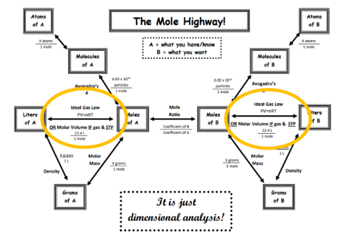N27 – Gas Density and More

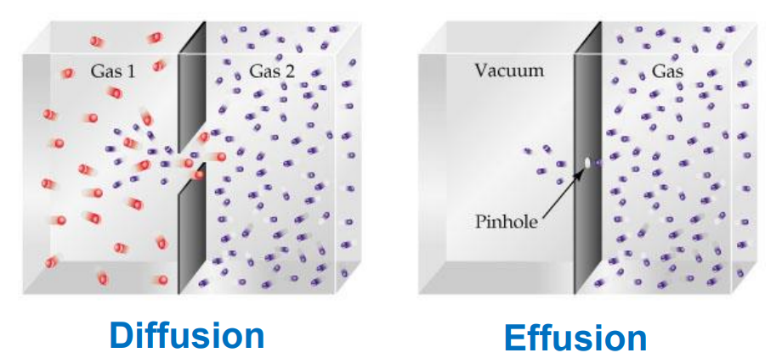 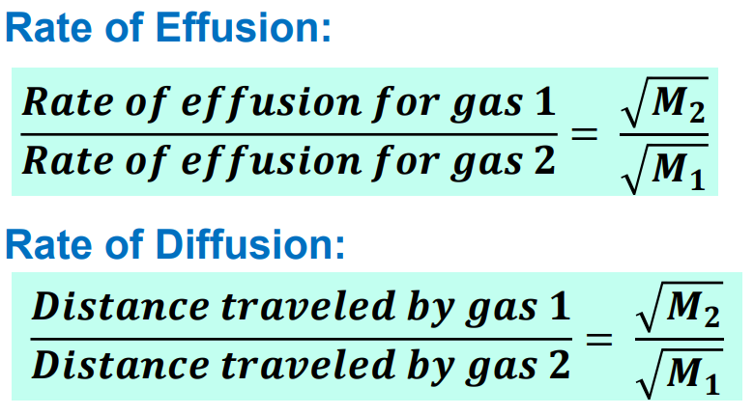

 N27 – Gas Density and More

 

 N27 – Gas Density and More

 

 N27 – Gas Density and More

 

 N27 – Gas Density and More

 