Unit 8 – IMFS – GLUE INS

N29 – Going in Depth

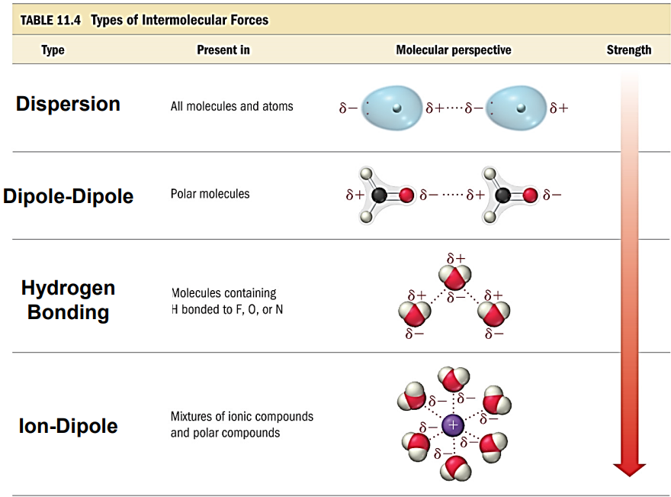

N30 – Vapor Pressure and Phase Diagrams

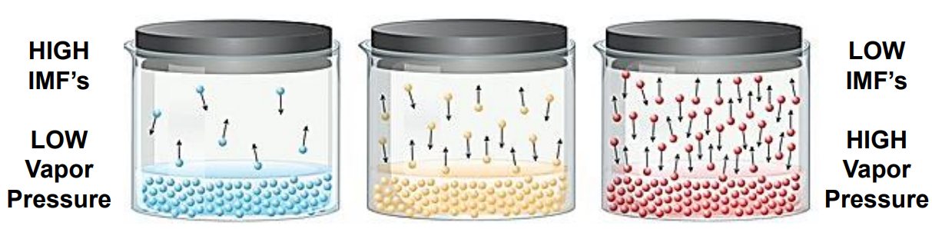

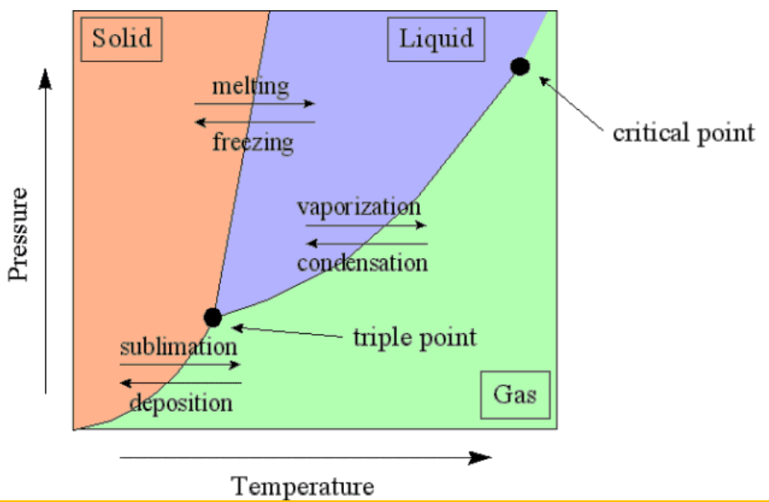

Unit 8 – IMFS – GLUE INS

N29 – Going in Depth

N30 – Vapor Pressure and Phase Diagrams

