N29 – Going in Depth

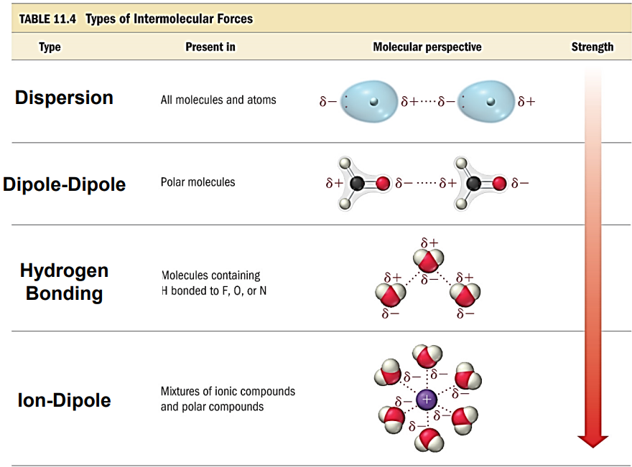

N29 – Going in Depth



N29 – Going in Depth



N29 – Going in Depth



N29 – Going in Depth



N29 – Going in Depth

