N30 – Vapor Pressure and Phase Diagrams

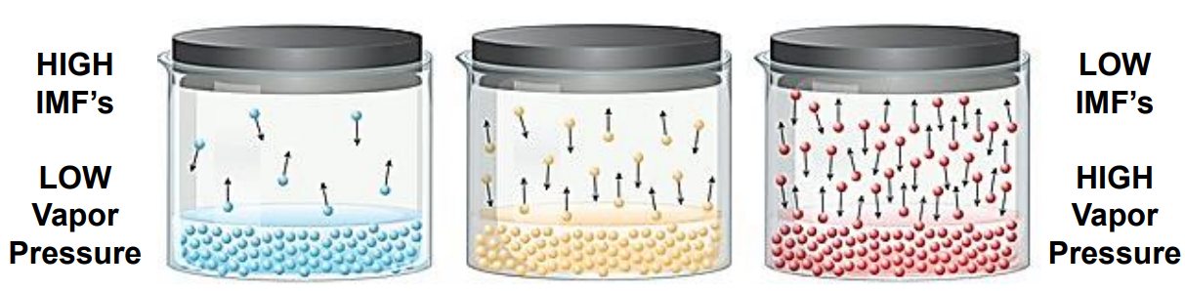

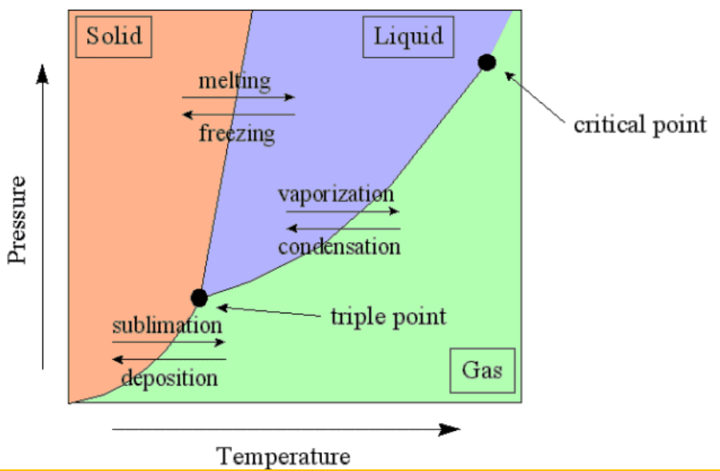

N30 – Vapor Pressure and Phase Diagrams





N30 – Vapor Pressure and Phase Diagrams





N30 – Vapor Pressure and Phase Diagrams





N30 – Vapor Pressure and Phase Diagrams





N30 – Vapor Pressure and Phase Diagrams



