**Dougherty Valley HS AP Chemistry**

**WORKSHEET #3**

**IMF – Heating Curve Practice**

**Name: Date: Period: Seat #:**

A heating curve for ice at -35ºC being converted to steam at 128ºC:

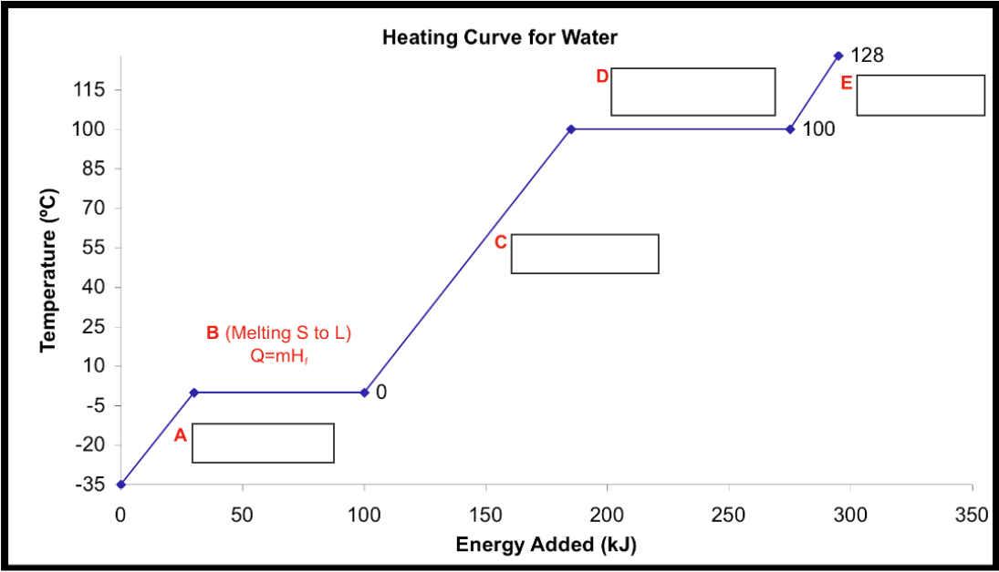

|  |  |
| --- | --- |
| [2] Label the following on the graph above: | Write the formula used: |
| Warming | q = |
| Melting | q = |
| Vaporizing | q = |

|  |  |  |
| --- | --- | --- |
| [3] What are the following values for water include both J/g and KJ/mol (include units): | | |
| Hfus = | J/g | kJ/mol |
| Hvap = | J/g | kJ/mol |

|  |
| --- |
| [4] How many calories are needed to convert 312.0g of ice at -35.0°C to liquid water at 25.0°C: (HINT: Use the graph  above to determine the formula(s) needed). 38220 cal |
| [5] How many joules (J) of energy are released when 6.80E3 g of steam at 100.0°C are completely frozen to ice at 0.0°C:  2.05E7J |
| [6] How much energy (in J) is required to completely melt 205.0 mol of ice at 0.0°C: 1.235E6J |

|  |  |  |  |  |  |  |  |
| --- | --- | --- | --- | --- | --- | --- | --- |
| **Substance** | **C (solid) $$\left(\frac{J}{g∙K}\right)$$** | **M.P.**  **($℃)$** | **ΔHfus** | **C (liquid) $$\left(\frac{J}{g∙K}\right)$$** | **B.P.**  **($℃)$** | **ΔHvap** | **C (gas) $$\left(\frac{J}{g∙K}\right)$$** |
| K | 0.560 | 62 | 61.4 | 1.070 | 760 | 2025 | 0.671 |
| Hg | ---- | -39 | 11 | 0.138 | 357 | 294 | 0.104 |

|  |
| --- |
| How much heat is needed to raise the temperature of 85 g of potassium from 25° C to 2,500°C? 3.41E5 J |