**Name: Period: Seat#:**

**Worksheet #3**

**Directions:**  Use the heating curve below for ice at -35°C being converted to steam at 128°C.

If you need a refresher on Heating Curve calculations here is a YouTube video of the Honors   
Chemistry lecture on the topic. <https://youtu.be/g2srRytHiX0>

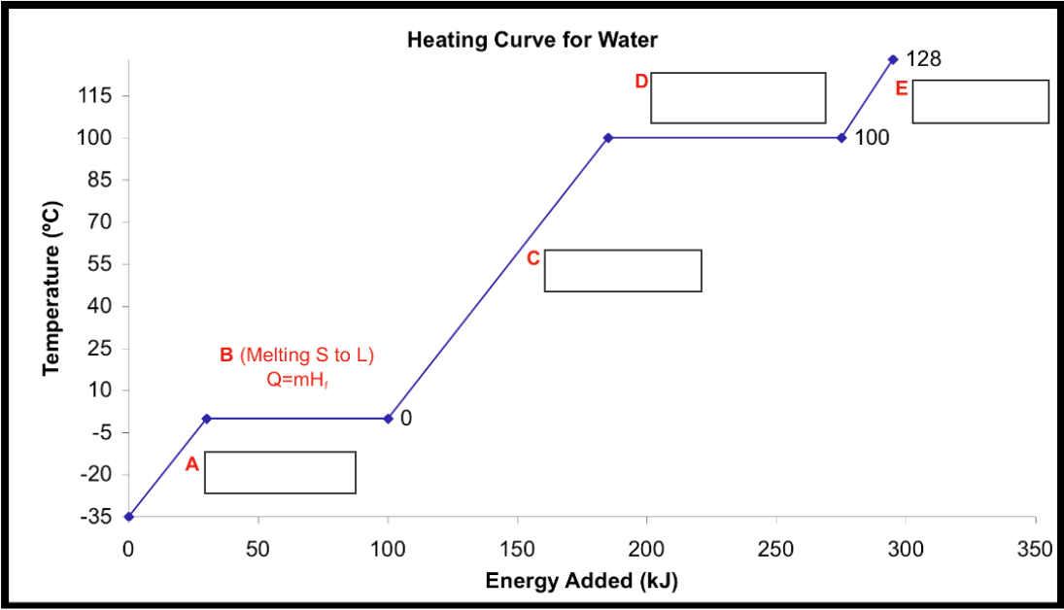

|  |  |
| --- | --- |
| 1. Label each of the blank rectangle boxes on the graph above with one of the following terms. Terms can be used more than once.    * Warming    * Melting    * Vaporizing | Which equation do you use for each of the following sections?   * Warming 🡪 q = * Melting 🡪 q = * Vaporizing 🡪 q = |
| 1. What are the following values for water?  Include both J/g and kJ/mol answers.   J/g kJ/mol   * + Hfus =   + Hvap = | 1. Indicate what is happening in each line segment   ∆ Kinetic Energy ∆ Potential Energy  Line 1  Line 2  Line 3  Line 4  Line 5 |
| 1. How many calories are needed to convert 312.0g of ice at -35°C to liquid to water at 25.0°C *38200 cal*   *(remember, 1 cal = 4.184J)* | |
| 1. How many joules (J) of energy are released when 6.80E3 g of steam at 100.0°C are completely frozen to ice at 0.0°C ? *2.05 x 107J* | |
| 1. How much energy (in J) is required to completely melt 205.0 mol of ice at 0.0°C ? *1.235 x 106 J* | |
| 1. Using the information in the chart below, how much heat is needed to raise the temperature of 85g of potassium from 25°C to 2,500°C ? *3.41 x 105 J*  |  |  |  |  |  |  |  |  | | --- | --- | --- | --- | --- | --- | --- | --- | | **Substance** | **C (solid) $$\left(\frac{J}{g∙K}\right)$$** | **M.P.**  ( $℃)$ | **ΔHfus** | **C (liquid) $$\left(\frac{J}{g∙K}\right)$$** | **B.P.**  ( $℃)$ | **ΔHvap** | **C (gas)** | | K | 0.560 | 62 | 61.4 | 1.070 | 760 | 2025 | 0.671 | | |