Name: Period: Seat#:
Worksheet #4

Directions: Show all work in a way that would earn you credit on the AP Test! This is always the rule! Grading rubrics posted in the Google Answer Key Drive. Check your work, correct in green pen after you try them yourself in an honest way! Don’t peek at rubrics while you work! USE BINDER PAPER, STAPLE TO YOUR WORKSHEET. Clearly label work.
LONG ASSIGNMENT! DON’T WAIT UNTIL THE LAST MINUTE! BREAK IT INTO CHUNKS!
SET A TIMER FOR 1.5 MIN PER FRQ PART AND SEE IF YOU FINISH ON TIME!

1999 | 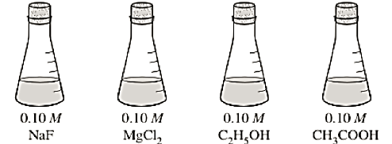  7. Answer the following questions, which refer to the 100mL samples of aqueous solutions at 25°C in the stoppered flasks shown above.  - Which solution has the lowest electrical conductivity? Explain.  - Which solution has the highest pH? Explain. (hint! Remember salts from Acid Base in Honors Chem???)
2008 | 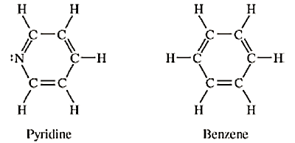  6. Answer the Qs by using principles of molecular structure and IMFs  - Structures of the pyridine molecule and benzene molecule are shown below. Pyridine is soluble in water, whereas benzene is not soluble in water. Account for the differences in solubility. You must discuss both of the substances in your answer.  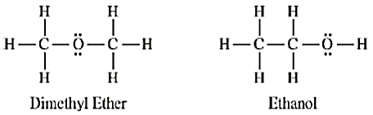  - Structures of the dimethyl ether molecule and the ethanol molecule are shown below. The normal boiling point of dimethyl ether is 250 K, whereas the normal boiling point of ethanol is 351 K. Account for the difference in boiling points. You must discuss both of the substances in your answer.  - SO₂ melts at 201 K, whereas SiO₂ melts at 1,883 K. Account for the difference in melting points. You must discuss both of the substances in your answer.  - The normal boiling point of Cl₂(l) (238 K) is higher than the normal boiling point of HCl(l) (188 K). Account for the difference in normal boiling points based on the types of intermolecular forces in the substances. You must discuss both of the substances in your answer.
2001 | 8. Account for each of the observations about pairs of substances. In your answers, use appropriate principles of chemical bonding and/or IMFs. In each part, your answer must include references to both substances.  - Even though NH₃ and CH₄ have similar molecular masses, NH₃ has a much higher normal boiling point (–33°C) than CH₄ (–164°C).  - At 25°C and 1.0 atm, ethane (C₂H₆) is a gas and hexane (C₆H₁₄) is a liquid.  - Si melts at a much higher temperature (1,410°C) than Cl2(–101°C).  - MgO melts at a much higher temperature (2,852°C) than NaF (993°C).
2003 | 6. For each of the following, use appropriate chemical principles to explain the observation. Include chemical equations as appropriate.  - In areas affected by acid rain, statues and structures made of limestone (calcium carbonate) often show signs of considerable deterioration.  - Methane gas does not behave as an ideal gas at low tempertures and high pressures.  - Water droplets form on the outside of a beaker containing an ice bath.
2003 | 8. Using the information in the table above, answer the following questions about organic compounds.  - For propanone,  - Draw the complete structural formula (showing all atoms and bonds);  Compound Name Compound Formula ∆H°_{vap} (kJ mol⁻¹)  Propane CH₃CH₂CH₃ 19.0  Propanone CH₃COCH₃ 32.0  1-propanol CH₃CH₂CH₂OH 47.3  - Predict the approximate carbon-to-carbon bond angle.  - For each pair of copounds below, explain why they do not have the same value for their standard heat of vaporization, ∆H°_{vap}. (You must include specific information about both compounds in each pair).  - Propane and propanone  - Propanone and 1-propanol  - Draw the complete structural formula for an isomer of the molecule you drew in part (a)(i)  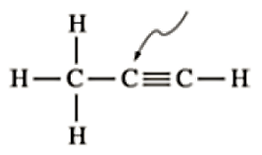  - Given the structural formula for propyne below,  - Indicate the hybridization of the carbon atom indicated by the arrow in the structure above.  - Indicate the total number of sigma (σ) bonds and the total number of pi (π) bonds in the molecule.
2004 | 7. Use appropriate chemical principles to account for each of the following observations. In each part, your response must include specific information about both substances.  - At 25°C and 1 atm, F₂ is a gas, whereas I₂ is a solid.  - The melting point of NaF is 993°C, whereas the melting point of CsCl is 645°C.  - The shape of the ICl₄– ion is square planar, whereas the shape of the BF₄– ion is tetrahedral.  - Ammonia, NH₃, is very soluble in water, whereas phosphine, PH₃, is only moderatly soluble in water.
2005 | 7. Use principles of atomic structure, bonding, and/or intermolecular forces to respond to each of the following. Your responses must include specific information about all substances referred to in each question.  - At a pressure of 1 atm, the boiling point of NH₃(l) is 240 K, whereas the boiling point of NF₃(l) is 144 K.  - Identify the intermolecular force(s) in each substance.  - Account for the difference in the boiling points of the substances.  - The melting point of KCl(s) is 776°C, whereas the melting point of NaCl(s) is 801°C.  - Identify the type of the bonding in each substance.  - Account for the difference in the melting points of the substances.  Element First Ionization Energy (kJ mol^{–1})  Si 786  P 1,012  Cl 1,251  - As shown in the table below, the first ionization energies of Si, P, and Cl show a trend.  - For each of the three elements, identify the quantum level (e.g., n = 1, n = 2, etc.) of the valence e–s in the atom.  - Explain the reasons for the trend in first ionization energies.  - A certain element has two stable isotopes. The mass of one of the isotopes is 62.93 amu and the mass of the other isotope is 64.93 amu.  - Identify the element. Justify your answer.  - Which isotope is more abundant? Justify your answer.
2005B | 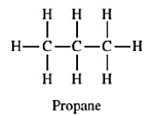  8. (a) Draw a complete Lewis electron-dot structure for the CS₂ molecule. Include all the valence electrons in your structure.  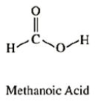  - The carbon-to-sulfur bond length in CS₂ is 160 picometers. Is the carbon-to-selenium bond length in CSe₂ expected to be greater than, less than, or equal to this value? Justify your answer.  - The bond energy of the carbon-to-sulfur bond in CS₂ is 577 kJ mol^{–1}. Is the bond energy of the carbon-to-selenium bond in CS₂ expected to be greater than, less than, or equal to this value? Justify your answer.  Substance Boiling Pt. Intermolecular Attractive Force(s)  Propane 229 K  Methanoic acid 374 K  - The complete structural formula of propane, C₃H₈, and methanoic acid, HCOOH, are shown above. In the table below, write the type(s) of intermolecular attractive force(s) that occur in each substance.  - Use principles of IMFs to explain why methanoic acid has a higher boiling point than propane.
2006 | 6. Answer each of the following in terms of principles of molecular behavior and chemical concepts.  - The structure for glucose, C₆H₁₂O₆, and cyclohexane, C₆H₁₂, are shown below.  Identify the type(s) of intermolecular attractive forces in  - pure glucose  - pure cyclohexane  - Glucose is soluble in water but cyclohexane is not soluble in water. Explain.  - Consider the two processes represented below.  Process 1: H₂O(l) H₂O(g) ∆H° = +44.0 kJ mol^{–1}  Process 2: H₂O(l) H₂(g) + ½ O₂(g) ∆H° = + 286 kJ mol^{–1}  - For each of the two processes, identify the type(s) of intermolecular or intramolecular attractive forces that must be overcome for the process to occur.  - Indicate whether you agree or disagree with the statement in the box below. Support your answer with a short explanation.  When water boils, H₂O molecules break apart to form hydrogen molecules and oxygen molecules.
Reflection: Think about the types of mistakes you made, things you need to restudy, things that tricked you, etc. One of the most important skills to develop in AP Chem is self reflection and not making the same mistakes. The joke is – you should always make NEW mistakes, not the SAME mistakes

