Lab – Calculating the Ksp of Calcium Hydroxide using Titration

**Overview**

Solubility product (Ksp) values represent the number of ions that remain in solution after a solution has reached the point of saturation. Because Ksp values represent salts that are largely insoluble in water, all of the Ksp values are incredibly small ( x <<< 1). As a result, an incredibly small concentration of ions exists in equilibrium with the solid. Most of the ions stay together in the solid, but a few ions exist in solution, and the system is in equilibrium.

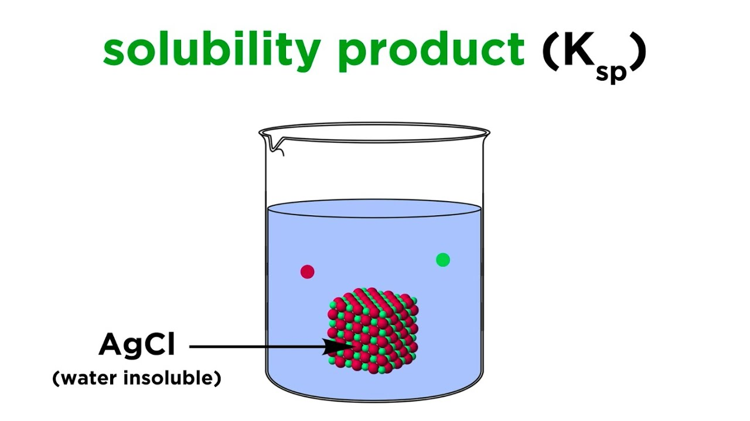

See the diagram to the right, which models what AgCl (s) in water is like. Most of AgCl remains a solid while a few ions exist in solution.

To calculate the Ksp values for different solids, chemists frequently use titration to add a precise amount of reagent that will react with one of the ions in solution.

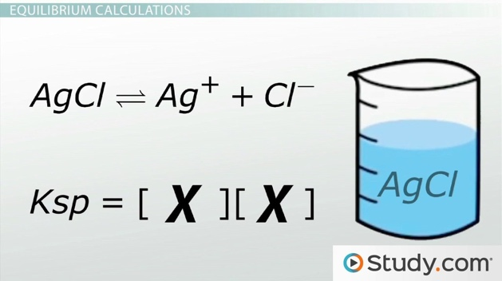For the experiment today, we will be reacting the OH- ions from a saturated Ca(OH)2 solution with a precise amount of HCl. To know when the reaction has completed, we will be using an indicator that changes color to indicate the pH of the solution has become neutral (i.e. all the OH- ions have been removed from solution).

**Pre-Lab Questions**

1. Write out the equilibrium reaction of a saturated solution of Ca(OH)2.
2. Write out the Ksp expression for the above reaction.
3. HCl—a strong acid—will be added to our solution today. Write out the reaction of HCl in water below.

|  |
| --- |
| HCl (*aq*) + H2O (*l*) |

1. Write out the balanced neutralization reaction between Ca(OH)2 and HCl below.

|  |
| --- |
| HCl (*aq*) + Ca(OH)2 (*aq*) |

**Procedure**

**Part 1 – Preparing a dilute solution of hydrochloric acid**

Materials: 100 mL volumetric, 10 mL graduated cylinder, graduated pipette, water bottle

1. Using a graduated pipette or a graduated cylinder, transfer exactly 4.00 mL of the stock 1.00 M HCl to a 100 mL volumetric flask. Carefully fill to the line with water.
2. Using $M_{1}V_{1}=M_{2}V_{2}$, calculate the molarity of this diluted solution. You’ll be using this solution as the titrant (i.e. the solution of known concentration that goes into the burette) for your titration.
3. Use a small portion (~10 mL) of this diluted acid to rinse the insides of the burette. Then, fill the burette with this solution so that the volume is somewhere between 5and 0 mL.

**Part 2 – Determination of Ksp for Ca(OH)2 via titration**

Materials: stand, burette clamp, burette, glass funnel, 50 mL beaker, plastic pipet, 125 mL Erlenmeyer flask, 10 mL graduated cylinder

1. Using a small beaker, obtain ~ 40 mL sample of the saturated calcium hydroxide solution from the beaker at the front of the room. You’ll take this back to your table and keep this for the duration of the lab for each of your trials.
2. 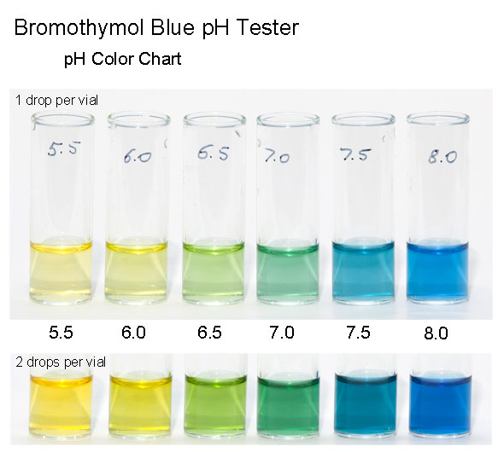Using your graduated pipette or a graduated cylinder + plastic pipette, measure out precisely 10.0 mL of the saturated solution from your beaker and place into your flask. Then, add 5 drops of bromothymol blue indicator to this solution. Because the solution is slightly basic from the presence of OH- ions, it will be blue in color. See the diagram on the screen (to the right) to see the color correlating to pH. The goal is to get to pH neutral…a darker green color.
3. The calcium hydroxide solution is now ready to be titrated. Record the initial volume of HCl in your burette to the nearest 0.01 mL on your data table.
4. Titrate with the diluted HCl until the color of the solution changes from blue to greenish yellow, thus indicating that all of the OH- ions have reacted completely with the H+ ions from the HCl. When you’ve reached the end point of the titration, bring your flask up to the screen at the front of the room to compare your flask to the image from step 5. Record the final volume of the HCl solution to the nearest 0.01 mL on your data table.
5. Dump the contents of the flask into the waste beaker by the sink. Rinse the flask thoroughly with water.

1. Repeat steps 6 - 9for a total of 3 titrations.
2. CLEAN UP AND DISPOSAL: Dispose of the extra calcium hydroxide solution into the same waste beaker at the end of the experiment. Put the remaining dilute HCl in the labeled beaker at the front of the room. Rinse all equipment (especially the burette) and put all the equipment where you found it.

**Data & Calculations**

|  |  |  |  |
| --- | --- | --- | --- |
|  | **Trial 1** | **Trial 2** | **Trial 3** |
| Initial volume of HCl solution, mL |  |  |  |
| Final volume of HCl solution, mL |  |  |  |
| Total Volume of HCl used, mL |  |  |  |
|  |  |  |  |
| Moles HCl added to Ca(OH)2 solution |  |  |  |
| Molar Ratio of HCl to Ca(OH)2  2 HCl + Ca(OH)2 H2O + CaCl2 |  |  |  |
| Moles Ca(OH)2 in flask  (based on molar ratio) |  |  |  |
| Volume of Ca(OH)2 in flask, mL |  |  |  |
| Concentration of Ca(OH)2, |  |  |  |
| Concentration of Ca2+, |  |  |  |
| Concentration of OH-, |  |  |  |
| Calculate Ksp.  Ksp = [Ca2+] [OH-]2 |  |  |  |
| Textbook value of Ksp @ 25 oC  Ksp = 5.5 x 10-6 |  |  |  |
| Percent Error  % Error = |  |  |  |

In 2 – 3 sentences, summarize what the purpose of this lab was, what we were trying to calculate, and how we did that specifically. (This is a great to remember the experiment).