N31 – Separation Techniques and [ ] Calcs

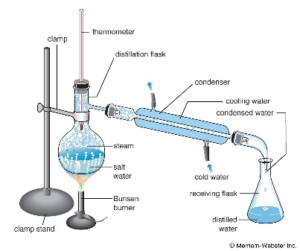

N31 – Separation Techniques and [ ] Calcs

N31 – Separation Techniques and [ ] Calcs

