N32 – Heat of Solution

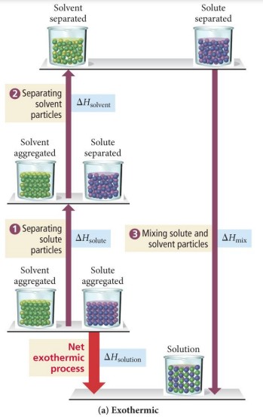 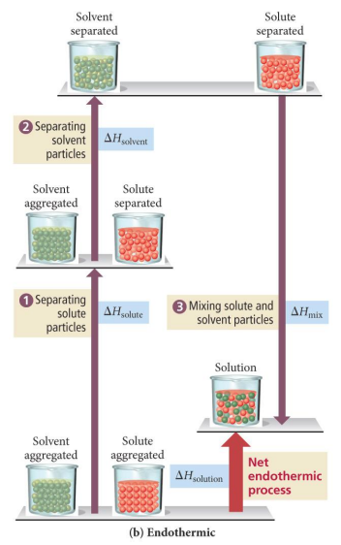

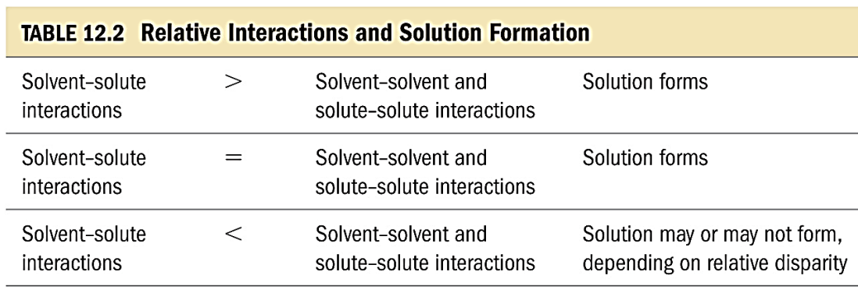

N32 – Heat of Solution

N32 – Heat of Solution

 



 